Phet Lesson, Equality Explorer, 6th Grade intro to solving and equality statements
Overview
This lesson is meant to have students explore the underlying principles of solving one-step equations.
Prerequisite Skills:
- Students can identify the additive inverse of an integer.
- Use variables to represent values.
Learning Goals:
- I understand and can describe the equals sign as a balance that states each side of the equation is equal to the other.
- I can use opposite operations (additive inverse) to make zero pairs.
- I can use opposite operations to isolate (get by itself) the variable.
Common Core Standards:
- 6.EE.B.5 Understand solving an equation or inequality as a process of answering a question: which values from a specified set, if any, make the equation true? Use substitution to determine whether a given number in a specified set makes an equation or inequality true.
- 6.EE.B.6 Use variables to represent numbers and write expressions when solving a real-world or mathematical problem; understand that a variable can represent an unknown number, or , depending on the purpose at hand, any number in a specified set.
- 6.EE.B.7 Solve real-world and mathematical problems by writing and solving equation of the form x+p=1 and pxq for cases in which p, q and x are all nonnegative rational numbers.

Mathematical Practices:
- Reason abstractly and quantitatively.
- Construct viable arguments and critique the reasoning of others.
- Look for and make use of structure.
Materials
- One-to-one or one-to-two device setup.
- Projector for warm up.
- Class set of activity sheets.
- Ideally some manner by which to share a web link with students (Google Classroom, etc.)
Estimated Time: approximately 50min

Equality Explorer
Warm Up | 7min
Project the below image from https://im.openupresources.org/6/students/6/3.html. Have students think quietly for 2min, then discuss with a partner for 2min. Have a few students share out an idea they discussed with their partner.

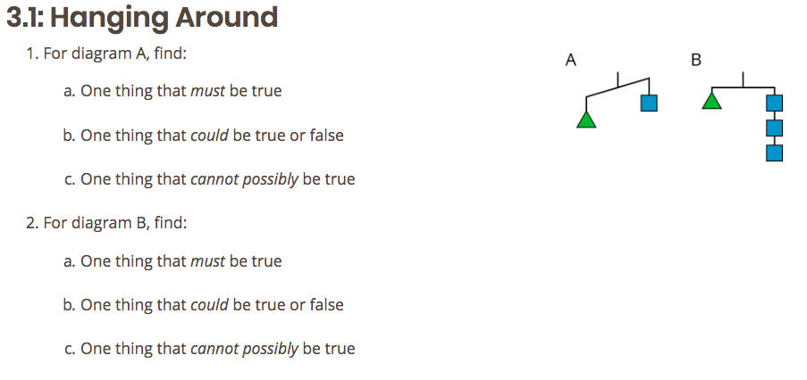
Adapted from Open Up Resources/Illustrative Mathematics. Download the original lesson for free at openupresources.org
Simulation Introduction | 7-10min
Teacher will... | Students will...
- Make sure each student has a pencil.  - Hand out an activity sheet to each student.  - Help students get to the correct link / sim.  - Tell students that the interactive screen is called a simulator or sim.  - Show students what the Basics screen looks like on the projector.  - Ask students to play around with the sim and discover what it can do.  - Tell them they will have a chance to share out. | Follow along with instructions and then play with the sim.
- Ask students to share out.  - Make sure that the following items are covered  - The balance arrow is green when the two sides are of equal weight  - Snapshots  - 4 different modules  - Reset button  - Eraser and Restack button | Share out to the class
Investigation: Problems 2-7 | 10-25min  Students work in pairs.
- Point out to students that there is a checkpoint after question 7.  - Ask students to begin working through problems 2 through 7, checking in with their partner for each question to share and discuss answers.  - For the checkpoint, push students to explain what an equals sign says about a relationship.  - Each side of the balance must be the same value. | Students should be discussing each problem. If necessary, the teacher should add talking accountability structures.
Investigation: Problems 8-13 | 25-40min  Students work in pairs.
- When all or almost all pairs have continued on to the Numbers part of the sim (past #8), pause the class.  - Ask for students to share out what is new or different about this sim?  - Make sure to cover:  - The lock button  - Making zero pairs on one side of the scale  - Taking away something that isn’t there (in lock mode) | Students pause and follow teacher led discussion.
Closure  - Tell students that one of our most important takeaways is being able to explain the meaning of an equals sign. Have them move ahead to #13 and discuss if they have not yet. | Skip to #13 and discuss with their partners.
Exit Ticket (formative assessment) | Last 6min of class
Provide the below exit ticket problems on a half or third of a sheet. Have students work independently and show and explain their thinking.

Exit Ticket:

- Explain the meaning of an equal sign.

- How can you change an equation and keep it balanced?

