Grade 6 Area Model Decimals Lesson Plan
Note: this lesson plan is adapted from Illustrative Mathematics, Grade 6, Unit 5, Lesson 7 under the Creative Commons OER License. It was originally developed by Open Up Resources. Download the original lesson for free at openupresources.org. The original lesson is here. Access is free, but you may need to create a login.

Overview
Prerequisite Skills:
- Fluently multiply multi-digit whole numbers using using strategies based on place value and the properties of operations, and the standard algorithm. Illustrate and explain the calculation by using equations, rectangular arrays, and/or area models. (4.NBT.B.5 and 5.NBT.B.5)
- Explain patterns in the number of zeros of the product when multiplying a number by powers of 10, and explain patterns in the placement of the decimal point when a decimal is multiplied or divided by a power of 10. (5.NBT.A.2)
- Add, subtract, multiply, and divide decimals to hundredths, using concrete models or drawings and strategies based on place value, properties of operations, and/or the relationship between addition and subtraction; relate the strategy to a written method and explain the reasoning used. (5.NBT.B.6)
- Find the area of a rectangle with whole-number side lengths. (3.MD.A.7a-d)
- Decomposing shapes to determine the area. (6.G.1)
Previous lessons on this topic:
- Students use place value to reason about multiplication and division. For example, students can explain why (.6)$⋅$(0.5) is equivalent to 6(.1)$⋅$5(0.1), 6($\frac{1}{10}$)$⋅$5($\frac{1}{10}$), etc. Students can explain why (0.2)(0.002) = 0.0004 by reasoning about place value.
- Students know and can explain more than one way to multiply decimals using fractions and place value. Students know and can explain the relationship between 21$⋅$47=987 and (2.1)⋅(4.7) and 21⋅(0.047), (0.021)⋅(4.7), etc.
Subsequent lessons on this topic:
- Students calculate products of decimals using the algorithm and compare to area model.
- Students determine a method for calculating products of decimals that is the most efficient and effective for them.
Learning Goals:
- Use area diagrams to represent, reason, and find products of decimals.
Common Core Standards:
6.NS.B.3 Fluently add, subtract, multiply, and divide multi-digit decimals using the standard algorithm for each operation.
Standards for Mathematical Practices:
6. Attend to precision.
7. Look for and make use of structure.
Materials:
- PhET Area Model Decimals Simulation
- Computers/tablets for each student or pair of students
- Area Model Decimals Activity Sheet (1 per student); the extension problems are included if needed
Estimated Time:
50-60 minutes
Lesson Plan
Warm-up (5 minutes)
This warm-up gives students a preview of the area models that they will see in the lesson. Note that this warm-up in intentionally short. The purpose is not to teach them about features of the PhET simulation nor is it to name these features, but for them to have a reference for how they could make the simulation look, to inspire students to find these features in the simulation.

Launch
Give students the handout and display the four images below for all to see. Ask students to give a signal when they have noticed one expression that does not belong and can explain why. Give students 1-2 minutes of quiet think time and then time to share their thinking with their small group. While in small groups, students should share their reasoning about why a particular picture does not belong, and then together in their small group, find at least one reason each expression doesn’t belong.

Student Task
Which one doesn’t belong? Be ready to explain your reasoning.

A B
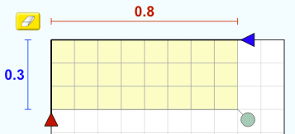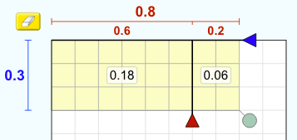

C D
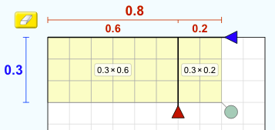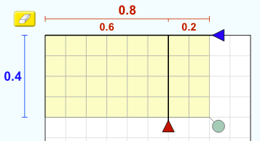

Sample Student Responses
- It is the only one with only one rectangle
- It is the only one with one number written inside each smaller rectangle
- It is the only one with a product written inside each smaller rectangle
- It is the only one with 0.4 as the height (number in blue)

Whole Class Discussion
Ask each group for a reason that one of the images does not belong. Record and display the responses next to the image, for all students to see. After each response, ask the class if they agree or disagree. Since there is no one correct answer, allow students to help each other with precision in their responses.
Activity 1: Simulation
Open Play and Sharing Out (10 minutes)
Explain to students that the pictures in the warm-up are called area models. Ask who is familiar with these. Tell students that they are going to play with some area models like these.

Give students the link to the simulation (above) or tell them to search “phet area decimals”

Give students about 5 minutes to simply explore the Area Model Decimals simulation. Resist the urge to interfere and interrupt. If any students are struggling to get started, encourage them first to work in a pair. If a pair in struggling, encourage them to make one or more of the models from the warm-up.

Then, in the next 5 minutes, tell students: “I want you to play some more, but at the end of this play, I’m going to ask you to teach me how this simulation works in a few minutes. See if you can find a feature that you think no one else will find.”

While students work, use the 5 Practices for Orchestrating Productive Mathematics Discussion
Anticipate that students will discover:
- Make the rectangle bigger by dragging the green dot in the lower right corner or with the up/down arrows
- Partitioning the bigger rectangle with the red and blue sliders
- Showing the partial product two ways, A and a x b
- Showing the grid and coloring the rectangles yellow
- Changing the size of the grid to work on

Monitor & Select:
While students work, circulate to determine which students can share each of these features. Tell each student what feature you want them to share. Possible questions to ask students while you circulate to determine which students to select for the whole class share out (you may be able to select students just by watching what they do):
- How did you make the rectangles bigger?
- How did you break the bigger rectangle into smaller rectangles?
- (If the bigger rectangle is split) What do the smaller red (or blue) numbers tell you? Where do those numbers come from?
- What is the multiplication problem that you’re showing with your area model?

Sequence student responses:
Call on pre-selected students and ask them to share what they discovered in the order of the “Anticipate” section above.
After you hear from the pre-selected students, ask if there are any other features that we should look at as a class.

Connect ideas:
We can use this area model to help us show multiplication of two numbers. Today, we are seeing how we can use this model to help us multiply decimals.
Guided Exploration (20 minutes)
In this part of the lesson, students will explore three different ways to partition a rectangle.

Possible modifications:
- For #3, consider deleting the partial products from the rectangles and have students determine those. Or consider asking students to determine how to partition the height of Model 2 and the length of Model 3.
- For #6, consider making more challenging by asking students to create a multiplication problem with decimals what would best be solved with this area model:
 | ____ | ____
_____

- For #7, consider making more challenging by asking students to create a multiplication problem with decimals with numbers that are too big for the simulation.

Launch
Students in groups of 2.
Give students 5-8 minutes to answer #1, #2, #3a, and #3b with their partner. As students work, monitor for students who need more support coming up different ways to partition in #2.

Discuss parts #3a) and b).
Commonalities that students should notice: all diagrams have a total area of 3.12, all lengths are 2.4, and all heights are 1.3.
Differences that students should notice: the first rectangle has been partitioned into four smaller rectangles and the others are partitioned into two
Students may use informal language (split, broken into) at this time. If students do not use the word partitioned, introduce it to them.

Work
Students should work in pairs on #4 individually. Then they should share with their partner what they decided. It’s important here that there are many correct ways to partition each side - students should look for ways to partition that make the multiplication “easier.”

Students can then continue with #5 - #9. As students work, monitor for students who need more support using the simulation.
Select students to share their area models/answers for #4, #5, and #6.
Notice that #5-7, students will likely get stuck trying to make their area model because...
for #5, it less efficient to split into 4 smaller rectangles, but to split into 2 rectangles (although 4 rectangles can work)
for #6, the rectangle doesn't fit on the sim, so students will work it out on paper
for #7, again, doesn't work on the sim, so students will have to figure out a way to do it on paper
Discussion and Summary (5 minutes)
Ask students how they decided how to make their model for #4 and/or #5 and/or #6 (depending on where students got/what you have time for).
Lesson Synthesis (5 minutes)
(From Illustrative Mathematics Grade 6, Unit 5, Lesson 7)
We can use the area of a rectangle to represent products of decimals, just as we have done so with whole numbers.
- How can a rectangle help us represent the product of two numbers? (The sides of a rectangle can represent the factors, and the area of the rectangle represents the product.)
- How do we use a rectangle to help us find the product of two numbers? (We can decompose each factor by place value—tens, ones, tenths, hundredths, etc., partition the rectangle into regions, and find the areas of these regions. The sum of these partial areas is the product of the two numbers. This method can be used with whole numbers and decimals.
Cool-Down (5 minutes)
Give students the following two problems on a sheet of paper. If time is an issue, make sure students complete #1.

Student Task
1. A student used the following area diagram to compute 28$⋅$49. The student found that 28$⋅$49 = 1372
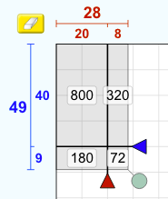

Create an area diagram to show how to compute (2.8)$⋅$(4.9). If you can, determine the answer.

2. Which of the following is the correct value of (2.2)⋅(0.4)? Show your reasoning.
a. 8.8
b. 0.88
c. 0.088
d. 0.0088

Sample Student Responses
1. 13.72
 | 2 | 0.8
4 | 8 | 3.2
0.9 | 1.8 | .72

2. 0.882
