Area Models Decimals

Warm-up: Which one doesn’t belong? Be ready to explain your reasoning.

A B
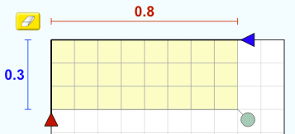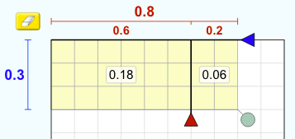

C D
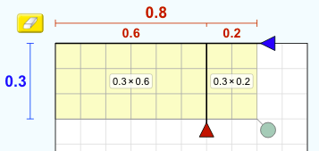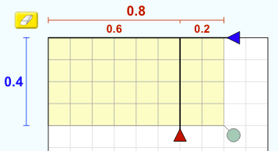

Here is an area model for $(2.4) ⋅ (1.3)$.
 | 2 | 0.4
1 | 2 | 0.4
0.3 | 0.6 | 0.12
 | Area Model 1

1. Here is another area diagram that represents $(2.4) ⋅ (1.3)$.
 | 1.2 | 1.2
1
0.3
 | Area Model 4

  - Use the simulation to create this area model.

  - Use the simulation to label each of the regions with their respective areas on the diagram above.

2. Use the simulation to create another way that shows (2.4)$⋅$(1.3) decomposed into four rectangles. Then, share with your partner. Record each others’ rectangles and then come up with a third way.
My model: My partner’s model: Another model:

 | ___ | ___
___
___

 | ___ | ___
___
___

 | ___ | ___
___
___

3. Take a break from the simulation. Here are three ways of finding the area of a rectangle that is 2.4 units by 1.3 units. All area models give the correct answer of 3.12.

 | 2 | 0.4
1 | 2 | 0.4
0.3 | 0.6 | 0.12
 | Area Model 1

 | 2.4
1 | 2.4
0.3 | 0.72
 | Area Model 2

 | 2 | 0.4
1.3 | 2.6 | 0.52
 | Area Model 3

Discuss with your partner:
- What do the three area models have in common?

- How are they different?

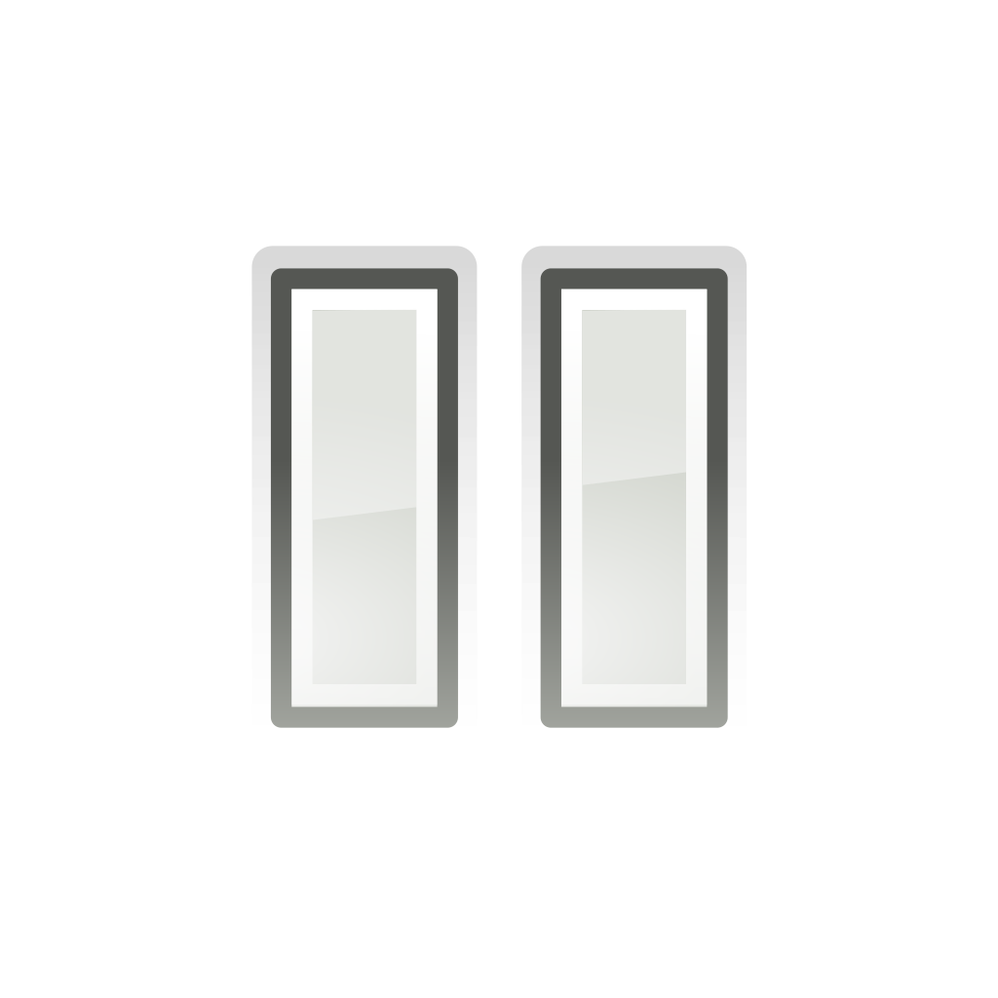

Pause here for a class discussion.

4. If you were to find the area of a rectangle that is 3.7 units by 1.9 units, how would you create your area model? Why? (If you’d like, you may use the simulation and draw your area model.)

5. Find the product (1.8)$⋅$(2.9) by drawing and labeling an area diagram. Show your reasoning. Use the four rectangle model below or make your own. Use the simulation if needed.
 | ___ | ___
___
___

6. Find the product of (0.4)$⋅$(2.1) by drawing and labeling an area diagram. Show your reasoning.

7. Find the product of (3.6)$⋅$(1.5) by drawing and labeling an area diagram. Show your reasoning.

8. Find the product of (2.12)$⋅$(1.1) by drawing and labeling an area diagram. Show your reasoning.

9. If you were to tell another student how to set up an area model to solve a multiplication problem with decimals, what steps should they follow?

Extension:

10. Here are two ways of calculating $(2.4) ⋅ (1.3)$. Analyze the calculations and discuss the following questions with a partner.
- 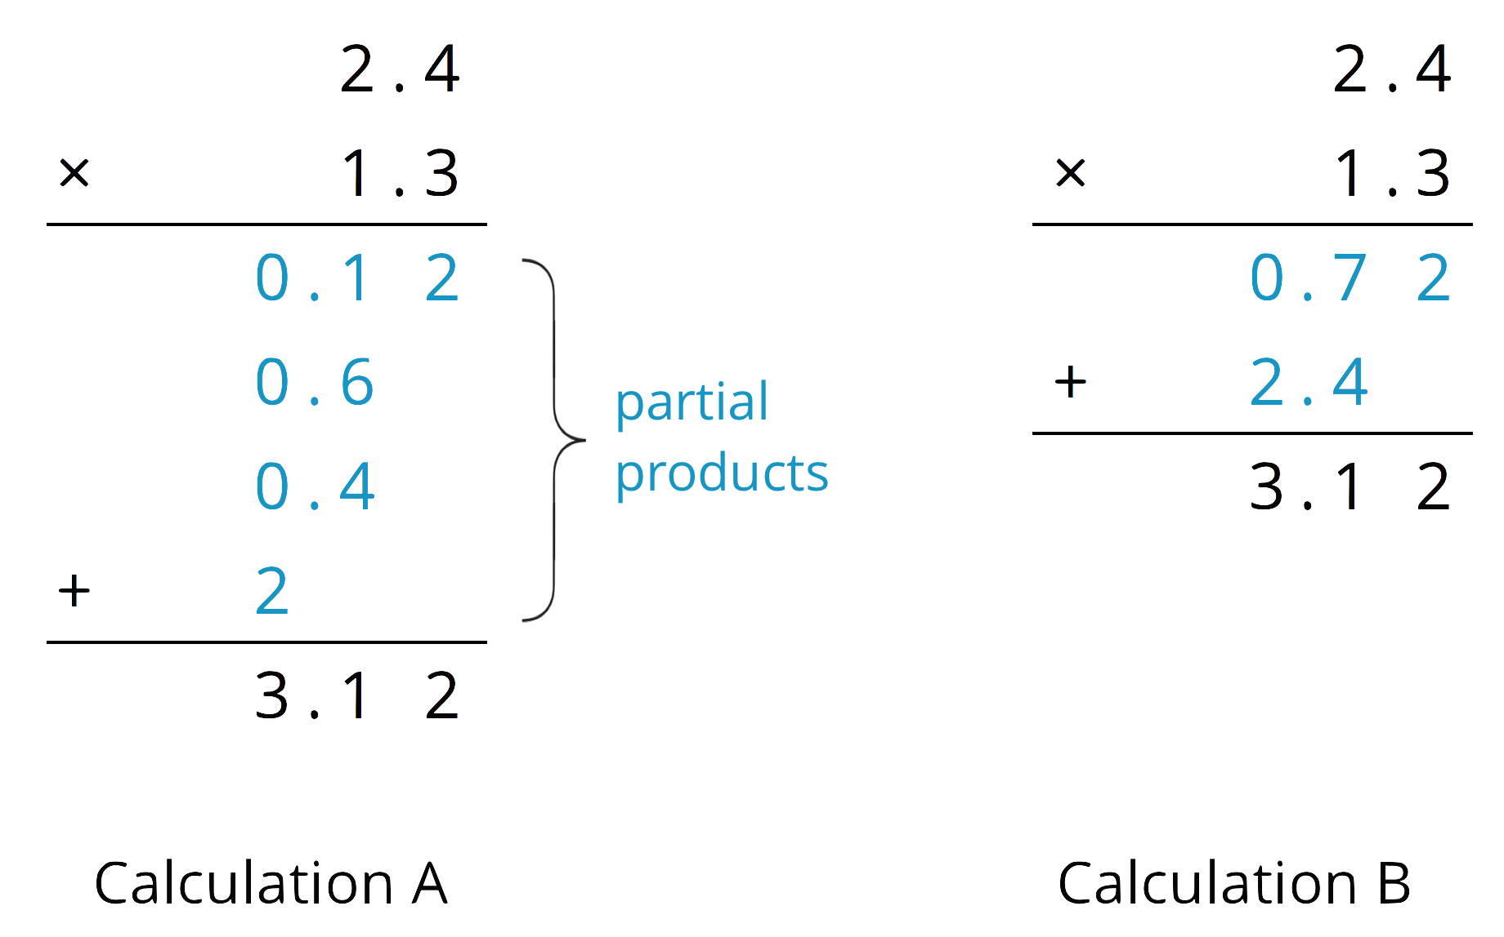
  - In Calculation A, where does the 0.12 and other partial products come from? In Calculation B, where do the 0.72 and 2.4 come from?

  - In each calculation, why are the numbers below the horizontal line aligned vertically the way they are?

10. Find the product of $(3.1) ⋅ (1.5)$ by drawing and labeling an area diagram. Show your reasoning.

11. Show how to calculate $(3.1) ⋅ (1.5)$ using numbers without a diagram. Be prepared to explain your reasoning. If you are stuck, use the examples in a previous question to help you.

