Would You Rather ...

Learning Goals:
Identify different representations of polynomial products
Model binomial by trinomial multiplication using an area model
Compare the area model to the FOIL method

1. Play with the 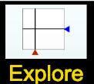screen of the Area Model Algebra simulation for a few minutes, then record three things you discovered.

A.

B.

C.

2. Play with the 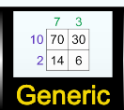 screen of the Area Model Algebra simulation, then record three “new” things you discovered. Have you clicked on ALL the buttons, checked ALL the boxes, open/closed ALL the windows, explored ALL the drop down options?

A.

B.

C.

3. What do you wonder about this simulation? Make a prediction about what you will see on the next screen, called Variable. Share your ideas with a partner.

4. Try a few problems using both strategies. The simulation can be used to check your work. Record both a pro and a con for each method for both types of problems.
Problem | Multiply using FOIL method | Multiply using area model
(x + 12)(x + 3) |  | 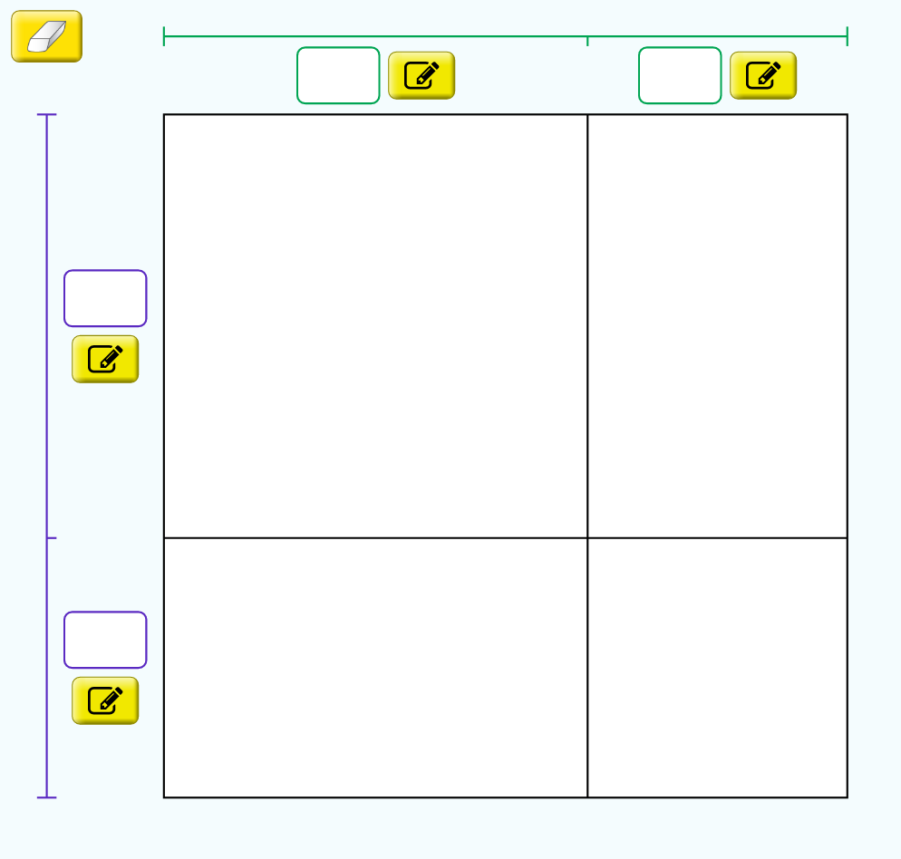
Which strategy would you rather use and why? | Pro -  Con - | Pro -  Con -
(2x - 5)($x^{2}$+ 5x - 7) |  | 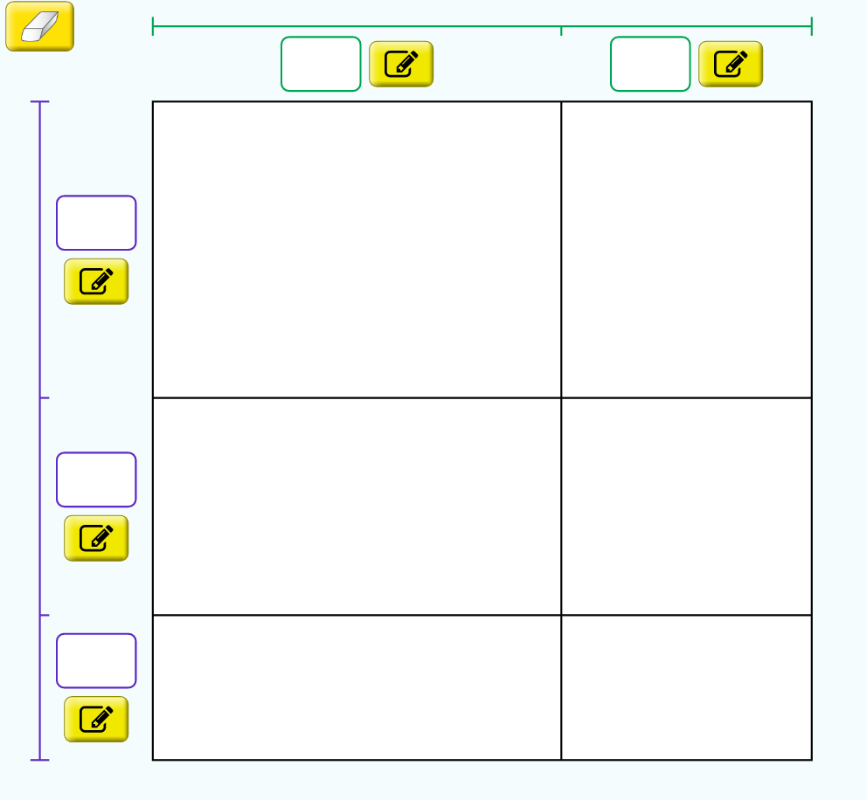
Which strategy would you rather use and why? | Pro -  Con - | Pro -  Con -

6. Would you rather use the FOIL method or the area model? List 3 reasons why the FOIL method is better and 3 reasons why the area model is better.
 | Reason #1 | Reason #2 | Reason #3
FOIL method
Area model

