Overview
Grade level: Algebra 1 or Algebra 2
Placement: In Algebra 1, use the lesson in the middle of a quadratic unit, as in intro to vertex form, and following work with quadratic functions written in factored and standard form. For Algebra 2, place during transformation work or prior to completing the square.
Prerequisite Skills:
- Have constructed graphs of quadratics in standard form using a table of values.
- Have factored quadratics and found the x-intercepts.
- Can locate the y-intercept of a quadratic.
- Can write the equation of a quadratic from a table of values and the second difference.
Learning Goals:
- Analyze quadratic expressions in vertex form and see the form as a coefficient times a squared term plus a constant.
- Connect the parameters of a quadratic expression in vertex form to the graph that represents it.
- Identify the vertex from the equation in vertex form.
- Recognize the vertex as a maximum or minimum value.
- Connect the axis of symmetry with the vertex.
- Predict maximum or minimum based on the value of a.
Common Core Standards:

HSF-BF.B.3: Identify the effect on the graph of replacing by f(x), f(x) + k , kf(x), f(kx) and f(x+k) for specific values of k (both positive and negative); find the value of k given the graphs. Experiment with cases and illustrate an explanation of the effects on the graph using technology. Include recognizing even and odd functions from their graphs and algebraic expressions for them.

HSF-IF.C: Analyze functions using different representations.

HSF-IF.C.7.a: Graph linear and quadratic functions and show intercepts, maxima, and minima.
Mathematical Practices:

Make sense of problems and persevere in solving them.

Model with mathematics.

Use appropriate tools strategically.

Attend to precision.

Look for and make use of structure.

Look for and express regularity in repeated reasoning.

Materials:
- Devices that run PhET Graphing Quadratic Function (ideally 1 per student)
- Vertex Form Activity Sheet (1 per student)
- PhET Graphing Quadratic Functions simulation
Estimated Time: 50 minutes
Citation: Illustrated Mathematics, Algebra 1 Curriculum, Unit 6, Lesson 15
https://curriculum.illustrativemathematics.org/HS/students/1/6/15/index.html
Curriculum used for warm-up, practice, and some intermediate questions.
Vertex Form of a Quadratic
Warm Up 15 minutes
Ask students to access prior knowledge about standard form and factored form and introduce the new vertex form.

What do you notice? What do you wonder?
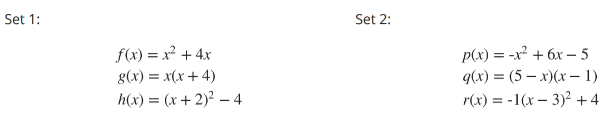
Things students may notice:
- Each set has equations in standard form, factored form, and one other form.
- The equations in standard and factored form are equivalent.

Things students may wonder:
- Why are the equations in each set grouped together?
- Is the last equation written in a particular form?
- What is it called?
- Is the last equation in each set equivalent to the other two?

Have students show that each set of equations are equivalent. Afterwards, each student can check the equivalency by graphing one set using desmos.
Simulation Introduction 10 minutes
Teacher will:
- Hand out the activity sheet.
- Encourage students to complete questions 1-5 of the activity sheet.
- Circulate the room and ask good probing/guiding questions of students.
- Facilitate the class discussion of the simulation.

Students will:
- Explore the “graphing the vertex” simulation by changing the values of a, h & k.
- Observe the transformations caused by changing those values.
- Discuss with their partner or group mates questions 2 through 5.

Guided Exploration 15 - 20 minutes
Teacher will:
- Encourage students to begin working on the table. Do not answer any questions while students experiment with PhET.
- Begin circulating the room. Possible questions to ask are:
  - What do you notice if a is positive?
  - What do you think might happen if a is a fraction?
  - How is vertex form related to standard form?
  - What is common between vertex and standard forms?
  - What part of the equation creates the parabolic shape?
  - Where is the a in standard form?
  - Where is the a in factored form?
  - Why is the sign of the h “negative” but the k is “positive”?
  - How does this form help us know whether the vertex is a maximum or a minimum (day 2 lesson)?
  - How might you convert from vertex to standard form (again and again!)?
  - Challenge: How might you convert from standard form to vertex form?
  - Review: How might you find the vertex from factored form?

Students will:
- Complete the table on the activity sheet.
- Respond to teacher and fellow student questions.
- Ask questions or ask for help, as needed.
- Use newly acquired knowledge to fill in the predict table.
- Use PhET to check predictions
Discussion and Summary 10 minutes
Teacher will:
- Write a table on the board with following columns:

a | h | k

- Call on random students to write their findings in the section on the board.
- Ask students to close chromebooks to limit distraction.
- Facilitate a class discussion to verify student understanding
- Ask students to fill in the summary at the bottom of the activity.

Students will:
- Contribute observations to the board.
- Fill in activity summary.
Practice
Students will complete lesson 15 practice problems.

