PhET Lesson Plan
Exploring Linear Functions

Visit the Function Builder Simulation at the following URL: https://phet.colorado.edu/sims/html/function-builder/latest/function-builder_en.html?screens=2,3

Take 15-20 minutes to explore and play with both screens of the Function Builder Simulation:
NUMBERS and EQUATIONS

Be sure to learn about the following features:

*The OPERATION chevrons located directly below the FUNCTION pipe.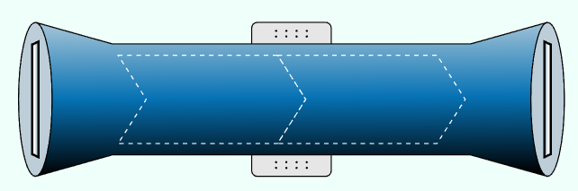
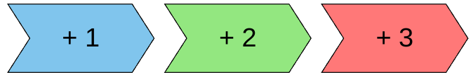

*A column on the left for suggested INPUT values. Can you change these?

*A column on the right for calculated OUTPUT values. Can you change these?

*INPUT and OUTPUT slots at each end of the FUNCTION pipe.

*How to move INPUTS through the FUNCTION pipe to become OUTPUTS.
Try moving an OUTPUT backwards through the FUNCTION pipe. What happens?

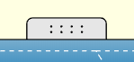

*TABS attached to the FUNCTION pipe: Table, Graph, Equation

*The “EYE” chevron - what does it do and when should it not be selected?

*The “STEP” chevron - what does it do and when should it not be selected?
Name_______________________________ Date ____________________ Class __________

PhET Lesson Plan
Exploring Linear Functions

Use the NUMBERS option from the Function Builder Simulation to create the following:

the function “$+3$” followed by “$x 2$”. the function “$x 2$” followed by “$+ 3$”.

1. Write an algebraic rule for this function. 3. Write an algebraic rule for this function.
(use parentheses as necessary) (use parentheses as necessary)

2. Complete the table of values and graph. 4. Complete the table of values and graph.
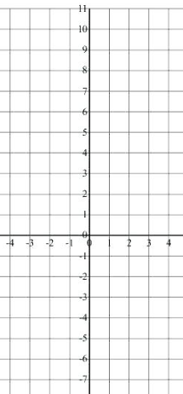
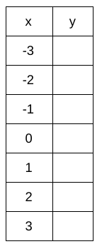

5. Explain why the two linear functions are not the same. Use appropriate linear vocabulary.

Use the EQUATIONS option from the Function Builder Simulation to create a 3-step function for the following point-slope equations:

$y=2(x+1)-3$ $y=2(x-2)+3$

6. Complete the table of values and graph. 7. Complete the table of values and graph.

8. Explain why the two linear functions are the same. Use appropriate linear vocabulary.

BONUS: Can you build a slope-intercept equation that matches the two functions above? Explain and/or show your work in the space below.

