Parabolas on the move! Exit ticket
Parent Function  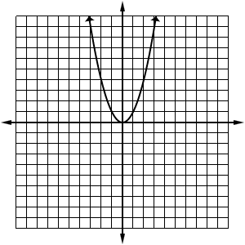 | Based on the parent function…  How would you make the parabola dilate...get narrower (stretch) or get wider (compress)?  How would you make the parabola translate to the left or to the right (and not up and down)?  How would you make the parabola reflect across the x-axis?  How would you make the parabola translate up or down (and not left and right)?

Parabolas on the move! Exit ticket
Parent Function | Based on the parent function…  How would you make the parabola dilate...get narrower (stretch) or get wider (compress)?  How would you make the parabola translate to the left or to the right (and not up and down)?  How would you make the parabola reflect across the x-axis?  How would you make the parabola translate up or down (and not left and right)?

