PhET Investigation of Acids & Bases Name:__________________________________________
pH Scale Simulation
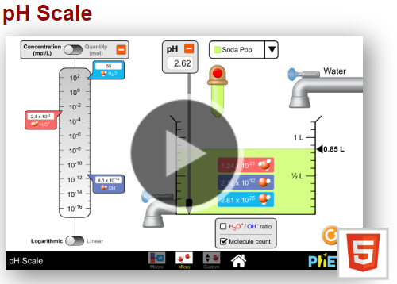
Directions:
- Open the pH Scale Simulation
https://phet.colorado.edu/en/simulation/ph-scale
  - There are 3 Parts to the Simulation
    - Macro
    - Micro
    - My Solution
- Start with the Micro Option
Part I: Pre-Simulation Research Questions
- Research the following definitions of acids and bases.
  - Arrhenius Definition
  - BrØnsted-Lowry Definition
  - Lewis Definition
Part II: Macro
- Create a table in Google Sheets with the following columns.
  - pH, [H₃O⁺], [OH⁻], Product of [H₃O⁺] & [OH⁻]
- Each row of the table will be for the 11 available substances.
- Using the pH Meter, measure and record the pHs of all 11 substances.
Questions
- What is the pH range for an acid?
- What is the pH ranger for a base?
- When is a solution is considered neutral? What pure substance has a pH of 7?
- What happens to the pH of the solution when more of the substance is added?
- What happens to the pH of the solution when water is added to the solution?
- What does pH measure? (Research)
- What basic equation is used to calculate the pH of a solution? (Research)

Part III: Micro
- Switch over to the Micro Option of the simulation.
- Record the concentrations for the H₃O⁺ and OH⁻ ions for each solution in the data table.
  - Use the following format : for 1.0 x10⁻⁷ type in 1.0 E-7
- Calculate the product of the two ions ( [H₃O⁺], x [OH⁻] ) and record in the table.

Questions
- What relationship exists between the concentration of the [H₃O⁺], and [OH⁻]?
- Does adding water to a solution change the product of the two ions?
- If the solution is acidic, which ion is found in greater concentration?

Part IV: My Solution
- Check the ratio box.
- Slide the Red or Blue sliders up and down and observe what happens to the pH as well as the number of particles represented in the solution?

Questions
- What happens to pH when the red slider increases (goes up)?
- What happens to the red particles (acid) when the red slider increases?
- What happens to the blue particles (base) when the red slider increases?

