Title: Seeing in Color!

Important Questions
How do we perceive specific color combinations?
What are the primary colors of light?
How is white light created?

Instructions
In this activity, we will be using the deflection of RGB bulbs to determine what color a person sees when different combinations of light are used. You will be working between this document and the simulation.

Click here and then click the play button to enter the simulation.

This screen will appear:
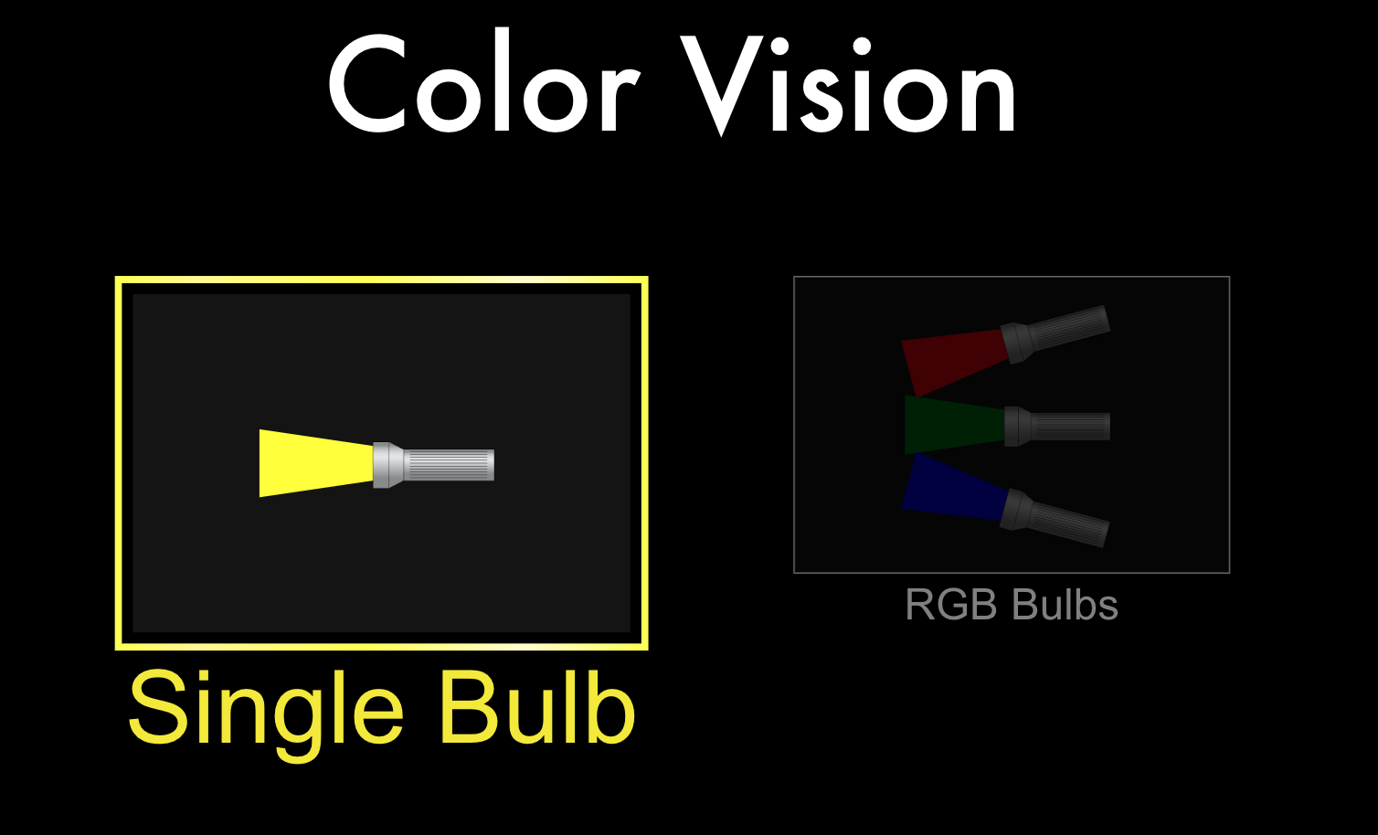

Select RGB bulbs by double clicking.

Exploration Phase
1. Briefly explore this sim.

2. Have different combinations of red, green and blue light entering the person’s eyes.

3. Observe the different colors that are perceived by the human based on the combination of colors (the circles above the human’s head represents what color he is seeing)

4. Then at the bottom of the screen, select the Single Bulb mode and explore that section; using the color filter see what colors can be seen through different filters.

5. Notice the pause, frame by frame, and reset buttons.

Questions

1. How can you make the human eye perceive the color purple?

2. What color does the person see when one color is raised to the maximum level?

3. What color does the person see when all three colors are raised to the maximum level?

4. In Single Bulb mode, when you have a green filter and yellow bulb shining what does the human eye perceive?

Explanation Phase
Aim: Students will investigate how the primary colors interact to create perceived colors in the human eye.

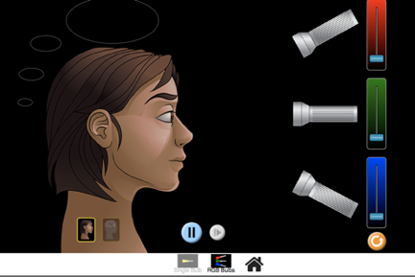

When different amounts of light are applied, a person will see a specific color.

Predict the secondary color a person will see when two primary colors are raised. Make sure that both colors are raised to the maximum level.

Primary Color | Primary Color Added | Predicted Perceived (Secondary) Color
Red | Green
Green | Blue
Blue | Red

Now test your predictions!

Primary Color | Primary Color Added | Perceived (Secondary) Color
Red | Green
Green | Blue
Blue | Red

How were your predictions similar or different to your actual results?

Application Phase
Now go to the Single Bulb phase of the simulation, and select the white bulb and light particles options. Your screen should look like this:

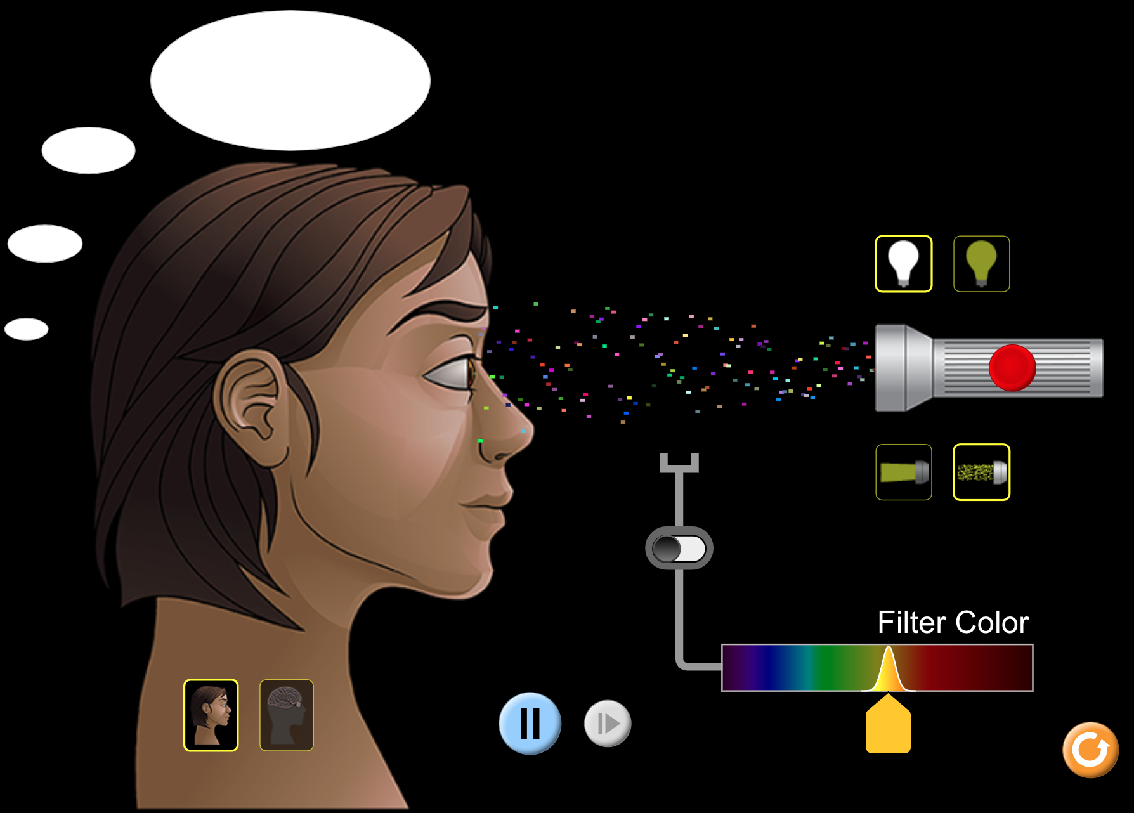
1. What color(s) is actually being emitted from the flashlight?

2. What color is being perceived by the human eye?

Turn on the filter color option by clicking the switch, and a yellow filter should appear in between the flashlight and the human.

3. Now what color is the human eye perceiving from the flashlight?

4. What colors are being absorbed by yellow filter and what colors are passing through?

5. Change the color filter a few times by sliding the arrow along the bottom. Summarize how the filter affect what is seen from the white lightbulb.

To complete this chart you will be using BOTH the white and colored bulbs. Fill in each missing box by using the color filter and color bulb.

Color of Light | Color of Filter | Color Perceived
White | Yellow
Red | Magenta (Purple-ish)
White | Blue
Yellow | Red
 | Green | Green
Yellow |  | Yellow

6) In your own words, create a rule explaining how color is seen through a colored filter?

You have seen the light!! Congratulations!!

