Name __________________________ Period # _______________

Virtual Density Lab

- On Mr. Hewitt’s website click on “Virtual Density.”
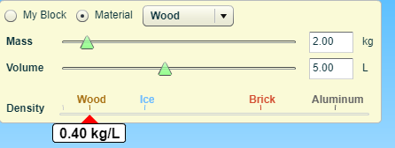
- You will see a block of wood in water.
- Using the table at the top left and clicking on the drop down menu at the top find the following information:
Material | Mass | Volume | Density | Float or Sink?
Styrofoam
Wood
Ice
Brick
Aluminum

- What can you say about the density and the material’s ability to float?
________________________________________________________________
________________________________________________________________
________________________________________________________________
- Use your cursor to remove the block from the water.
- In the table at the top left click on “My Block.”
- Use the sliders to adjust a mass and volume for a block that doesn’t sink or float on top of the water. Test your hypothesis by putting the block into the water.
- What was its mass? _______________
- What was its volume? _______________
10. What is its density? _______________
11. Why did it do this?
_____________________________________________________________
_____________________________________________________________

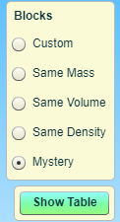
Part 2
- In the box at the top right click on the bubble left of “Same Mass.”
- When you do, do they all have the same volume? __________________
- Explain why or why not.
__________________________________________________
__________________________________________________
__________________________________________________

- In the same box, click on the bubble left of “Same Volume.”
- When you do, do they all have the same mass? ___________

- Explain why or why not.
________________________________________________________________
________________________________________________________________

- IN the box at the top right click on the bubble left of the “Same Density.”
- What can you say about the blocks now?
________________________________________________________________
________________________________________________________________
________________________________________________________________

Part 3.
- In the box on the right click on the “Mystery” bubble. You will see boxes A through E, a scale, and a volume meter. Mass the blocks by putting them on the scale and recording their mass in the data table on the next page. To find their volume you might have to use your cursor to hold them under the water to get the correct volume.
- Use the formula Density = mass/volume to determine the density of each mystery block. By clicking on the “Show Table” tab you can compare and then determine the identity of each block. Put your hypothesis in the data table.

Block | Mass | Volume | Density | Material
A
B
C
D
E

- Which of these blocks floated? ___________________________
- Which of these blocks sank? __________________________
- Why did they do this?
________________________________________________________________
________________________________________________________________

