Name ________________________________ Period # ____________

States Lab

In this activity you will be exploring the various states of matter. Atomic theory states that all matter is made up of tiny particles in random, constant motion. In this activity you will be able to see how.

- Click on the “States Lab” link on Mr. Hewitt’s web page.
- You should be seeing Neon in the solid state with a temperature of 14K. If not press the reset button.
- What do the particles seem to be doing?
_______________________________________________________________
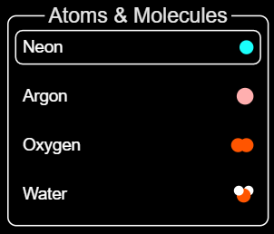
_______________________________________________________________
- Try out the other Atoms & Molecules.
- What can you say about what you observed?
________________________________________________
________________________________________________________________
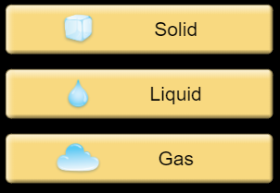
- Explore all the Atoms & Molecules by clicking on the different states tabs at the side and record the temperature and what you observe in the following data table.

- Data and observations:
Atom & Molecules | Temp. in K/Cº | Appearance of the particles | Temp. in K/Cº | Appearance of the particles | Temp. in K/Cº | Appearance of the particles
Neon
Argon
Oxygen
Water
Solids Liquids Gases

- What do you notice about the solid state of water compared to the other solid states?
________________________________________________________________________________________________________________________________
- Pick any one substance from the Atom & Molecule list. Pick any one state of matter. List your choices here:
Atom & Molecule ___________________________________
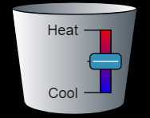
State of Matter ___________________________________
- Using the Heat/Cool tool at the bottom move the slider up and down to add/remove heat. Describe what you noticed.
ACTION | RESULT
Add Heat

Take Away Heat

11. Summarize what you have learned:
___________________________________________________________
___________________________________________________________

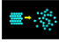
Part 2 Phase Change
- Click on the “Phase Changes” at the bottom of the screen.
- On the screen you see Neon particles in which state of matter? _________________________________
- From the screen what two factors does it appear that we will be able to change?
_________________________ & ___________________________
- Record the Temperature in K and Cº ______________________
- Record the Pressure in atms. ______________________
- Using the “Heat/Cool” tool add and remove heat and record what you observe in the data table below:
Type of Change | Temperature in K and Cº | Pressure in atm. | What you notice about the particles
Add heat
Remove heat

- Put your cursor on the “finger” and push down about half way.
- Describe what, if any, changes you noticed.
____________________________________________________________
____________________________________________________________
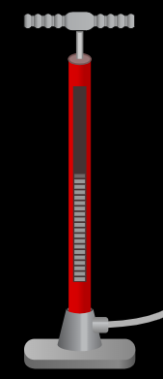
____________________________________________________________
- Put more Neon into the chamber by using your cursor to pump the handle up and down on the pump.
10. Describe what, if any, changes you noticed.
______________________________________________________________
______________________________________________________________
______________________________________________________________
11. Using the “finger” tool push down as far as you can.
12. Describe what happened and explain why.

_______________________________________________________________
_______________________________________________________________
_______________________________________________________________

13. What relationship did you discover using this simulation?

_______________________________________________________________
_______________________________________________________________
_______________________________________________________________

