Name ______________________ Period # _______

Color My World Virtual Lab
Both light and pigments give us the rainbow of colors we see. Pigments are the chemicals which reflect the light that bounces on them and gives us colors we see. But what about the color of light itself? How does the color of the light affect what we see?

Please follow the steps below to avoid confusion.
- Go to Mr. Hewitt’s website and click on the “Color My World” link at the bottom of the page.

- Click on the single bulb flashlight on the first screen.
You should see this:
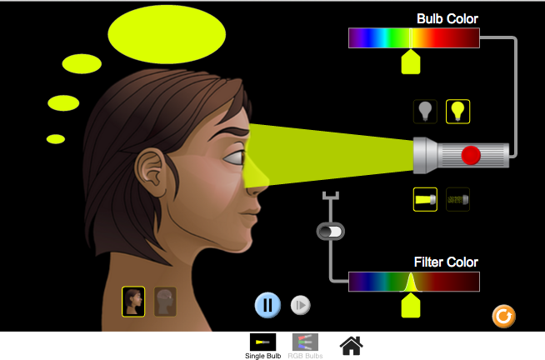

- The flashlight should not be on. What is the subject seeing? (what they see is in the bubbles around their head) ________________________________________
- Click on the red dot on the flashlight.

- What is the color of the light that is directed at the subject’s eyes?
___________________________________________
- What color do they perceive? (in the bubbles around their head)
____________________________________________
- Drag the slider below the bulb color to the left or right. What do you notice about what is perceived?
______________________________________________________________________________________________________
______________________________________________________________________________________________________
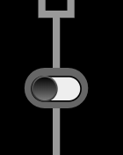
- Click on the grey button and move it to the right to add filters.

- Click and drag the slider below the filter color spectrum. What do you notice about the light that is perceived?
_____________________________________________________________________________________________________
_____________________________________________________________________________________________________

- What does the filter do?
___________________________________________________________________________________________________
___________________________________________________________________________________________________

- Click on the white light bulb (the one on the left) and move the slider for the filter color. What do you notice?
_________________________________________________________________________________________________
_________________________________________________________________________________________________
- Why do you suppose this happens?
___________________________________________________________________________________________________
___________________________________________________________________________________________________
- Click on the light beam on the right, move the filter slider, and make some observations about what you notice about the light, the filter, and what is perceived.

____________________________________________________________________________________________________
___________________________________________________________________________________________________
___________________________________________________________________________________________________
___________________________________________________________________________________________________

- What did the filter do to the light?
__________________________________________________________________________________________________
__________________________________________________________________________________________________

Part 2
- Click on the reset button: Then click on the RGB bulbs button:

- No lights are on. What color is perceived? _________________________________________

- Click on the Pause/Play button:

- Click on the sliders and add light by sliding up all the way. Fill out the data table below with your observations:
Light Color | Perceived Color
Just red
Just green
Just blue
Red and green
Red and blue
Green and blue
Red, green, and blue

- If you don’t move the sliders all the way up, how does it change what you perceive?
________________________________________________________________________________________________________
________________________________________________________________________________________________________
________________________________________________________________________________________________________
- Summarize what you have learned from this investigation.
_______________________________________________________________________________________________________
_______________________________________________________________________________________________________
____________________________________________________________________________________
____________________________________________________________________________________

