Activity: Measuring Current and Voltage
Part 1: Prediction Questions - comparing circuits
Consider the pictures of each of these circuits, then answer the questions below. Answer the prediction questions before you build these circuits:
Series Circuit Parallel Circuit Complex Circuit
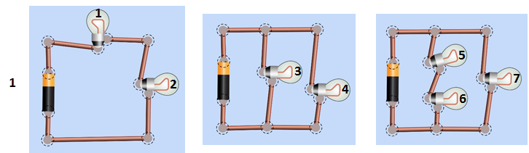
- From the circuits above, predict which bulb (or bulbs) will be the brightest. Why do you think that?

- Current is the flow of charge (measured in coulombs/sec = amps) in a circuit. Describe how you think current will flow in the different types of circuits above.

Part 2: Explore the simulation
- Visit the PhET circuit construction kit simulation: ______________________ and choose Intro

- Explore the simulation
- Build a circuit: figure out how to make a light bulb light up, then make any circuit you want.
- Figure out how to measure current and voltage.

Questions:

- Imagine you’re an engineer making a string of battery powered holiday lights. If a bulb burns out current cannot flow through that bulb any longer (like if the wire at the bulb has been cut). Figure out how to hook up 2 light bulbs and a battery so that when one bulb burns out (or is disconnected) the other stays lit.

- You instead want to make sure the battery for your string of lights will last as long as possible. A battery will last longer if it powers a circuit with low current. How could you hook up a battery and 2 light bulbs so the least amount of current flows through the battery? Use the measurement tools in the simulation to check your design.

Part 3: Measuring Current and Voltage
Instructions: Your goal in this part is to come up with rule to describes how patterns of current and voltage in a circuit relate to the structure of the circuit (how the battery and light bulbs are connected).
To do this, you will need to measure current and voltage in multiple places on several different circuits.
Examples:
Measuring Current | Measuring Voltage
“Current” is the flow of charge, measured in Amps (Coulombs/s). An ammeter measures the current past a single point in the circuit.  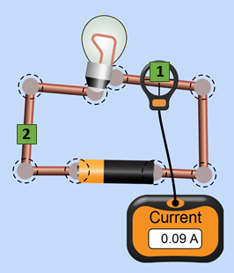  The current flowing through point 1 can be written as:  I₁ = 0.09 A. | “Voltage” is a measure of the difference in electric potential between two points. The voltmeter measures this difference by placing the two leads (pronounced “leeds”) at two different points.  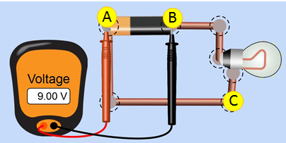  The voltage between points A and B can be written as V_{AB} = 9 V.

Use the table below to record your measurements and patterns you notice. You decide where will be the most useful places to take measurements, and how many to take. Use the diagram to label the places you pick.
Circuit  Label the places where you decide to measure current and voltage. Try several places. | Current Measurements (Amps) | Voltage Measurements (Volts)  . | What patterns do you notice?  - Where is the current the same? Where is it different?  - Where does the voltage change? Where doesn’t it change?  - How do the different circuits compare?
- Simple Circuit  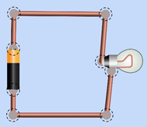  Label on the picture the places where you measure (See examples above ). | Example:  I₁ = ______ A  ____________________________________________________________________________________ | Example:  V_{AB} = ______ V.  ____________________________________________________________________________________
2) Series Circuit  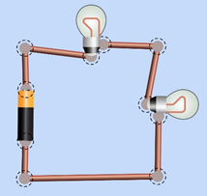 | ____________________________________________________________________________________ | ____________________________________________________________________________________
3) Parallel Circuit  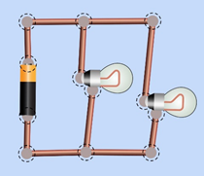 | ____________________________________________________________________________________ | ____________________________________________________________________________________
4) Complex circuit  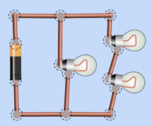 | ________________________________________________________________________________________________ | ________________________________________________________________________________________________

Summary (your rule):
- Compare the patterns you see in a series circuit to the ones you see in parallel and complex circuits. Try to establish the rules about voltage and current for each type of circuit.
For example, “In a series circuit, I see that the current ….., whereas in a parallel circuit I see… ”.

Analysis Questions
- From your rules above, sort (or list) the light bulbs in these circuits from brightest to dimmest (i.e greatest current to least current). Some bulbs might be the same brightness.
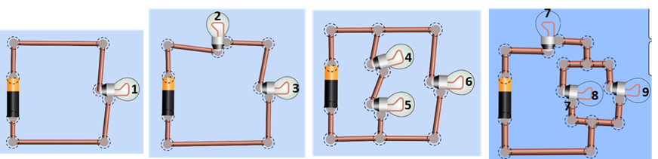
- (sort the bulbs by brightness)

- After you make your rankings, build some circuits to check your answers and list the correct ranking below.

- Did your rules allow you to correctly rank the bulb brightness?

- If yes, explain the ranking using your rules.
If no, describe changes you can make to improve your rules.

- You have two batteries and a lightbulb, and you want to make a flashlight. Draw how you would hook them up to make the brightest flashlight, and explain why.

