ACTIVITY NO. 2: Reflection and Refraction of light

- Objective: To verify laws of reflection and refraction of light.

- Materials:
PhET Simulation on Resonance
Laptop
Activity sheet
Pen

- Procedure:
  - Open the PhET Simulation on “Bending Light” distributed last week.
  - Click the tab “More Tools”. Explore the sim and play around with its functionalities.

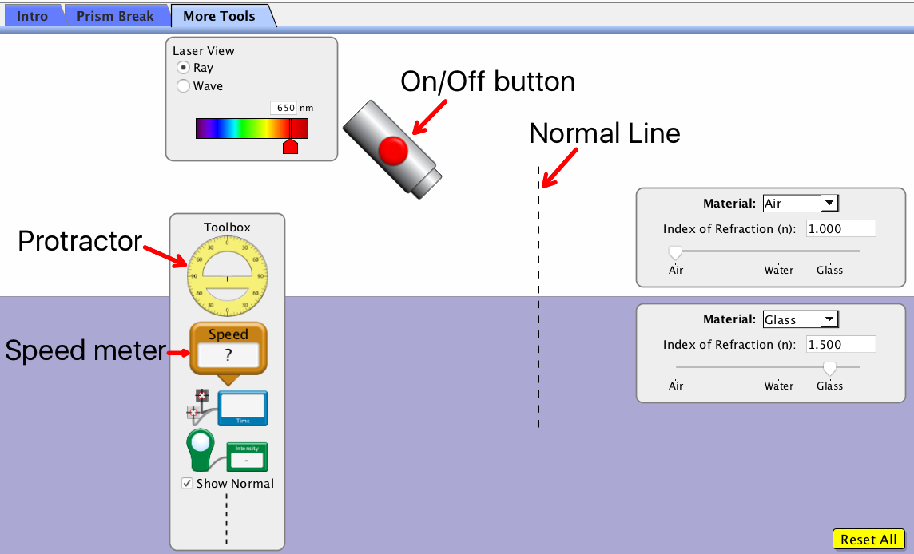

  - Activity proper:

PART I. Definitions
    - Turn on the light source. Refer to Figure 1 below and identify the rays based on the definitions below:
- Incident ray – is the light ray coming directly from the source.
- Reflected ray – is the light ray that bounces back to the 1st material once it hits the boundary of the 2nd material.
- Refracted ray – is the light ray that passes through and bends towards the Normal line as it hits the 2nd material.

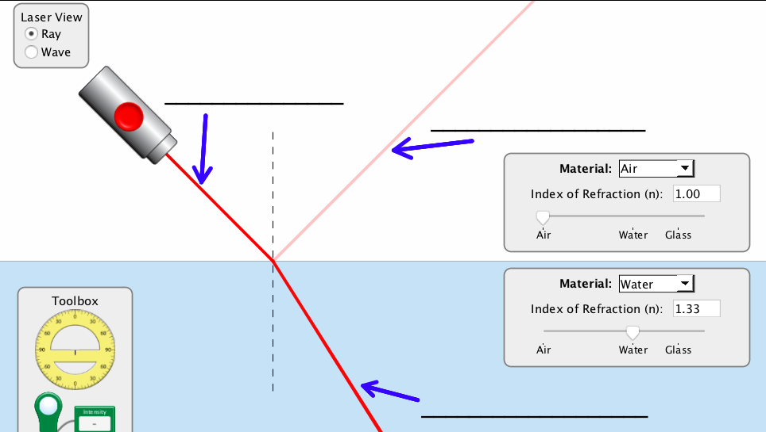

Figure 1. Light rays

PART II. Law of Reflection

- Place the center of the protractor at the intersection of the Normal line and boundary of the two materials.
- Set material #1 as air and material #2 as water. Record the index of refraction of the two (2) materials below.

Table 1. Index of Refraction of different materials
Material | Name | Index of refraction (n)
1
2

- Turn on the light source and move it so that the incident ray will have a reading of 30⁰ from the Normal line.
- Identify the angle of reflected ray from the Normal line and record it in Table #2.
- Now, move the light source to change the angle of incidence of your own choice. Record the angle of incident ray and reflected ray in Table #2 along reading #2.

Table 2. Angle of reflected ray
Readings | Angle of incident ray | Angle of reflected ray
1 | 30⁰
2

- Guide Question: From Table #2, what do you notice about the angle of incident ray and angle of reflected ray from the two (2) readings?________________________________________________________.
- Guided conclusion: The Law of Reflection states that the angle of incident ray is ____________ to the angle of the __________________.

PART III. Law of Refraction (Snell’s Law)
- Place the center of the protractor at the intersection of the Normal line and boundary of the two materials.
- Set material #1 as air and material #2 as water. Record the index of refraction of the two (2) materials below.

Table 3. Index of refraction of different materials
Material | Name | Index of refraction (n)
1 |  | n_{A} =________________
2 |  | n_{B} =________________

- Turn on the light source and move it so that the incident ray will have a reading of 30⁰ from the Normal line.
- Identify the angle of refracted ray from the Normal line and record it in Table #4.
- Now, move the light source to change the angle of incidence of your own choice. Record the angle of incident ray and refracted ray in Table #4 along reading #2.

Table 4. Angle of refracted ray
Readings | Angle of incident ray | Angle of refracted ray
1 | θ_{A} = 30⁰ | θ_{B} =
2 | θ_{B} = | θ_{B} =

- From your results in Table 3, compute the inverse ratio of the indexes of refraction and record it on Table #5 below.
- From your results in Table #4, compute the ratio of the sines of the angles θ_{A} and θ_{B} and record it on Table #5 below.

Table 5. Ratio of indexes of refraction and sines of the angles θ_{A} and θ_{B}.
Readings | $$\frac{n_{B}}{n_{A}}$$ | $$\frac{sinθ_{A}}{sinθ_{B}}$$
1
2
- Guide Question: From your results in Table 5, what do you notice about inverse ratio of the indexes of refraction and ratio of the sines of the angles θ_{A} and θ_{B}? _______________________________.
- Guided Conclusion: Snell’s Law states that inverse ratio of the indexes of refraction is ________________ to the ratio of the sines of the angles θ_{A} and θ_{B}.

