Dafna Acosta

Electric Field Hockey
All around us are negative and positive charges. Everything is made of protons and electrons, which hold such charges. When we rub a balloon on our heads, hair will stand up as if a force is making it do that. How?

Objective:
Students will be able to understand the basic properties of electric charge.
Explore
Copy and paste this link
https://phet.colorado.edu/en/simulation/electric-hockey
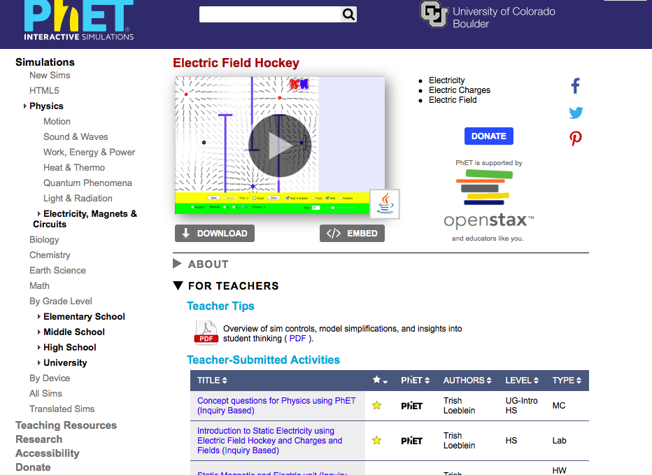
to arrive to a page that looks like this:

2. Click on download to open the simulation. (Ask instructor for assistance if an issue appears)
3. Once opened you should make sure everything appears as the following image:
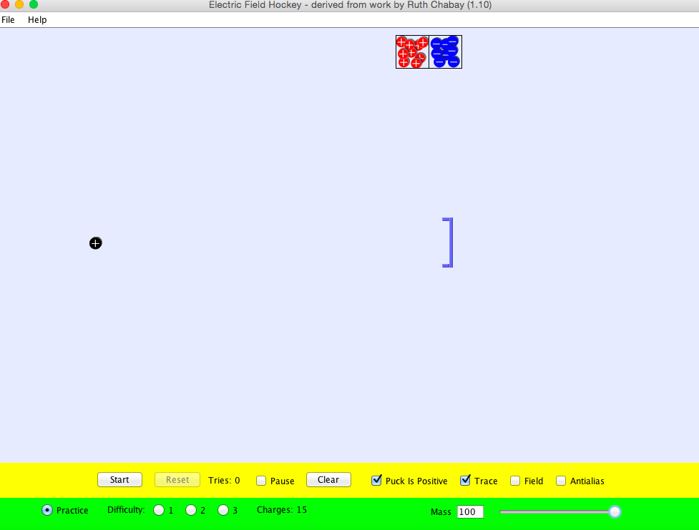

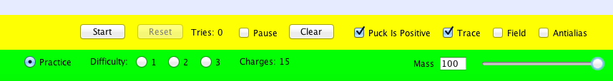
Make sure that “Practice” is picked and the mass scale is all the way to 100.

A positively charged black puck is at the left side of the page waiting to be forced into the goal.
- At the top of the page, there are red balls with a positive sign on each. Those are positively charged.
- Drag a red ball and put it any where you want on the field.
- Once placed, click on

What did you notice when doing step 3?
___________________________________________________________________________________________________________________________________________________________________________
_________________________________________________________

6. Press

7. Next to the red balls are blue balls. They have a negative sign on each blue ball. They are negatively charged.
8. Take a blue ball and place it anywhere on the field.
9. Once placed, click on

What did you notice when doing step 9?
_______________________________________________________________________________________________________________________________________________________________________________________________________________

Finish the sentence:

When a positive charge interacts with a positive charge, it __________.
When a positive charge interacts with a negative charge, it ___________.
1. Press

Now we are going to work with a negatively charged hockey puck. Uncheck “puck is positive”

Based on your observations of part 1:
- What do you think will happen when you put a negative charge next to the negative charged puck?
________________________________________________________________________________________________________________________________________________________________________________________________________________________
- What about a positive charge next to the negative puck?
________________________________________________________________________________________________________________________________________________________________________________________________________________________

Check and see!

EXPLAIN
Fill in the chart: use words “ Attract” and “Repel”.

Charge of puck | Positive | Negative
Positive
Negative

Mission: Level 1:
1. Press

2. Go to difficulty and click on level 1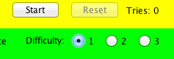

Use negative and positive charged balls to guide the positively charges hockey puck in to the goal.

How can you get the hockey puck into the goal using two different charged balls without any collisions?

Draw your plan!
Why do you think this plan will work? Explain.
___________________________________________________________________________________________________________________________________________________________________________
_________________________________________________________
TRY IT OUT!

Did it work? If not, what happened?
___________________________________________________________________________________________________________________________________________________________________________
_________________________________________________________

Apply:
Mission Level 2
- Press

2. Make sure your puck is positive

- Go to difficulty and click on Difficulty- level 2, your screen should look like this:
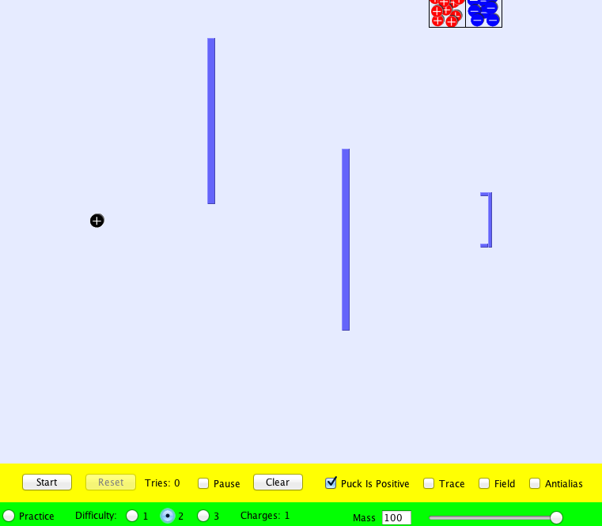

Use negative and positive charged balls to guide the hockey puck in to the goal.
How can you get the hockey puck into the goal using positive and negative charged balls without any collisions?
Draw your plan!
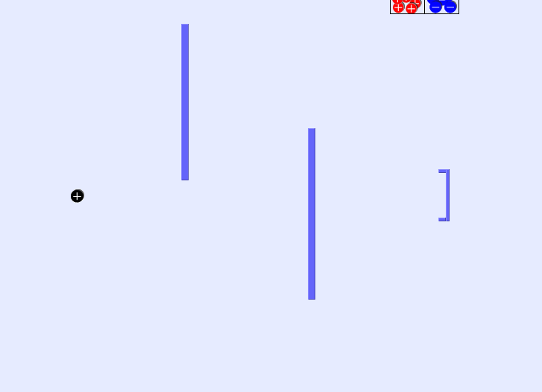
Why do you think this plan will work? Explain.
___________________________________________________________________________________________________________________________________________________________________________
_________________________________________________________
TRY IT OUT!

Did it work? If not, what happened?
___________________________________________________________________________________________________________________________________________________________________________
_________________________________________________________

Now, you can do the same with a negative charged black puck!

Draw how you made the negative charged black puck into the goal!

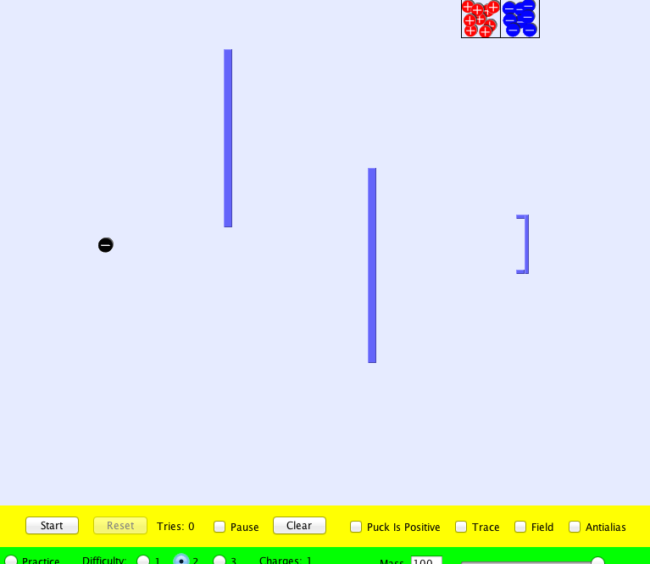
When charges are the same sign, they __________ while opposite charges ______________.

Challenge:
Using what you know, try making a goal on difficulty level 3.

