Title: Area and Perimeter Garden
Aim: Students will explore and play with area and perimeter. They will use the simulation to create gardens to find the area and perimeter.
Definitions:
Area is defined as the amount of space an object or shape takes up.
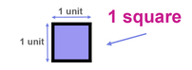
Perimeter is defined as the distance around an object or shape.
Unit square is a square with a length of one on each side.
Width is the short side of a shape and Length is the longest side of shape
Important Questions:
How can you find the perimeter of a shape? (In your own words.)
How can you find the area of a shape? (In your own words.)
What shapes do you notice when using area and perimeter?
Instructions:
In this activity, the above questions are investigated. Complete this document by filling in the data tables and answering questions completely. This investigation has three phases.
1. Click this link: https://phet.colorado.edu/sims/html/area-builder/latest/area-builder_en.html
This is a screen shot of the website:

2. Enter “Area Builder” (simulation) in the search bar.
3. Find “Area Builder” and click the large start button.
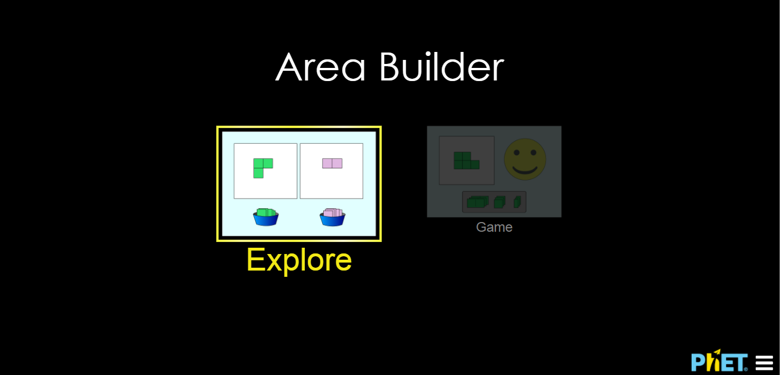
4. This screen should appear.

Exploration Phase:
1. Click the “Explore” picture on the simulation.
2. Create different shapes by placing the square units onto the grid.
3. Use the “values” box on top of the grid while making your shapes. Take the “values” box away when making shapes. Notice the area and perimeter on top of the screen.
4. Switch the grid into two by pressing the toggle on the left-hand side.

Questions:
1. Create a garden space on the grid. Sally planted 5 rows of tomatoes and there were 6 seeds in each row. Find the perimeter of the garden. *Remember to count up all the sides.
2. Fill in the grid. Create a garden space for peppers. John planted 2 rows of peppers and there were 4 seeds in each row. Find the area. * Remember to count all the squares inside the garden.
3. Create a garden on the grid. Katie was making a flower garden. She planted 3 rows of flowers and there were 3 flowers in each row. What is the area and perimeter of her garden?
4. How would you find the area and perimeter of a garden that had 4 rows of corn with 1 seed in each row? Draw a picture to show what the garden would look like.

Explanation Phase:
Aim: I can find the area and perimeter of a given shape.
Make sure you are on the big grid and everything is reset.
Remove the “values” box
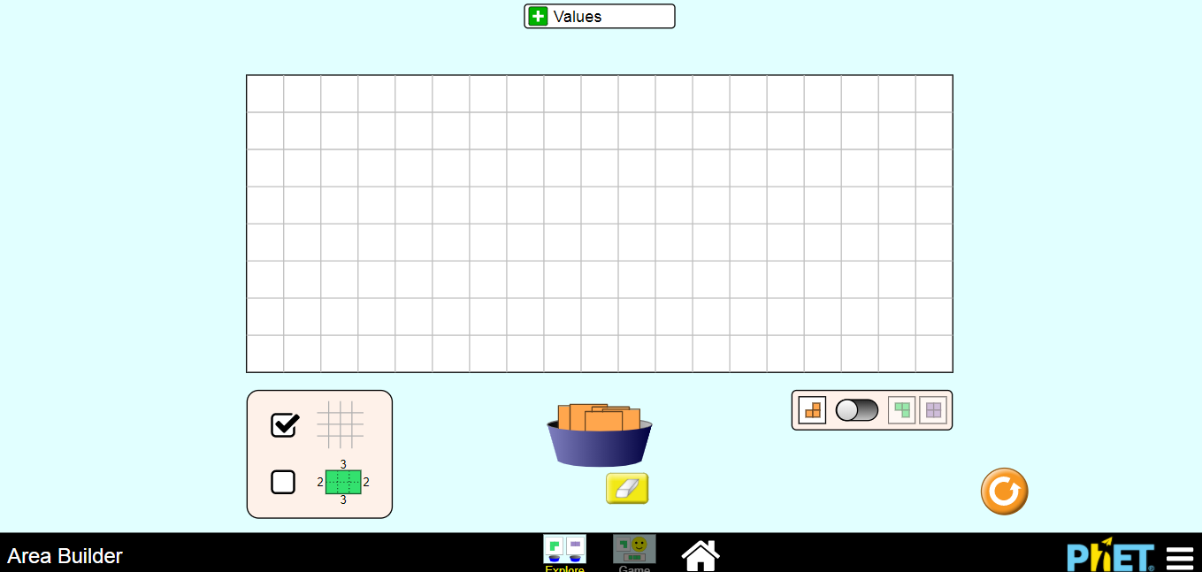
Using the simulation, create the shapes to find the area and perimeter. Fill in the missing parts.
Shape | Width  (short side) | Length  (longer side) | Area | Perimeter
1. | 3 sq. units | 2 sq. units |  | 10
2. | 2 sq. units |  | 14
3. |  | 8 sq. units | 40
4. | 10 sq. units | 1 sq. units
5. |  |  | 9 | 12

1. Write a rule to help you find the length if given the width and area. ______________________________________________________________________________
2. In your own words, write a rule to help you find the perimeter if the length and width are provided. ______________________________________________________________________________

Application Phase:
Click the “Game” tab and play “Game 1 only. Make sure you check off the box under the grid with the numbers around it. Please fill in the length, width, and area while you are playing on your table. Use your formula from above to help you find the area of the shape. Good Luck!

 | Width | Length | Area
Game 1

Conclusions:
Look at your data from game one. Do you notice any patterns?
Create a shape on the simulation. Have a partner find the perimeter and area of the shape you created.

