Exploring Pressure
Objectives
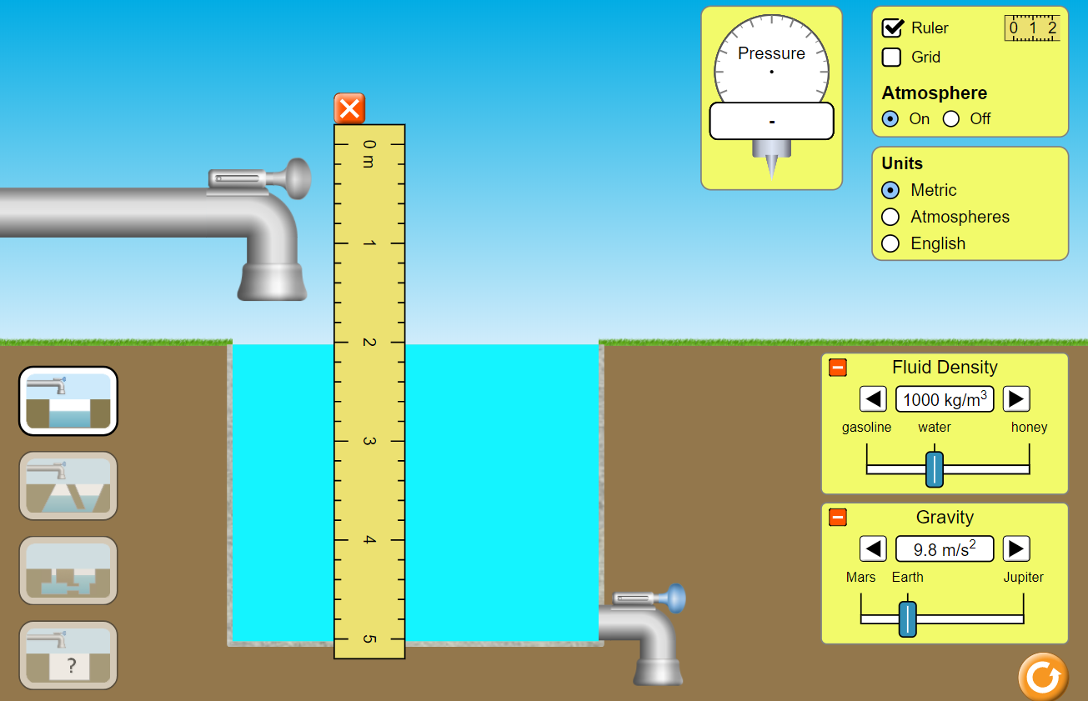
- Determine the relationship between pressure and depth.
- Determine the relationship between pressure and density.
- Determine the density of an unknown fluid.

Directions
- Go to the PhET simulation “Under Pressure” https://phet.colorado.edu/en/simulation/under-pressure
- Push the big Play arrow. Start with the default settings. In addition, fill the tank with water and select “Ruler”, like the diagram to the right.
- Click on the pressure gauge to move it toward the water. Measure the pressure in the water at every 0.50 m from the surface to the bottom. Record your results on the table below. Note that the simulation will give you kPa. Convert to Pa before entering the values on the table.
Depth (m) | Pressure (Pa = N/m²)

- Use Excel, or similar, to make a graph of pressure vs depth. Do a linear best fit and include the equation on the graph. Copy and paste your graph and equation below.

  - What is the physical meaning of the slope?

  - What is the physical meaning of the y-intercept?

- Now, pick a depth and vary the fluid density from 700 to 1,400 kg/m³. Record your results on the table below. Note that the simulation will give you kPa. Convert to Pa before entering the values on the table.
My chosen depth was: .
Density (kg/m³) | Pressure (Pa = N/m²)

- Use Excel, or similar, to make a graph of pressure vs density. Do a linear best fit and include the equation on the graph. Copy and paste your graph and equation below

  - What is the physical meaning of the slope?

  - What is the physical meaning of the y-intercept?

- How would your two graphs differ if you gathered data from Mars? Jupiter? Explain why. Try to come up with the answer before testing it.

- Click on the icon with the question mark on the sink to access the mystery fluid portion. Determine the density of a mystery fluid. If your last name starts with A-H, test Fluid A. If your last name starts with I-N, test Fluid B. If your last name starts with O-Z, test Fluid C. Describe your method and results below.

- Based on what you learned in this activity, what is the formula for determining the pressure in a fluid? State what each of the symbols mean.

