Name __________________________ Mod ___________ Date_____________

Rutherford’s Gold Foil Experiment
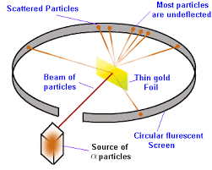

Go to phet.colorado.edu. Once there, go to the Play with Simulations tab and click on the HTML5 tab. Scroll down and find Rutherford Scattering. When the new window pops up, click on the play button to open the simulation.

Once the simulation opens, click on the the Rutherford Atom.

Rutherford Atom

Once open, set the number of protons to 20 and click on the blue button above the Alpha Particles to start firing Alpha particles towards the gold foil.

- Click on the Traces button. What do you notice about the paths of most of the alpha particles?

- Increase the number of protons to 60. Does it change how the alpha particles move? If so, how?

- Now, increase the number of protons to 100. How does this increase change how the alpha particles move through the gold foil as compared to when you started? Why do you think this change occurred?

- Repeat the above steps, but vary how many neutrons are present with the protons. Does this change how the Alpha particles travel? Why or why not?

- Click on the red/gray sphere and reset the number of protons to 20. Watch and describe how the alpha particles move in relationship to the nucleus. Make a sketch of the motion.

- Click on the red/gray sphere and reset the number of protons to 20. Watch and describe how the alpha particles move in relationship to the nucleus. Make a sketch of the motion.

- Now increase the number of protons to 100. Watch and describe how the alpha particles move in relationship to the nucleus. Make a sketch of the motion.

- How are the situations in #6 and #7 different? Why do you think this is?

Plum-Pudding Atom 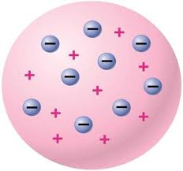

- Switch the simulation to the Plum-Pudding Atom. Once the simulation opens, click on the trace button. Click on the blue button on the Alpha Particle gun to turn on the Alpha particles. What type of path do the Alpha particles take?

- How is this different than the Rutherford simulation?

Conclusion

- Why do you think that our model of the atom changed after Rutherford’s experiment?

- Why were the Alpha particles deflected by the nucleus and not attracted to it?

