Introduction to the Gas Laws
Name: _____________________________ Period ___________ Date :_________________
You have read the introduction to the gas laws in section 13-1 of your text. In this computer lab you will observe the behavior of gases when different variables are changed. The variables that we will be changing and measuring are pressure, temperature, and volume.

Getting to know the system:
- Search for the “PhET chemistry sims.”
- Open the “Gas Properties” simulation and select “Run Now!”
This will give you a screen that looks like this:
Variable Opening (lid)

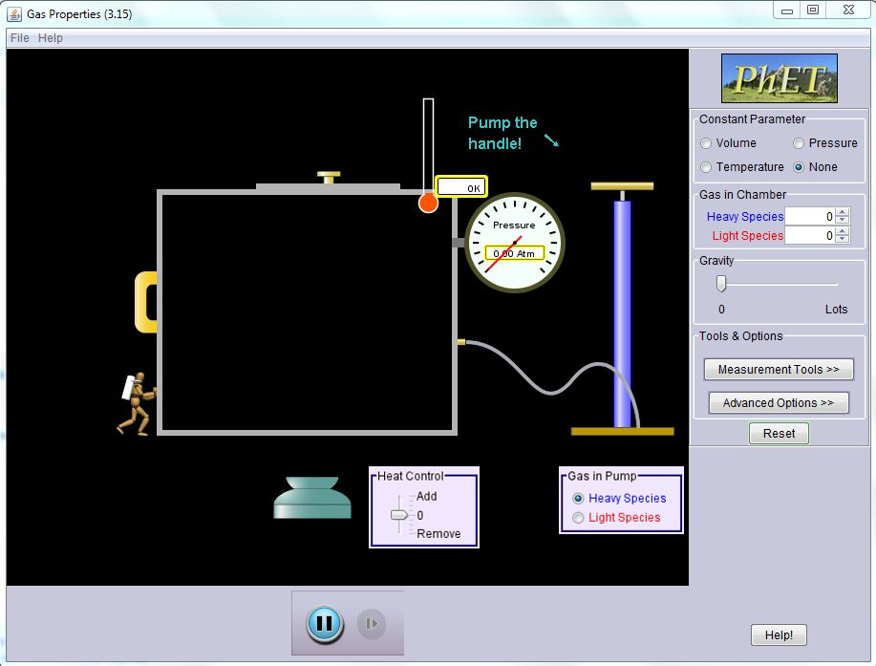
RESET
To Add Gas Molecules
Heavy or light
To add or remove energy
Gravity Control
To choose a constant variable

- Spend a few minutes just messing with the controls to see what happens.
- Notice the effect of changing the constant variable from “None” to something else like volume, pressure, or temperature.

Activity #1
- Reset the system and make sure the constant parameter button is set to “None.”
- Use the molecule counters in the “Gas in Chamber” box, to add 50 heavy species molecules and 50 light species molecules. How do the velocities of the two molecules compare?

- Use the heat control to add energy. Notice that the thermometer shows an increasing temperature. What happens to the velocities of the molecules?

- Use the heat control again, to remove energy. What happens to the velocities of the molecules?

Activity #2
- Reset the system again.
- Add 200 light molecules.
- Set the Constant Parameter button to “Volume.”
- Record the temperature and pressure of the system.
Temperature: ___________ K Pressure: _______________ Atm
- Add heat to the system using the heat control.
- What happens to the temperature and pressure?

- Record the temperature and pressure of the system again.

Temperature: ___________ K Pressure: _______________ Atm

- What is the mathematical relationship between temperature and pressure, direct or inverse?

- Write the mathematical equation for this relationship and the name of the scientist credited with its discovery.

Activity #3
- Reset the system again.
- Add 200 light molecules. Notice the way the little man moves to maintain the same pressure.
- Set the Constant Parameter button to “Pressure.”
- Record the temperature and pressure of the system.
Temperature: ___________ K Pressure: _______________ Atm
- Add heat to the system using the heat control.
- What happens to the volume of the chamber?

- What happens to the temperature and pressure?

- Record the temperature and pressure of the system again.

Temperature: ___________ K Pressure: _______________ Atm

- What is this mathematical relationship between the temperature and the volume, direct or inverse?

- Write the mathematical equation for this relationship and the name of the scientist credited with its discovery.

Activity #4
- Reset the system again.
- Add 200 light molecules.
- Set the Constant Parameter button to “Temperature.”
- Record the temperature and pressure of the system.
Temperature: ___________ K Pressure: _______________ Atm
- While you are watching the heat control, move the little man so that the volume of the chamber is smaller.
- What does the heat control do when you move the little man?

- What happens to the temperature and pressure?

- Record the temperature and pressure of the system again.

Temperature: ___________ K Pressure: _______________ Atm

- What is this mathematical relationship between the pressure and the volume, direct or inverse?

- Write the mathematical equation for this relationship and the name of the scientist credited with its discovery.

Activity #5
- Reset the system using the “Reset” button. Set the constant parameter to “None.”
- Using the molecule counters again, add 100 heavy molecules to the chamber and watch the gas molecule move.
  - Describe their motion.

  - Do all the molecule move at the same velocity?

  - Record the temperature ________________ K.

- Slide the lid to make a small opening and notice the rate of effusion. Try to count the number of heavy molecules that leave the chamber in 30 seconds.

  - Record your answer here: ____________ heavy molecules /30 seconds.

- Reset the activity and add 100 light molecules.
  - How do the velocities of the light molecules compare to the velocities of the heavy molecules that you had in the chamber?

  - Record the temperature of chamber: _______________ K.

  - What is the relationship between the velocities of the small molecules vs. the velocities of the large molecules at the same temperature?

- Slide the lid to make a small opening again and notice the rate of effusion. Try to count the number of light molecules that leave the chamber in 30 seconds.

  - Record your answer here: ____________ light molecules /30 seconds.
  - You should recall that the rate of effusion is inversely related to the molar mass. Are your effusion rates reasonable? Discuss why or why not.
Activity #6
- Redo Activities 2 - 4 again.
- Collect five data points on the parameters that vary.
- Make a data table of the variable parameters for each parameter that is held constant.
- Use this data to make a graph of each relationship. The graph needs to include axis labels and units.
- Describe the relationship.

Data Table:
Name | Gay-Lussac’s Law |  | Charles’s Law |  | Boyle’s Law
Constant | #2 Constant Volume |  | #3 Constant Pressure |  | #4 Constant Temperature
Variables | Temperature | Pressure | Temperature | Volume | Pressure | Volume
Data 1
Data 2
Data 3
Data 4
Data 5

Graphs of relationships

Describe the relationships:

