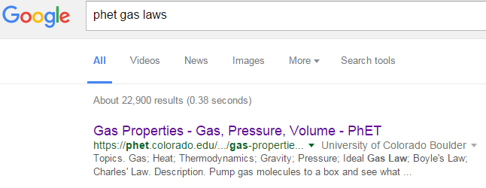
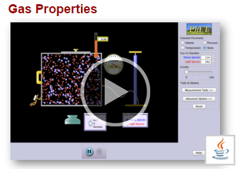
Gas Properties – There outta be a law!
NO Chromebooks!
Sim uses JAVA…
0. CLICK JAVA CUP
3. Pump Handle Once
1. CLICK “Temperature”
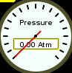
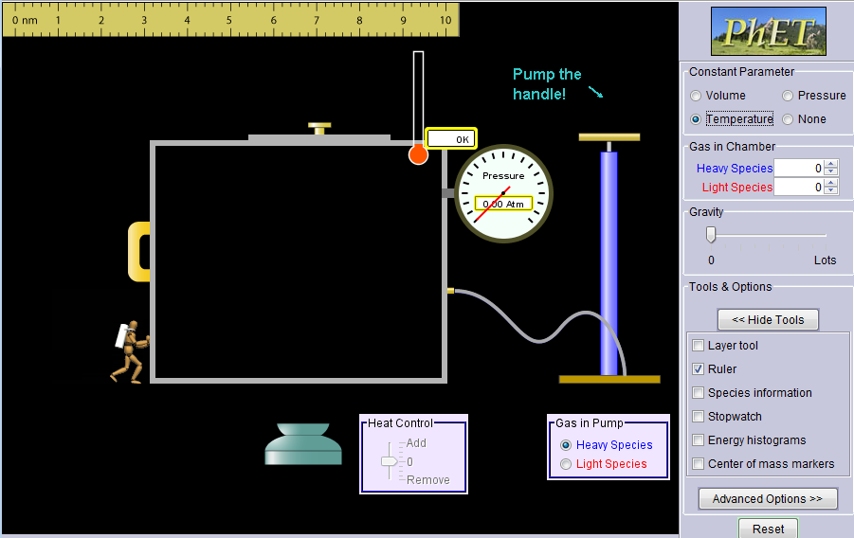
4. Move
2. CLICK “Ruler”

Part 1:
- The diver is around the 3 on the ruler. Move the diver to 1, 2, 3, 4, 5, 6, 7 and 8. Record the pressures in the table, below:

Ruler setting (independent variable, YOU control it!) | Pressure (atm) (dependent variable)
1
2
3
4
5
6
7

- What do you notice about the pressures in the table as you go down the column?

- If you could pull the diver out to 0, what do you think the pressure would do??

- If you could squeeze the diver into the 10 what would the pressure do???

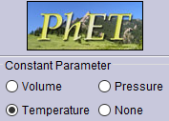
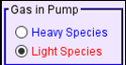
Part 2: A. Click . B. Select C. Pump handle once.
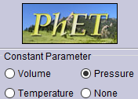
D. Wait 10 seconds then change constant parameter to pressure:
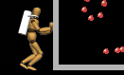
- What does the diver do to keep the pressure constant?

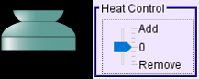
- Use the temp. control to change the temperature. Fill in the following table:

Temperature (K) (independent variable, YOU control it!) | Ruler setting (nm) (dependent variable)
100
150
200
300
400
500
600

Part 3: A. Click . B Select

C. Pump handle once:

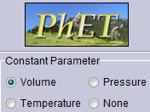
D. Wait 10 seconds then change constant parameter to volume:

- Use the temp. control to change the temperature. Fill in the following table:

Temperature (K) (independent variable, YOU control it!) | Pressure (atm) (dependent variable)
100
200
300
400
500
600
700
800

- What happens to the pressure as you change the temperature? (Sentence(s)!)

- Play with the sim. Make the lid pop off. How did you do it?

- Make the lid pop off again in a different way. How did you do it?

