Physics – Thermodynamics Inquiry Names:_____________________________
_____________________________
Hour:__________
Go to https://goo.gl/7gxzM7
Click the play button on the picture. Ask for help if the lab simulator does not open.
Part 1.
- Check the “Energy Symbols” box.
- Press the pause button at the bottom of the simulator.
- Click and drag the iron and the brick onto the racks.
- Click on one bucket. Use the up arrow on your keyboard to dial the bucket to full heat. Repeat for the other bucket.
- Move the three thermometers, one on each block, and one in the air.
- Your setup should look like this:
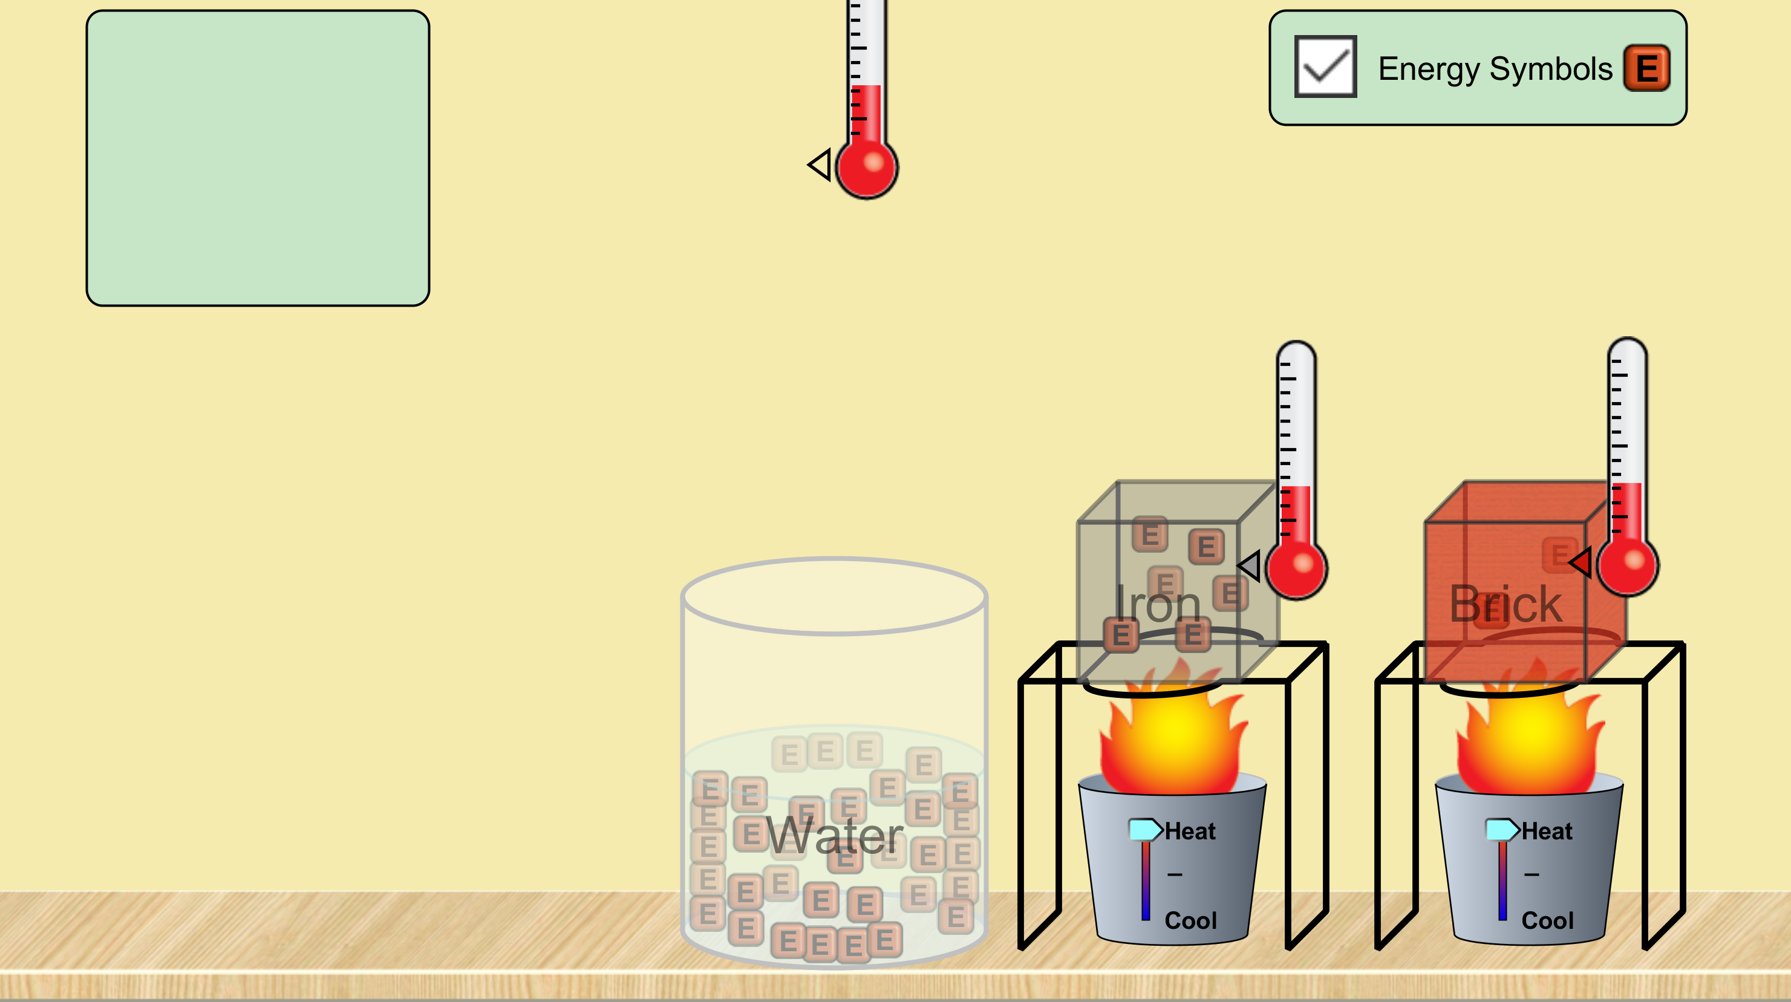
- Press play.
- Between the bucket and the block above it, which direction is the heat energy moving?

- Between the block and the surrounding air, which direction is heat moving?

- After some time, compare the temperatures of the blocks and the air. Which is hotter?

- In general, heat moves from a hot/cold (circle one) place to a hot/cold (circle one) place.
- Press pause.
- Click on each bucket and use the down arrow on your keyboard to move each bucket to full cool.
- Press play.
- Between the bucket and the block above it, which direction is the heat energy moving?

- Between the block and the surrounding air, which direction is heat moving?

- After some time, compare the temperatures of the blocks and the air. Which is hotter?
- Click “Reset All”
Part 2.
- Press pause.
- Match the setup from step 6 in part 1.
- Press play, and watch the thermometers on the blocks.
- Do the blocks gain temperature at the same rate? If not, which gains faster?

- Do the blocks absorb heat at the same rate? If not, which gains faster?

- How many energy particles can the brick hold? How many can the iron hold? (You may have to pause to count these.)

- Which block is at a higher temperature?

- Press pause.
- Move the iron block into the water.
- Move the thermometer from the air so that its touching the water.
- Watch the energy particles and the thermometers as you press play.
- What happens to the energy particles? Which direction do they travel (into the water or into the iron?)

- What happens to the thermometers? After some time, which is hotter, the iron or the water?

- Keep watching. Where do the energy particles start to go?

- What happens to the temperature as the particles leave?
Part 3.
- Click “Reset All”
- Press pause.
- Check the “Energy Symbols” box.
- Place the bucket of water on one rack, and the brick on the other.
- Attach a thermometer to the brick and place a thermometer in the water.
- Click on each bucket and use the arrow keys on your keyboard to dial each up to full heat.
- Press play.
- Watch the temperature of the water. What happens to the water when the temperature stops going up?

- Which has the higher maximum temperature, the brick or the water?

