Title: Adding Double Digit Numbers

Important Questions:

How do we add double-digit numbers with a sum under 100?

Instructions:

In this activity, we will be adding double-digit numbers with sums under 100.

1. Click this link: https://phet.colorado.edu/sims/html/make-a-ten/latest/make-a-ten_en.html
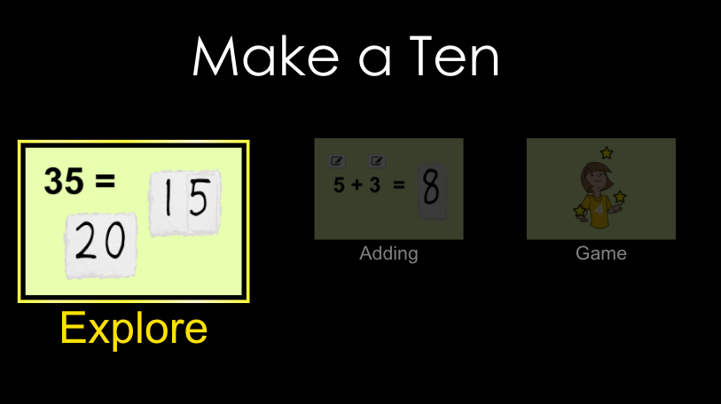

Exploration Phase:
(5 minutes)

1. Briefly explore this sim. Click the “Explore” tab.

2. On this screen you will see:
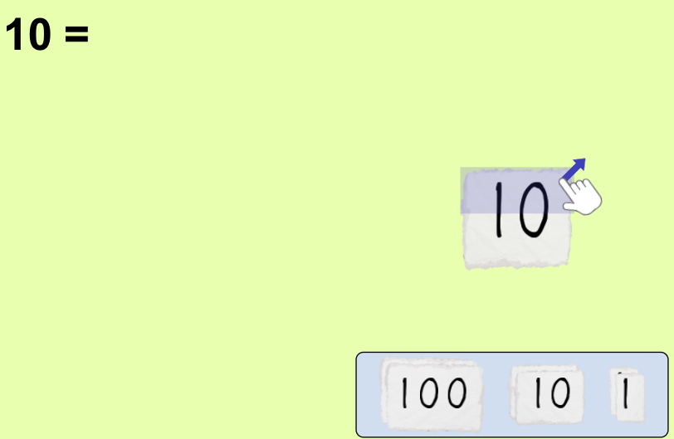

3. Explore different combinations of 100s, 10s, and 1s.

4. Notice the reset button in the bottom right hand corner. Click the reset button.

5. Pull out 3 tens and 2 ones.
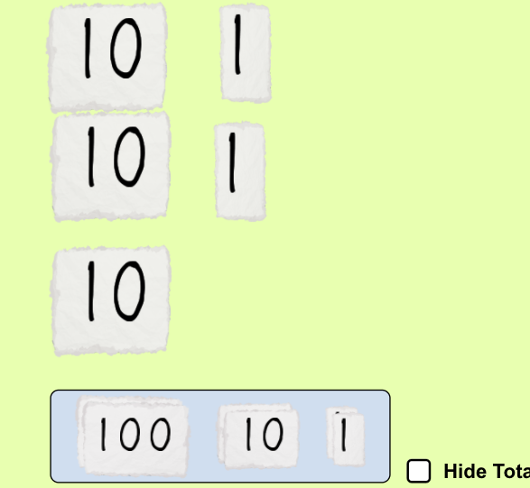

Stack the ones first. Then stack the tens.
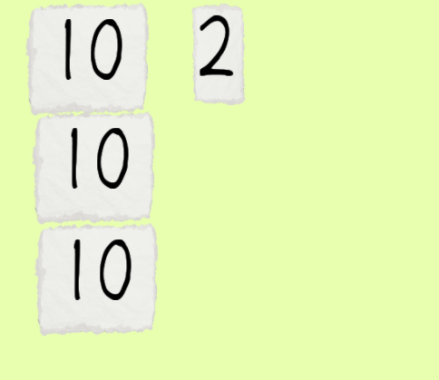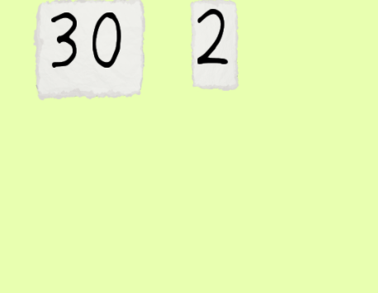

Add the two numbers together.
1) What number did you get? _____________________
2) How many tens are in the tens place? ____________________
3) How many ones are in the ones place? _____________________

Explanation Phase:
(10 minutes)

This Phase has an investigative goal.

Aim: Adding double-digits together with sums under 100.

Go back to home and click on the adding screen.
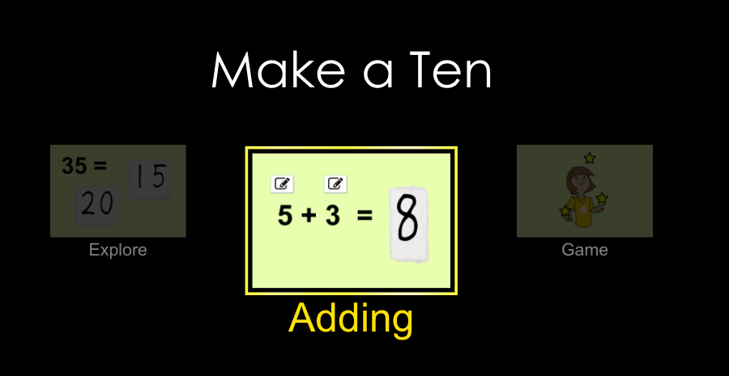

1) Type in the numbers:
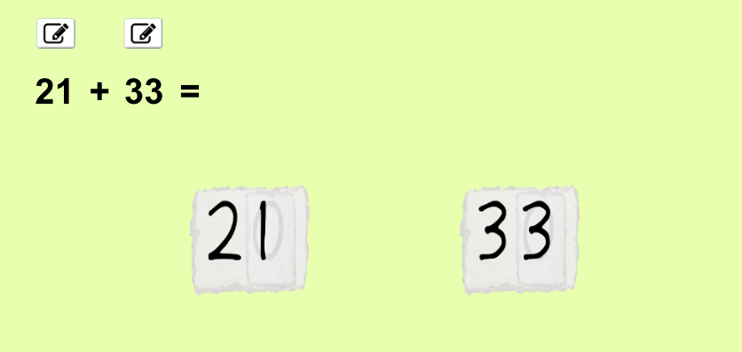

Separate the ones from the tens for both 21 and 33.
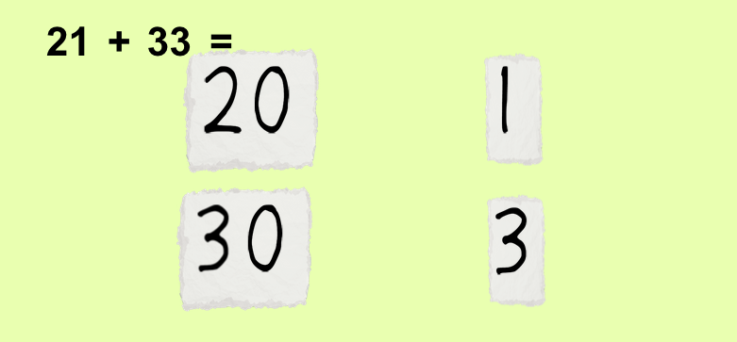

Add all of the ones together. Add all of the tens together.
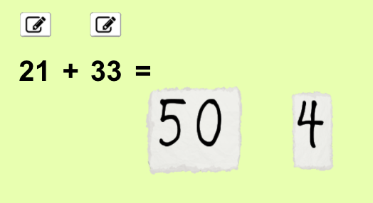

21+33= __________

2) Type in the numbers:
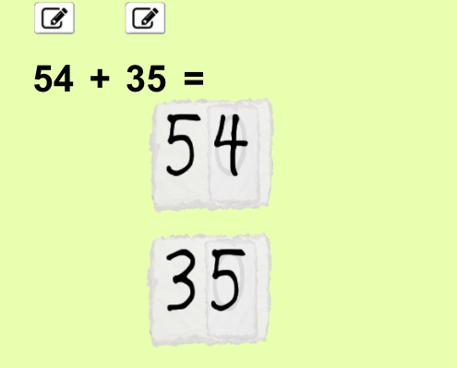
Separate the ones from the tens.
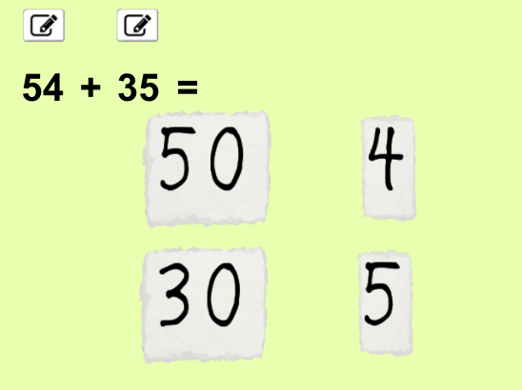

Add the ones together. Add the tens together.

54+35= _____________

Try these:
- 47+ 33= _____________
- 58+ 23= ______________

Explain:

What happens when you add 7+3 together?

_________________________________________________________________________________________________
_________________________________________________________________________________________________
What happens when you add 8+3 together?

_________________________________________________________________________________________________
_________________________________________________________________________________________________
Application Phase:
(25 minutes)

Click the “Game” tab. The screen below appears.
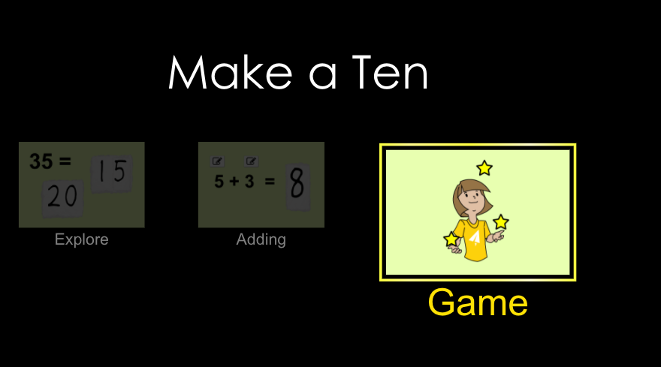

Complete level 6: Add double-digit numbers with sums under 100.
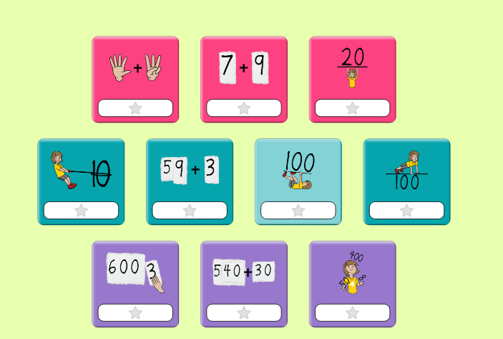

Record your answer below.

1) 2) 3) 4)
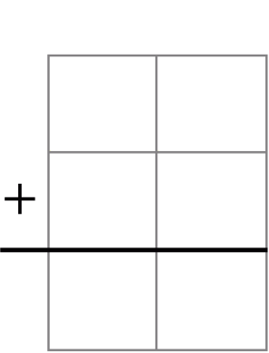

5) 6) 7) 8)

9) 10)

