States of Matter: Basics
Definitions: Matter: Anything that takes up space.
Solid: Particles of Matter are packed tight together giving it a definitive shape that does not change on its own.
Liquid: Particles of Matter have some space in between, therefore allowing it to only having the shape of its container.
Gas: Particles of matter have a lot of space between them and move around freely. They have no shape at all and take the shape of the container it is in.
Objective:
In this activity, you will explore and investigate the different states of matter. You are going to see how atoms and molecules change states from solids to liquids to gases as temperatures are changed and identify freezing and boiling points of liquids.
Procedure:
- Click on the link: http://phet.colorado.edu/
This is what you should see:
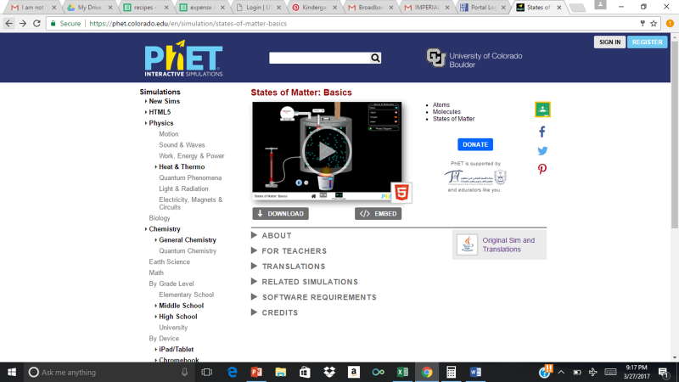
- Click the “Play” button.
Exploration:
1.When you open the sim, you will find different types of atoms and molecules to explore on the upper right hand side. There is neon, argon, oxygen, and water. click the on the upper left hand corner.
2.Under the atoms and molecules, there is a box marked “Solid, Liquid, Gas”, click on one and watch as the atoms and molecules change to represent that state of matter.
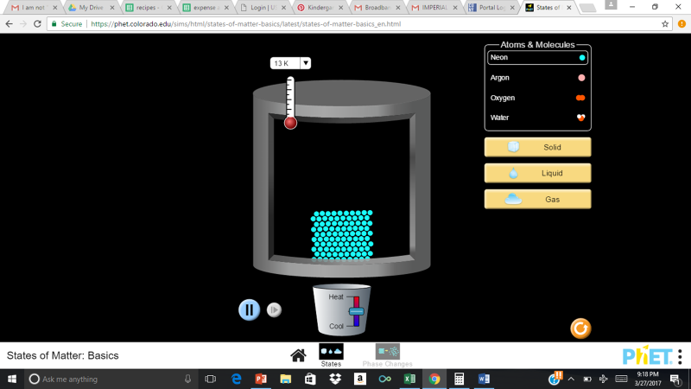

3. First click the “neon” button, then the solid button and increase the heat and observe what happens to the particles. Then decrease the heat and observe what happens to the particles. Observe the temperature as well.
4. Repeat step 3 for the argon, oxygen, and then water.
5. Change the state of matter and repeat step 3 for each state.

Questions:
- How did the particles of neon in solid react when the pot was heated?
- How did it react when the heat was decreased?
- As the Neon cooled, did it go back to its original shape? Why or Why not?
- Did the argon, oxygen and water, in the state of solid, react the same as the neon. Explain?

Explanation Phase:
Aim: Create a rule that determines the temperature that the particles change their state from a solid, to liquid, and then to gas using just water.
**Click on water under Atoms and Molecules then click on Solid to determine the following:
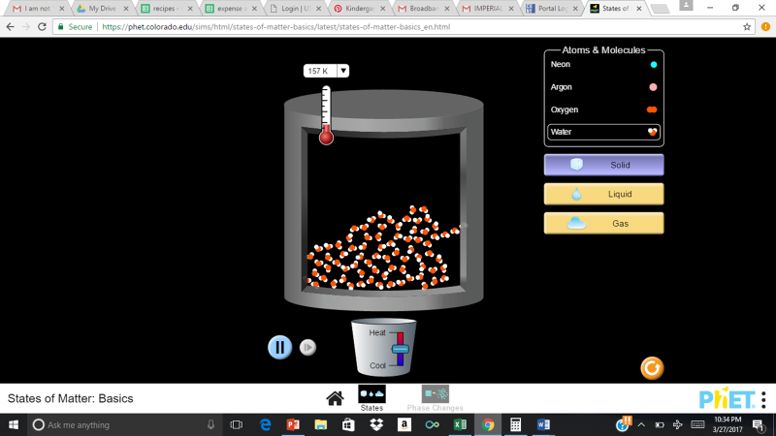

- When the container is hot, do the particles become a solid, liquid, or gas?

- When the container is cooled, do the particles become a solid, liquid, or gas?

- By looking at the arrangement of atoms, how do you determine the phase change (ex: solid to liquid, liquid to gas, etc.) ?

- Use the thermometer at the top to record the temperature where the state of matter changed:

Solid (Freezing point): _________

Gas (Boiling point): __________

- As the states of matter change, pause the simulation and sketch the molecules at each of the points in the boxes below
Solid | Liquid | Gas

Application Phase
*Press reset button on the lower right hand side.
Using the Simulation, record the following information. At what temperature do the particles reach their melting point, boiling point, and freezing point?
Atoms and Molecules |  | Boiling Point | Freezing Point
Neon:
Argon
Oxygen
Water

Conclusion:
Based on your data, what can you conclude about the different states of matter, and how each atom or molecule changed as the temperature changed?

