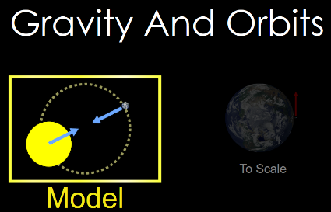
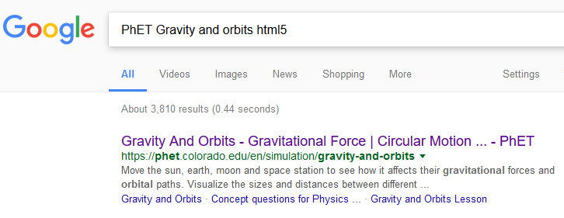
PhET Gravity and Orbits html5
Click the “5” shield
CLICK!

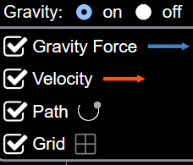
Part 1 Directions: Choose “Model”
Select all check boxes
- Click and describe
what you see.

- Click recheck the boxes and change either the planet’s mass, the star’s mass or both. Circle what you changed (star’s mass greater or smaller - planet’s mass greater or smaller). What happened to the orbit?

- Click recheck the boxes and change either the planet’s mass, the star’s mass or both. Circle what you changed (star’s mass greater or smaller - planet’s mass greater or smaller). What happened to the orbit?

- Click recheck the boxes and change either the planet’s mass, the star’s mass or both. Circle what you changed (star’s mass greater or smaller planet’s mass greater or smaller). What happened to the orbit?

- Were you able to have the planet leave the orbit of the star? What changed?
(star’s mass greater or smaller - planet’s mass greater or smaller)
- Were you able to have the planet crash into the star? Which scenarios?
(star’s mass greater or smaller - planet’s mass greater or smaller)
- If you answered “NO” to 5 or 6, play with the sim until you can answer “YES” to both. What changed?
(star’s mass greater or smaller - planet’s mass greater or smaller)
- Click recheck the boxes and add a moon. . Click . What happened to the planet’s orbit? What does the moon’s orbit look like?

- Click recheck the boxes and add a moon. . Change the mass of the planet, star of both. Click . What happened to the moon and planet’s orbit?

- Play with these two selected. What happens pretty quickly in each sim?
PhET Gravity and Orbits html5

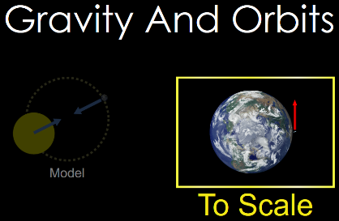
- A. Click and describe what you see.

Part 2 Directions: Choose “To Scale”
Select all check boxes
Select

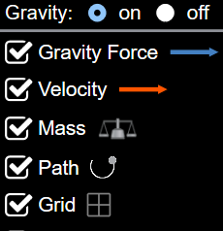

- Click recheck the boxes and change either the earth’s mass, the suns mass or both. Circle what you changed (sun’s mass greater or smaller - earth’s mass greater or smaller). What happened to the orbit?

- Click and select 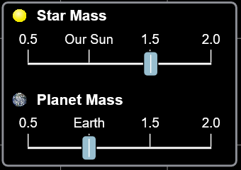 and . Click and allow an 365 days to pass. Describe what happened to the planet and the moon’s orbits?

- In any of the sims, what happens when you turn gravity off and hit play?

- With selected, what happens to the orbit when you change the satellite mass? When you change the planet’s mass?

- In all the sims, what happens to the planet as things go around it? (Hint: make sure all boxes are checked!)

AA31 Labs
AA31 Labs

