Simulation: Wave on a string
Go to: https://phet.colorado.edu/sims/html/wave-on-a-string/latest/wave-on-a-string_en.html
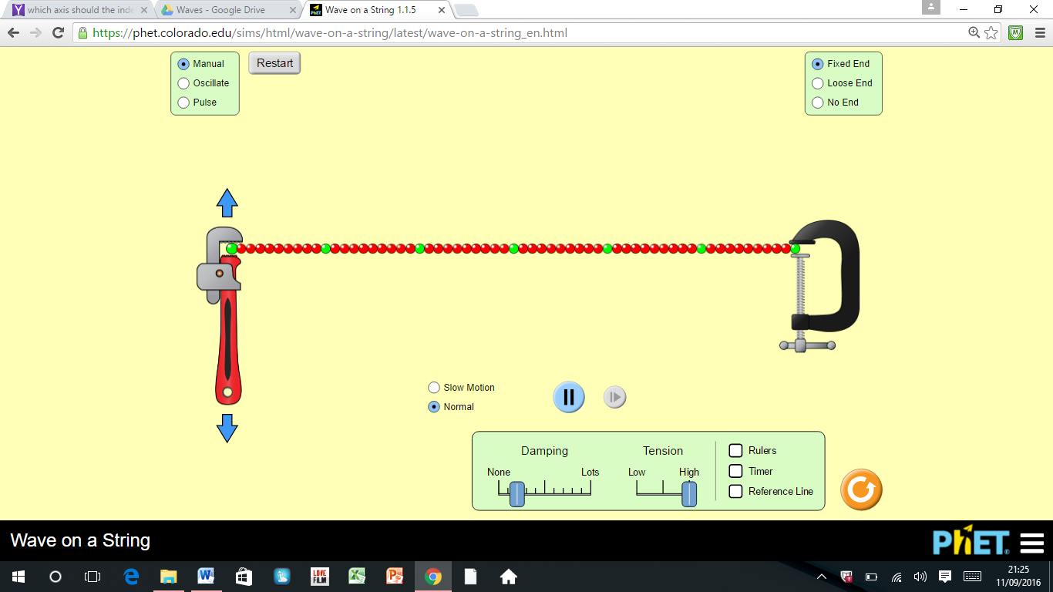
Switch on Rulers and Timer, practise moving rulers and making waves travel along the string.
- What does tension mean?
- How does the Tension of the string, affect the speed of the wave?
- What does damping mean?
- How does the amount of Damping affect how far the wave ravels along the string?
Reset the screen. Switch on Rulers, Timer and Slow Motion. Set to Pulse, High Tension, None Damping, maximum Amplitude (1.25cm), minimum Pulse Width (0.2s).
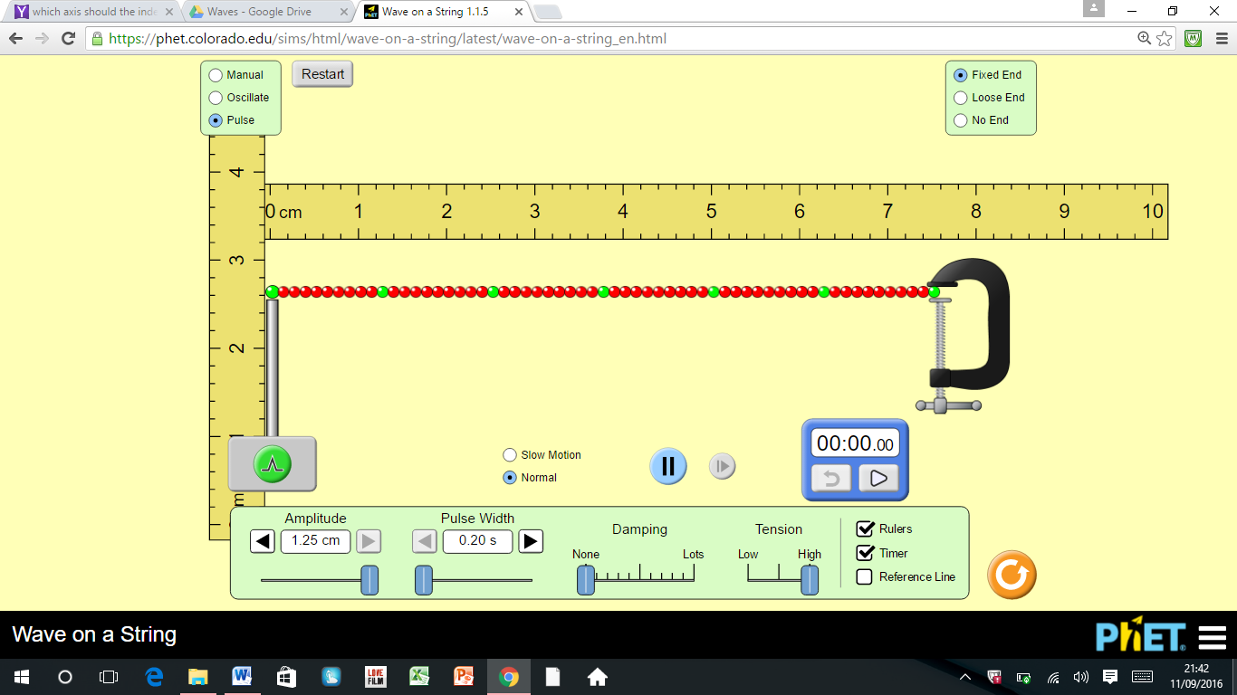
- Use the ruler to measure the length of the string.
- If it passes along the string 4 times, how far does a wave travel?
- Use the timer to find out how long it takes for the wave to pass along the string 4 times.
- Use 6 and 7 to calculate the speed of the wave as it travels along the string.
Set the tension to low.
- Repeat 6-8 to calculate the speed when the tension is low.
- Do 8 and 9 agree with your statement in 2?

