Student Guide for Density Simulation
Name:
Hour:

https://phet.colorado.edu/sims/density-and-buoyancy/density_en.html
- Go to the simulation website (on Google Classroom or link above).
- Experiment with the different materials by putting them in the water.
- Fill in the box with the appropriate information.

Material | S: Sinker or F: Floater | Density Given

5. Try to get aluminum to float. Can you? If so, how did you get it to float?

6. What do you see about the density triangle at the bottom of the box? Why do you think this does or does not move?

7. From class we have learned that ________________________ divided by _______________________ equals DENSITY.

8. What number does the density have to be less than for it to float in water? Write a paragraph that explains why and shows evidence of how you know this.

CLAIM:

EVIDENCE:

REASONING:

9. In the “blocks” box, click on MYSTERY.
10. Test the boxes in the water: just drag and drop them.
11. When you have determined which ones sink and float, fill in the data table for each box.

Sample | Starting Volume of Water | Volume of Water & Block | Volume of Block Alone (2nd column- 100L) | Mass (kg) | Density (kg/L) | What is it most likely made of? (use show table for help)
A | 100 L
B | 100 L
C | 100 L

12. Look closely at the GREEN BOX C and RED BOX D (still in mystery). Make 3 observations about these two blocks. List these observations in the boxes below.

1st Observation: | 2nd Observation: | 3rd Observation:

13. This is a picture of an aluminum boat. Use CLEAR to answer this question. Will this boat float?
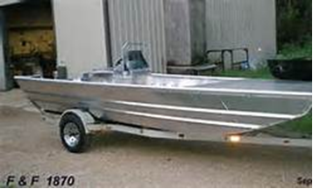

CLAIM:

EVIDENCE:

REASONING:

