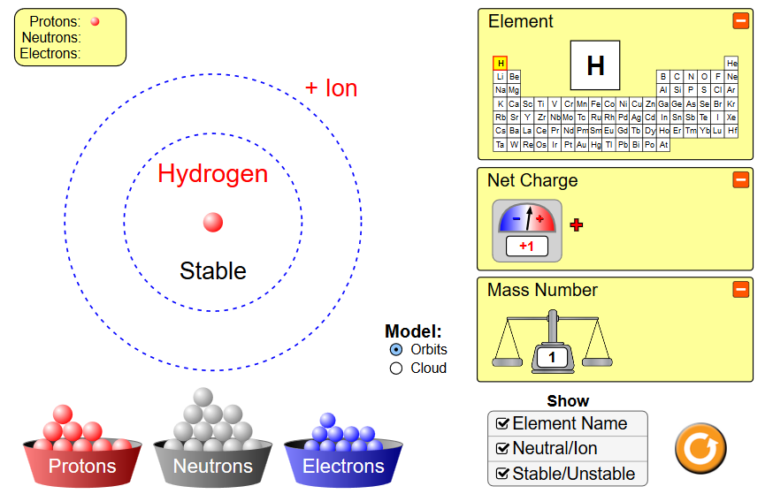
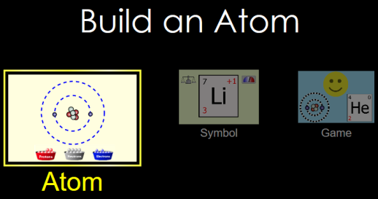
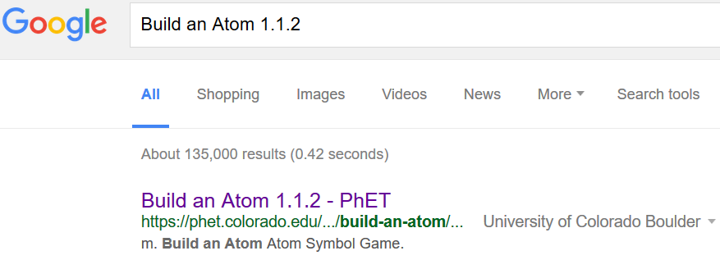
CLICK!
Build an Atom html5
Part 1 Directions: Choose “Atom”
Open tools, click boxes as shown

To create atoms, drag protons, neutrons and electrons onto and off of the “X”.
1A. Make 3 stable atoms (not H!) Draw the atoms below
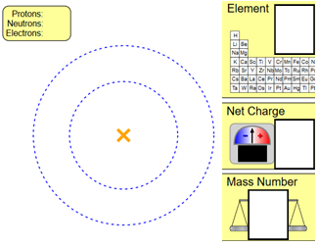
1B. Make 3 unstable atoms (not H!). Draw atoms below:
1C. You have just made unstable atoms. How can you make them stable?
1D. What did you change to get the numbers in the box to change?
Element

Net charge (more than one way!)
AA31 Labs
Mass Number (more than one way!)
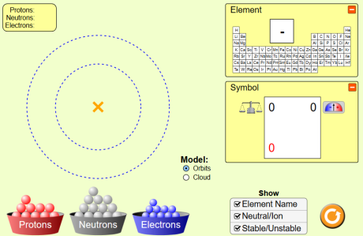
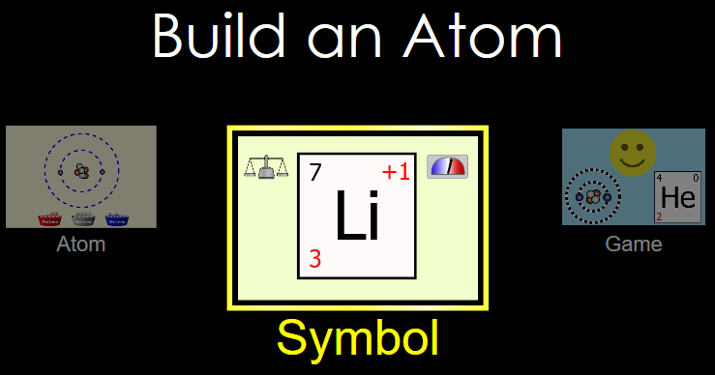
Part 2:

Directions: 2A 2B click, open
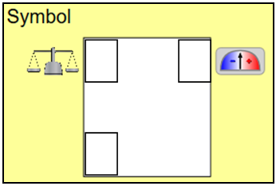
2C. Make 4 stable atoms (not H!) Fill in the 4 boxes for each stable atom:
2D. Make 4 unstable atoms (not H!). Draw atoms below:
2E. Can you make 3 different stable atoms that are the same element with a different mass? How?

2F. Can you make 3 different stable atoms that are the same element with a different charge? How?
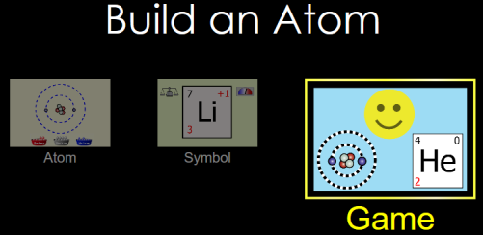
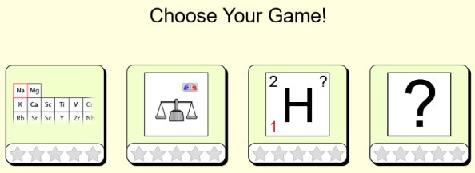
Part 3

3A 3B 3C

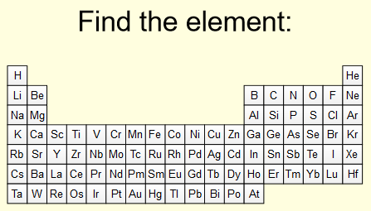

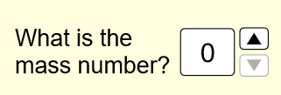

Score: _____ _____

Score: _____ _____

Score: _____ _____

Score: _____ _____

AA31 Labs

