Virtual Investigation into the behavior of L R Circuits

Name_____________________________________ Pledge______________
Please go to the following webpage - https://phet.colorado.edu/en/simulation/legacy/circuit-construction-kit-ac
Run the application and set up the following circuit.
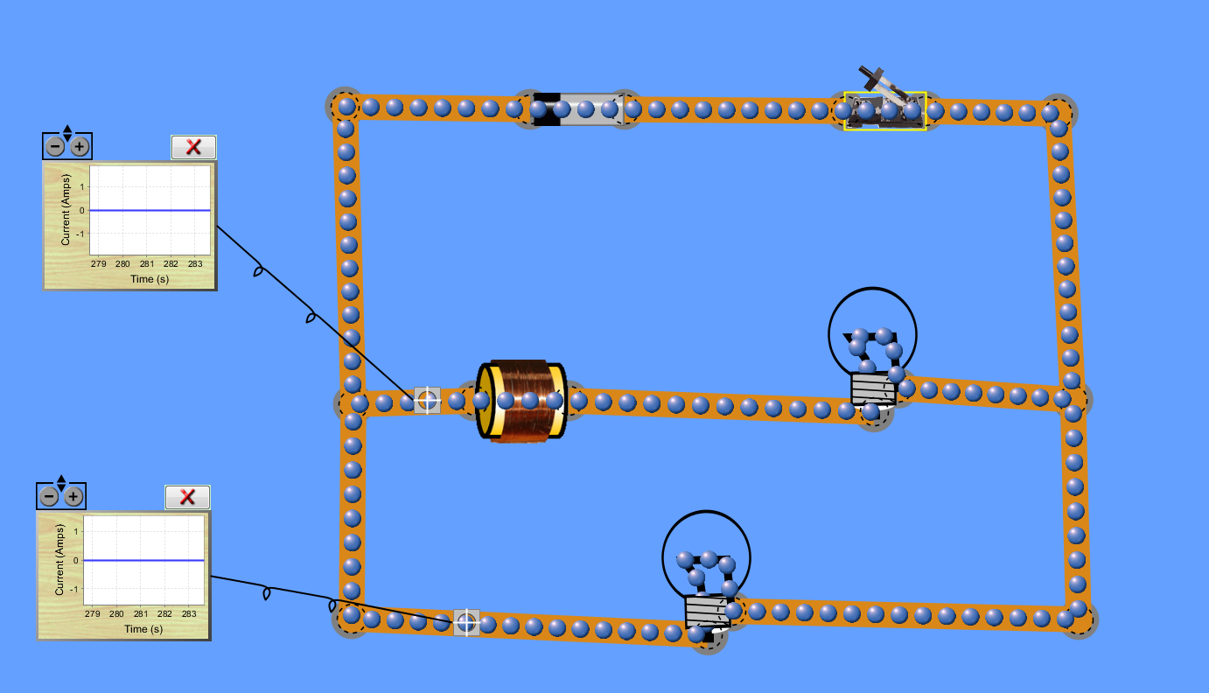
Typically, and inductor is usually a coil of wire wrapped around a piece of iron. Yes, it’s an electromagnet that we do not use for picking stuff up!
- By right clicking on the inductor, set it to 10 Henries (No, that really is the unit)
- Ensure that both bulbs are 10 ohms
- Close the switch. Describe your observations.

- Describe in your own words what effect the inductor has on the current.

- Now open the switch. Again, describe your observations.

- Why do you think a current was able to flow after we effectively removed the battery from the circuit?

A couple of things to consider. When the current through an inductor changes, Lenz’s law gives us a clue as to how the inductor will act.
- The inductor will generate an EMF which opposes the change taking place.
- The size of the EMF will be proportional to the rate of change of current (Why?)
- The constant of proportionality depends on the geometry of the coils and is called the inductance L, measured in Henries

$$ε=-L\frac{dI}{dt}$$

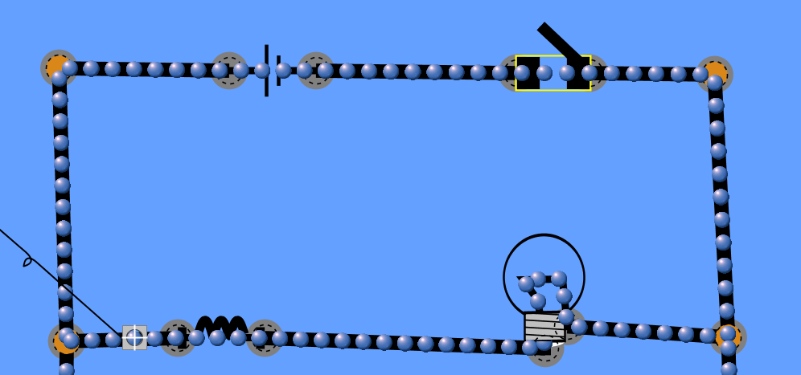
Consider the loop in the diagram above. We can use Kirchoff 2 (loop) to write a differential equation for current I
If ε is the emf of the battery and -$L\frac{dI}{dt}$ is the emf generated in the coil, the sum of these two should equal the p.d across the resistor, IR.
Write down and solve the differential equation, assuming I = 0 when t = 0

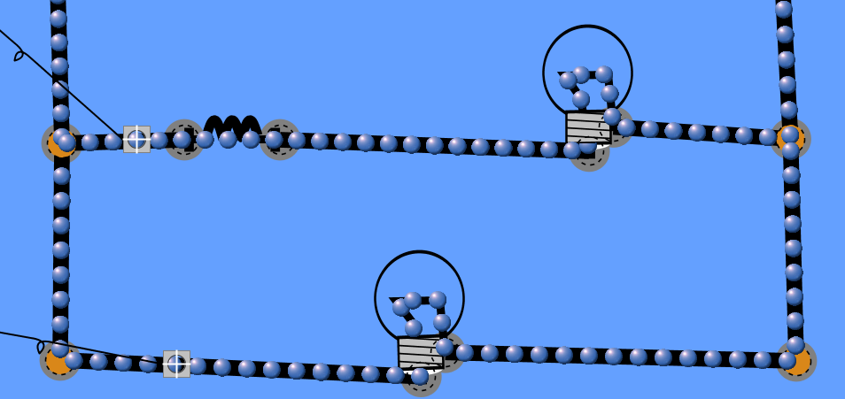
Now consider what happens to the bottom loop when we open the switch. There is now only one source of EMF. Write down and solve a differential equation in $I$ for this case, assuming that the current at $t=0$, when the switch was opened, was $I_{0}$

