Trig Tour - Connecting the Unit Circle with a Graph

PRE-PLANNING | PRIOR KNOWLEDGE
- Know the trigonometric functions of Sine, Cosine and Tangent
- Use Pythagorean Theorem to find the missing side of a right triangle
- Graph on a Cartesian coordinate system
 | LEARNING GOALS
- Easily translate between multiple representations of trig functions: as sides of a right triangle inscribed in a unit circle, graph of the function vs. angle, and numerical values of function.
- Deduce the sign (+, -, 0) of trig function for any given angle without a calculator using the unit circle concept.
 | Common Core Standards | Common Core Practices
 | CCSS.Math.Content.HSF.TF.A.4  (+) Use the unit circle to explain symmetry (odd and even) and periodicity of trigonometric functions.  CCSS.Math.Content.HSF.TF.A.2  Explain how the unit circle in the coordinate plane enables the extension of trigonometric functions to all real numbers, interpreted as radian measures of angles traversed counterclockwise around the unit circle. | 2. Reason abstractly and quantitatively  7. Look for and make use of structure
 | MATERIALS
- PhET Trig Tour simulation: http://phet.colorado.edu/sims/html/trig-tour/latest/trig-tour_en.html
- Laptop/Chromebook/tablet for each student or pair
- Seating chart that allows for occasional pairings of students.
- “Trig Tour - Connecting the Unit Circle with a Graph” Activity Sheet for each student (see below)
LESSON CYCLE | Develop a context 8 minutes
Ask students who has been on a Ferris Wheel. Keep in mind that for some students, this may not be a shared experience. Have students talk in pairs about their experience on a Ferris Wheel and the motion of the Ferris Wheel. You may also choose to show a brief video about Ferris Wheels such as the one found here:
https://www.youtube.com/watch?v=StPKfNXK3N0
Provide students with Part I of the handout. Tell the students they will be on the Ferris Wheel in the cross-hatched bucket. Ask students to work first independently, and later in pairs, to graph their height as they ride the Ferris Wheel.
Have students share their completed graphs and justify their strategy as to how they graphed the points.
 | Explore the simulation 5 minutes
Ask the students to access the Phet Trig Tours Simulation here:
http://phet.colorado.edu/sims/html/trig-tour/latest/trig-tour_en.html
Allow students 5 minutes to explore the sim. You can provide the PART II – EXPLORE handout to students to complete, or use that handout as questions to ask students as you walk around.
As a whole class, provide students with time to share what they learned about the sim, especially pointing out features of the sim’s controls, and making connections between the unit circle and the graph.
 | Making Sense of the Graph 10-15 minutes
Pass out the worksheet PART III to the students. Have the students work independently or in pairs to answer the questions.
Circulate the room to be available for student questions and to ask probing/pushing questions. If a student is struggling with the task, it can help to probe for more information.
- What do you see on the unit circle?
- Where is that same point on the graph?
- Where can you see how many degrees you have traveled?
BE SURE:
To check to see that students have the same starting point when comparing the sin and cos graphs.
 | Discussion 10 minutes
Bring the class together for a whole-class discussion.
- Remind students to close their laptops or turn around so that the sim does not distract them from listening.
- Use an established teaching strategy such as popcorn discussion (one student answers, calls on the next student to talk), think-pair-share (pose question, allow time to think, turn and talk to partner), or group discussions (print out questions and have groups talk to each other and write down consensus to share aloud with class). Sample questions include:
- How does that graph mimic the movement of the Ferris Wheel?
- Why does the graph continue to move up and down?
- What are the differences between the sin and cos graph? What caused these differences?
- When will the Ferris Wheel basket be at a height of 1/2? (Look for many answers – then give students time to think through a possible rule)
- When will the Ferris Wheel basket be at a height of -1/2? (Look for many answers – then give students time to think through a possible rule for radians)
 | Extend 10 minutes
Pass out the worksheet PART IV to the students. Have the students work independently or in pairs to answer the questions.
Circulate the room to be available for student questions and to ask probing/pushing questions. If a student is struggling with the task, it can help to probe for more information.
- What is different on each graph?
- How would you see this difference on a Ferris Wheel?
- What do you know about the height of the wheel?
- What do you know about how fast it is traveling?
 | Wrap Up 5 minutes
Bring the class together for a final whole-class discussion.
- Remind students to close their laptops or turn around so that the sim does not distract them from listening.
- Use an established teaching strategy such as popcorn discussion (one student answers, calls on the next student to talk), think-pair-share (pose question, allow time to think, turn and talk to partner), or group discussions (print out questions and have groups talk to each other and write down consensus to share aloud with class). Sample questions include:
- How does that graph mimic the movement of the Ferris Wheel?
- What differences did you notice?
- Which Ferris Wheel was largest? Smallest? Fastest?

TRIG TOUR - Connecting the Unit Circle with a Graph
Part I – Connect
Instructions: Assume that the Ferris Wheel makes a full circle in the space of the graph shown below. Where is your basket in HALF of that time? Where is it in one QUARTER of that time? Estimate the location of your basket in as many times as possible.
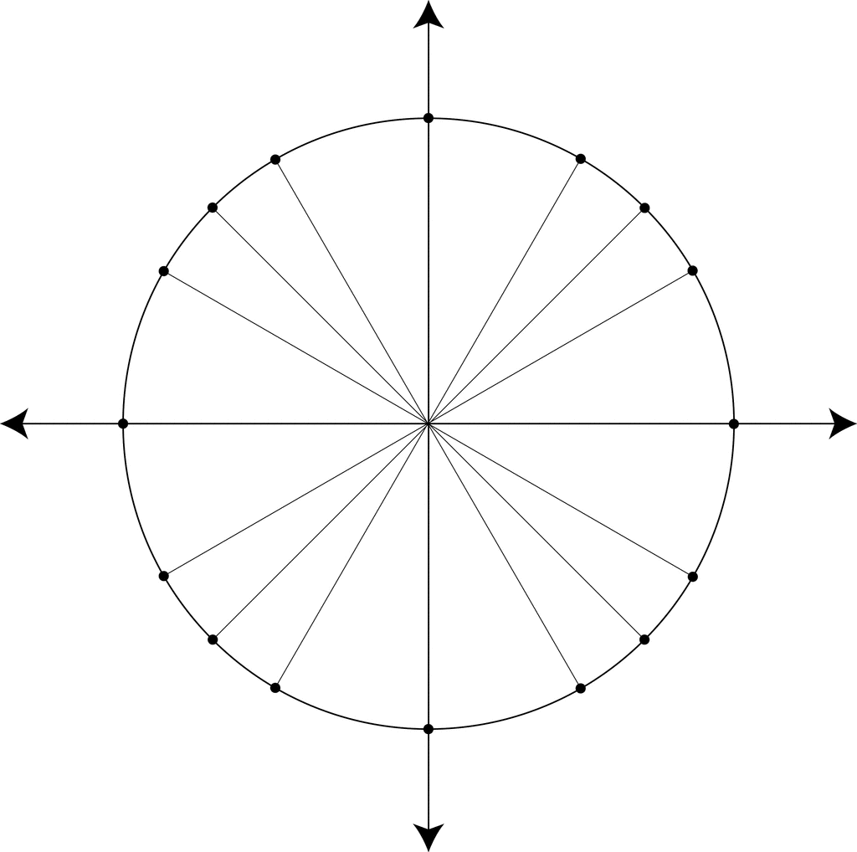

Compare your picture with another student. Once you both agree, compare your graphs with another pair. How should we label the axes?
TRIG TOUR - Connecting the Unit Circle with a Graph
Part II – Explore
Explore Trig Tour for five minutes. Try to figure out what’s going on.
What connections do you see between the circle and the graph?

Click between the SIN COS and TAN checkboxes. How does the graph change at different points?

Which graph (Sin, Cos or Tan) most closely matches the Ferris Wheel motion? Why?

What is the unit size of each line? How do you know?

How “tall” is this Ferris Wheel? How do you know?

What is the radius of this circle? How do you know?

At the end of the five minutes, you’ll be asked to share what you’ve noticed with your partner and then with the class.

TRIG TOUR - Connecting the Unit Circle with a Graph
Part III – Making Sense of the Graph
Using Trig Tour, answer the following questions:
In which quadrant(s) will you be above the midline of the Ferris Wheel?
In which quadrant(s) will you be below the midline of the Ferris Wheel?
In which quadrant(s) would you be moving up if you were in the Ferris Wheel?
In which quadrant(s) would you be moving down if you were in the Ferris Wheel?

Click on the SIN box.
If the Ferris Wheel travels around three full rotations, sketch the graph that shows your movement:

Click on the COS box and notice that the graph changes. Describe the change.

Study both the sin graph and the cos graph, moving the red dot on the circle.
What values is the sin graph plotting?

What values is the cos graph plotting?

Using the same starting point for each graph:

Graph the SIN of the angle for one full rotation

0° 360°
Graph the COS of the angle for one full rotation

0° 360°

Again, picture the Ferris Wheel. You can move the red dot around the unit circle multiple times to model going around and around on the Ferris Wheel.
Using both the unit circle and the graph, find three angles (In DEGREES) where you would be at the highest point on the Ferris Wheel.

What is your height at this point?

Using both the unit circle and the graph, find three angles (in RADIANS) where you would be at the highest point on the Ferris Wheel

Find three angles (in DEGREES) where your height is ½

Find three angles (in RADIANS) where your height is (- ½)

TRIG TOUR - Connecting the Unit Circle with a Graph
Part IV – Extending

You’ve been asked to consider three new Ferris Wheels are being considered for the new World’s Fair, but all they gave you were the graphs of the movement. What do you know about each of the Ferris Wheels?
