Balancing Act Activity
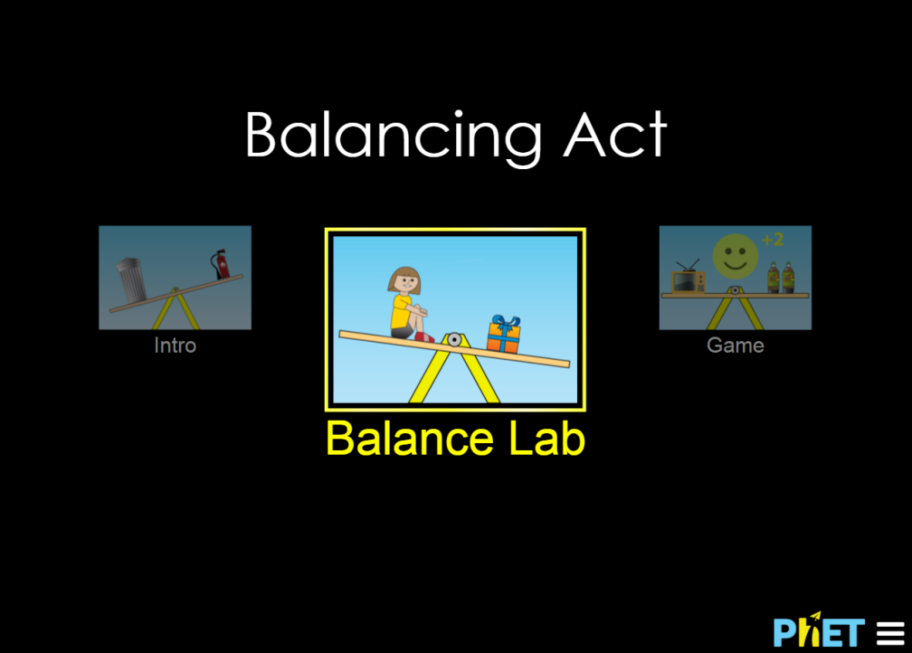
Click on the link above or go to the address below…
https://phet.colorado.edu/sims/html/balancing-act/latest/balancing-act_en.html
Then select “Balance Lab”
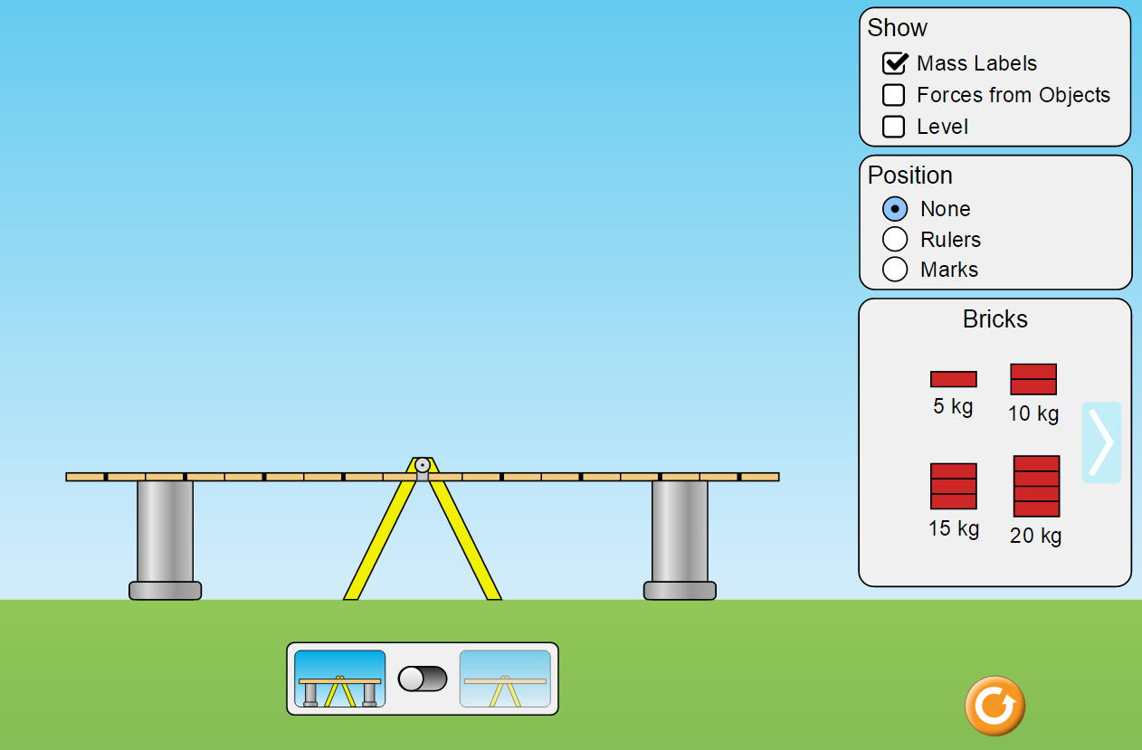

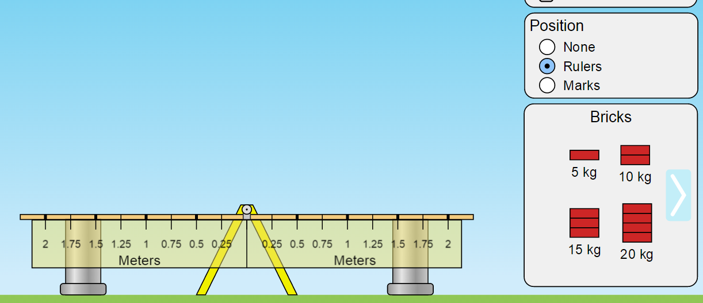
Name:
Period: Date:
Turn the “Rulers” to on

The lab challenges…
- Place the 10 kg mass at 1 m to the right of the pivot. Where would you place the 5 kg mass in order to keep it from rotating? In other words…how do you keep the plank balanced or in static equilibrium?

- Place the 10 kg mass at 1 m to the right of the pivot. Where would you place the 15 kg mass in order to keep the plank in static equilibrium?

- Place the 20 kg mass at 2 m to the right of the pivot. Where should you place additional mass(es) to achieve static equilibrium? Include the amount of mass and location in your answer

- Place the 20 kg mass at 2 m to the right of the pivot. Make sure the plank is in static equilibrium using only 5 kg masses. Where did you place the 5 kg masses?

- Using evidence from the lab describe the role the distance from the pivot plays in balancing the plank?

- What role does the mass play in balancing the plank? (Hint: Would you need to balance the plank in a “weightless” environment?)

- Using the mass distribution in problem #2, draw the forces acting on the plank. Forces are vectors so make sure and draw them to scale.

- Analyze your drawing…
  - How many forces did you draw?

  - Would the object be in translational equilibrium?

- Now imagine a different set up…

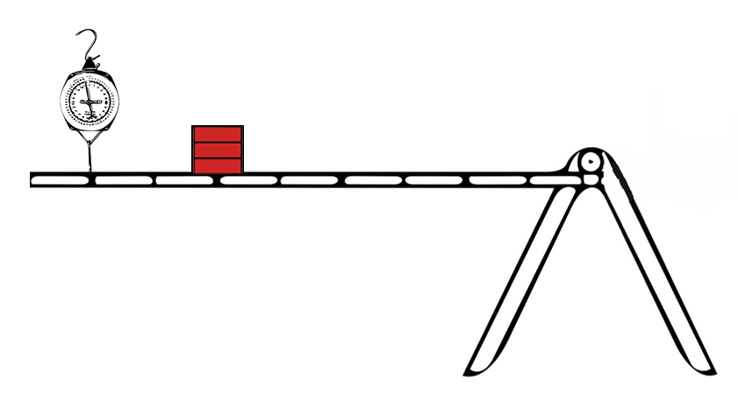
What would the scale read if the plank is in static equilibrium? The 15 kg mass is located at 3 m away from the pivot.

- What would be your answer to the scenario in problem #9 if I told you the mass of the plank was 5 kg?

