Name: __________________________ Date: _______________
Grade Level & Section: _____________

Seeing Colors
Objectives:
- To identify the color a person can see.
- To see what color appears when different colors are combined.
- To know which part of the brain activates when a person sees color.
I. Procedure:
- Enter or go to https://phet.colorado.edu/sims/html/color-vision/latest/color-vision_en.html to access the PhET stimulation color vision.
- Click the RGB Bulbs Tab.
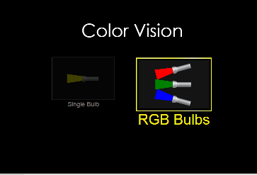

- Slide the bars of each color to manipulate the RGB Bulbs.
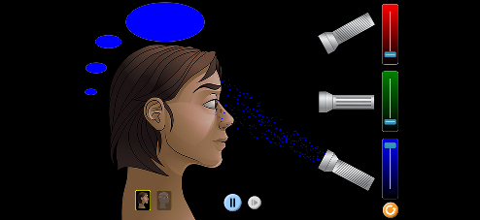

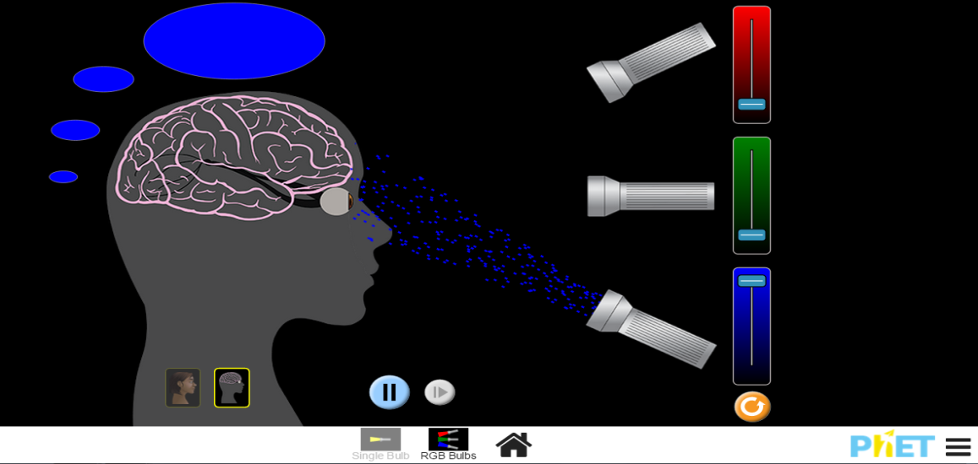
- For you to visualize the brain and nerves connected from the eyes you can click the button pointed by the arrow below.

Answer the following questions:
- What color is seen when:
a. the last bar is slide to the very top? ________________
b. the second bar is slide to the very top? ______________
c. the first bar is slide to the very top? ________________
- What happens when you slide:
a. the first and the last bar of color to the very top? ____________
b. the first and the second bar to the very top? _____________
c. the second and the last bar to the top? _____________
d. the first, second, and third bar to the top? ___________
- What do you think is/are the reason/s why when colors are combined makes another color? ______________________________________________________

- Which part of the brain areas activated when a person sees color?
______________________________________________________

