Wien’s Displacement Law
Online lab
Name: ________________________ Date:___________
Use the PHET – Wien’s Displacement applet for this lab found at the following URL: https://phet.colorado.edu/sims/blackbody-spectrum/blackbody-spectrum_en.html
Background:
All objects with a temperature above absolute zero (0 degrees Kelvin) emit radiation. The peak emission of this radiation depends on the temperature. The hotter an object is the more radiation it emits at shorter wavelengths with more energy (higher frequency).
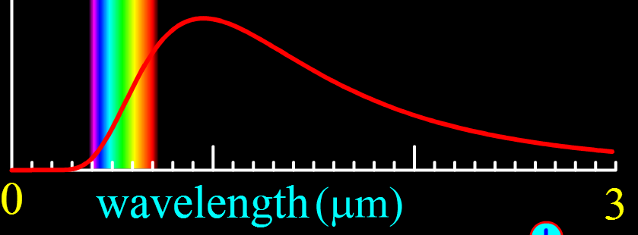
Figure 1

The following questions refer to Figure 1
1. In which direction is the frequency or energy of the electromagnetic waves increasing in Figure 1 (ignore the graph line)?
- To the right
- To the left
2. What do we call the area immediately to the left of the visible spectrum in Figure 1 (ignore the graph line)?
- Infrared
- X-ray
- Microwave
- Ultraviolet

3. What do we call the area immediately to the right of the visible spectrum in figure 1 (ignore the graph line)?
- Infrared
- X-ray
- Microwave
- Ultraviolet
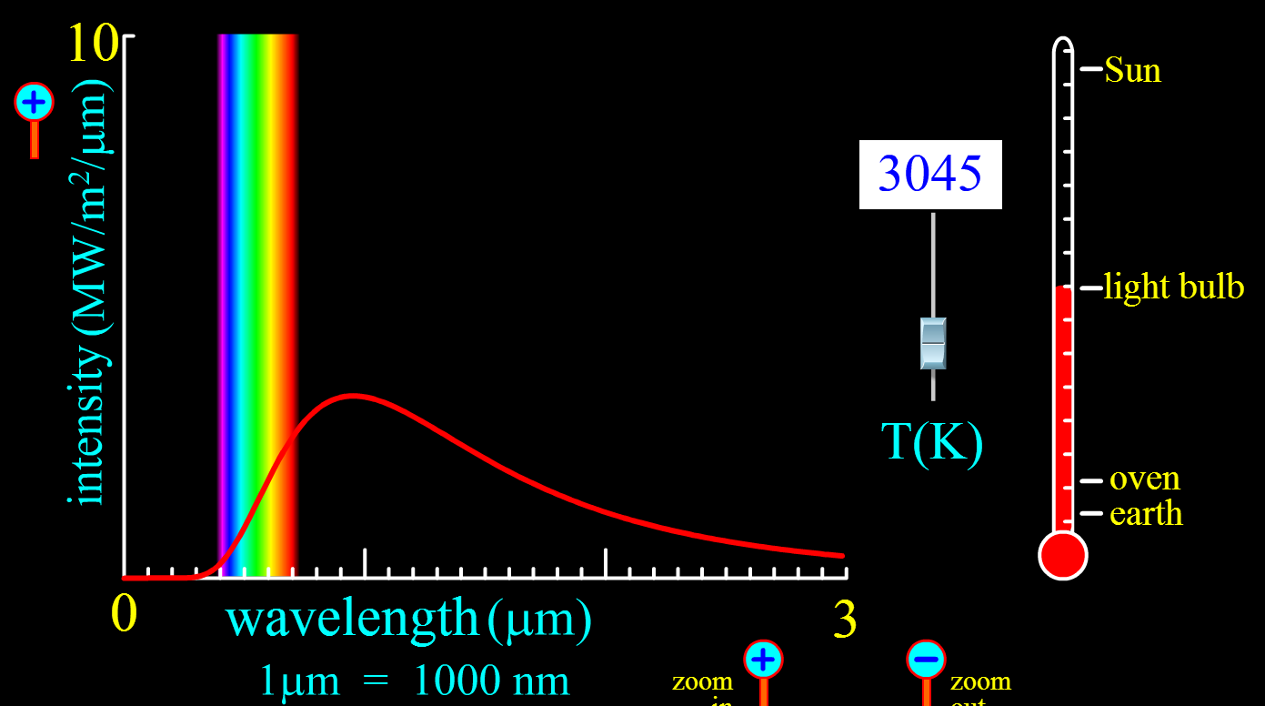
Figure 2

4. The graph above represents the electromagnet spectrum for a light bulb at 3045 degrees K. what is the approximate peak wavelength for this temperature from the graph? (Note the scale goes from 0 to 3 um in 1 um (major division) increments.
- 1000 nm
- 1000 um
- 3 nm
- 0.5 um
5. What the approximate temperature in Fahrenheit (research this)?
- 1019 deg F
- 502 deg F
- 5021 deg F
- 3000 deg F

6. The human body has a temperature of approximately 310 deg K (about 98 F). Find the approximate peak wavelength of this temperature by doing the following:
1. Enter 310 (body temperature in Kelvin) into the temperature field
2. Adjust the intensity zoom in the positive direction (zoom in) - more sensitivity
3. Adjust the wavelength zoom in the negative direction (zoom out) - wider wavelength view

- 24 um
- 1000 nm
- 10 um
- 5 um
7. Convert this answer to nanometers.
- 10,000 nm
- 240 nm
- 100000 nm
- 500 nm
8. What kind of instrument would let us “see” this wavelength (research)?
- Ultraviolet camera
- Cell-Phone camera
- Near Infrared camera
- Far Infrared camera

Figure 3

The BGR in figure 3 represent the Blue, Green and Red content of the light emitted by hot object.

9. What is the approximate color of the sun using BGR indicator and adjusting the sliding temperature scale to Sun?
- Yellow
- Orange
- White
- Blue
10. What is the approximate color of a light bulb in the BGR indicator and adjusting the sliding temperature scale to Light Bulb?
- Yellow
- Orange
- White
- Blue
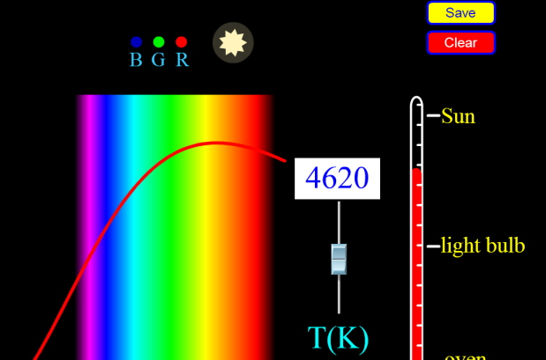
Figure 4

In Figure 4 the temperature is adjusted for a peak emission in the yellow part of the spectrum. Note the temperature is around 4600 degrees (4620) for yellow and the BGR is light yellow.
11. Astronomers see red stars and blue stars but not green stars. Adjust the sliding temperature adjustment for a peak wavelength of green and pick the approximate color you see in the BGR indicator?
- Yellow
- Green
- White
- Blue
12. If an object has a peak wavelength in the blue part of the spectrum what is the approximate temperature in Kelvin?
- 3,020K
- 4,100K
- 6,500K
- 10,000K

