Title: Completing a Circuit

Introduction:
In this activity you will investigate electricity and determine what is needed for a light bulb to light by trying out different electric pathways.

1. Click this link: https://phet.colorado.edu/en/simulation/circuit-construction-kit-dc-virtual-lab
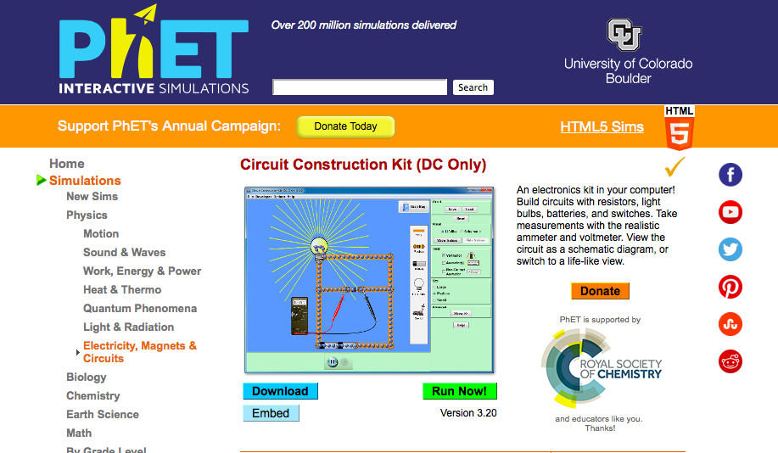
2. Click “Run Now!”. It will take time to load and then this screen appears:
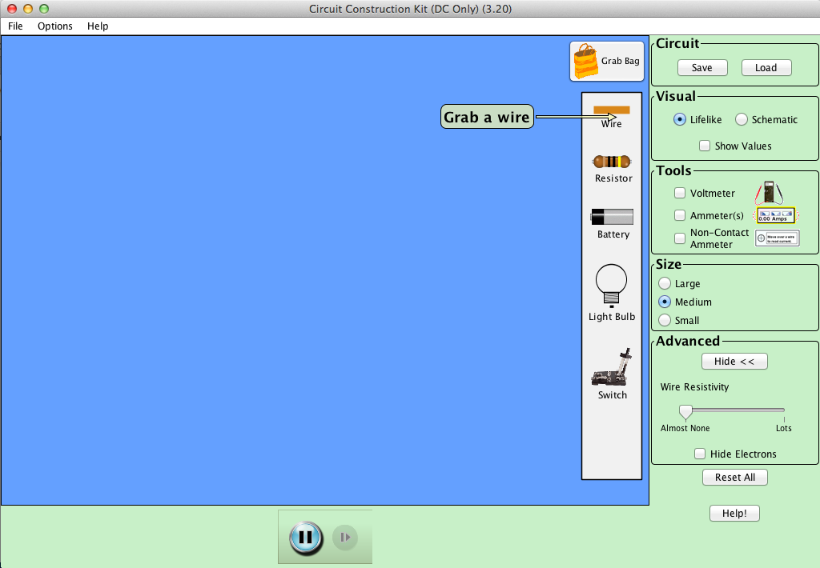

Switch between this document and the sim to complete the activity.

If using Mac OS: In order to right click and see options, hold Control button on keyboard and click on items or use two fingers on the trackpad.

Exploration Phase

- Under Advanced, click Show and check the box “Hide Electrons”
- Drag and drop a light bulb and a battery onto the screen.
- Use the wires to form connections to make the bulb light up.
- Freely explore different combinations of these objects and connecting at different junctions (red circles).
- Right-click to split junctions.
- Try combinations to get the light bulb to light up and note which methods work and which do not work.

Questions:
- What materials are needed to make a light bulb light?
- Take a look at the picture examples below and try it out in the sim. Which of these worked in lighting the bulb?
a. 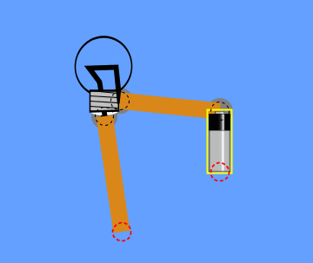 b.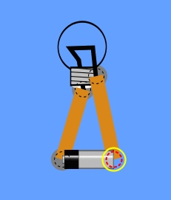
c.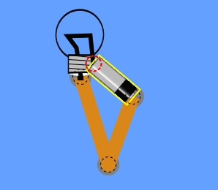 d.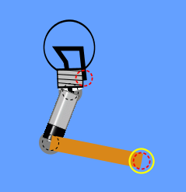

- What do you notice about the formation of a successful pathway (lightbulb did light up)?

- What do you notice about the formation of an unsuccessful pathway (lightbulb did NOT light?

- How do you make the light bulb light up?

Explanation Phase

Aim: Create a rule that describes the conditions needed to light a bulb and complete a circuit. Explain your answer and check with a teacher before proceeding.

We will call a successful pathway that allows electricity to flow through and light a bulb a complete circuit.

Please create a complete circuit on the sim.
Your screen should look similar to the one below:

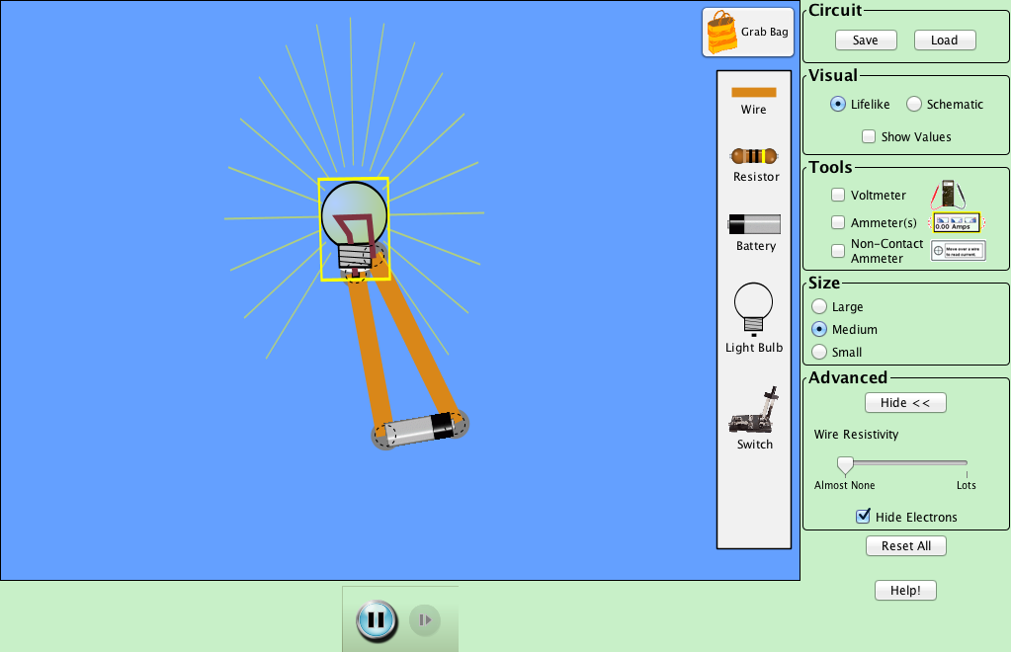
Once you have successfully lit up a bulb, under the Advanced menu make sure to uncheck “Hide Electrons”. You will see something similar to the image below:
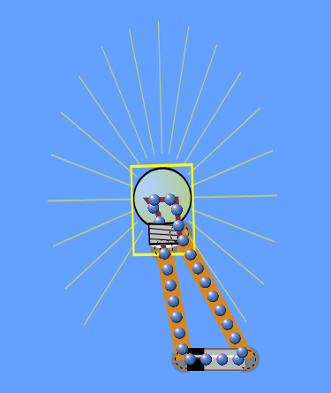

- What do you notice about the movement or flow of the blue circles or electrons?

- Where do you think they are coming from (source)?

- Right-click the battery and select “reverse”. What happens to the electron flow? Which end are the electrons coming from?

- What do you think the wire is made of? Do you think the material matters?

Concepts:

In order to light the bulb, the electric current (flow of electrons) needs a complete or closed pathway to travel from the source (battery) to the load (light bulb).
Electrons leave from only one end of the battery.

Application Phase
Please create the formation in the following picture in your sim. This is an incomplete circuit.
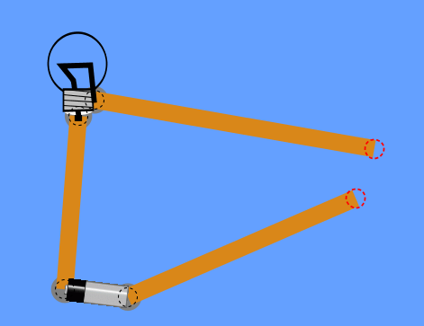
Click on the “Grab Bag” button on the top-right corner of the screen. A window should pop up with a list of items. Select one item at a time to put in the space between the two wires in order to find out if it completes the circuit and lights the bulb.
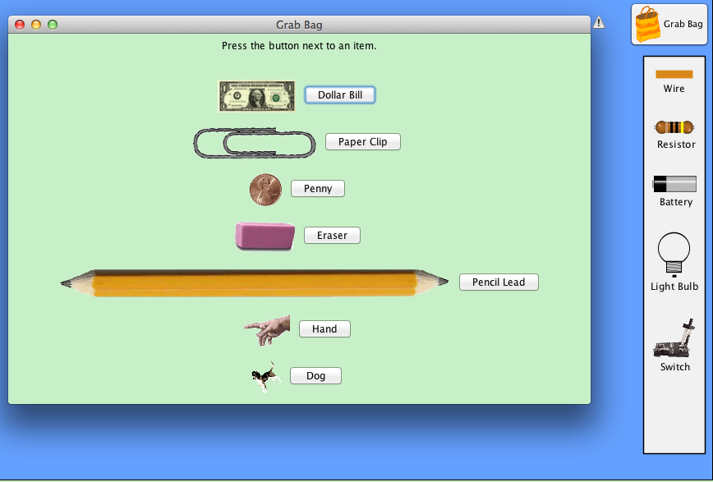

Make predictions about which objects you think will complete the circuit. Put an “X” in the box of your prediction.

Predictions:
Item | Completes Circuit | Does Not Complete Circuit
Dollar Bill
Paper Clip
Penny
Eraser
Pencil Lead
Hand
Dog

Please attach the objects one at a time between the two wires and find out which one lit the bulb. Record the results in the chart below by putting an “X” in the right box.

Results:
Item | Completes Circuit | Does Not Complete Circuit
Dollar Bill
Paper Clip
Penny
Eraser
Pencil Lead
Hand
Dog

How is your prediction the same as or different from the results?
Concepts:

1. When an item placed into the circuit results in the bulb lighting up, we can call that item a conductor.

2. When an item placed into the circuit does not result in the bulb lighting up, we can call that item an insulator.

Conclusions:

What is needed to form a complete circuit and to light a bulb?
How do conductors and insulators placed between the wires affect a circuit?
Modify your previous rule for the conditions needed to complete circuit to include conductor and battery.

