Title: The Speed of Particles in the Different States of Matter
Marlene Mosley

Introductions
In this activity you will investigate the physical science of how the three states of matter: solid, liquid and gas when varying the temperature changes the behavior of particles. You will be comparing particles in the three different phases.

1. Click this link: http://phet.colorado.edu/
This is a screen shot of the website:
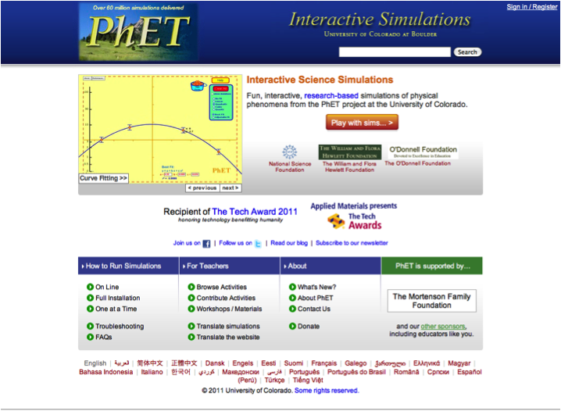
2. Click the “Play with sims” button.
3. Click “New Sims” -> Click “States of Matter: Basics”->Click “Run Now!”
4. It will take time to load and then this screen appears:
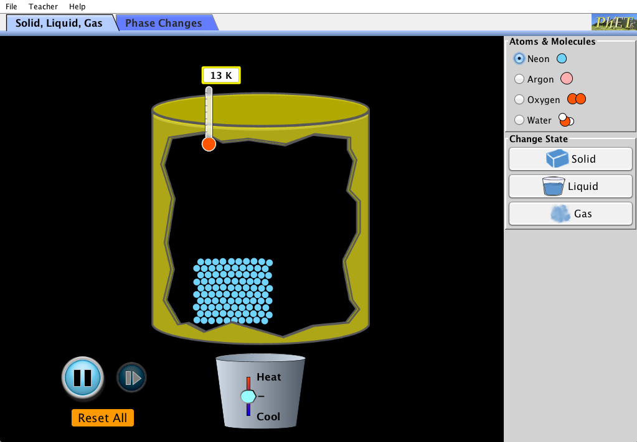
Switch between this document and the sim to complete the activity.

Exploration Phase
- Look at the images below, make a prediction which phase you think this matter is in (remember matter is made up of smaller particles which we call atoms and molecules):

Matter | Prediction  (Solid, liquid or gas) | Observation  (Solid, liquid or gas) | Rank the speed of the particles 1-5. (1 being the slowest, and 5 being the fastest)
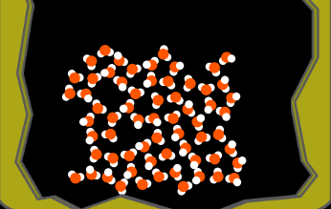
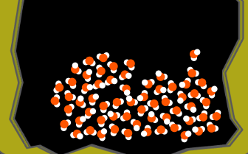
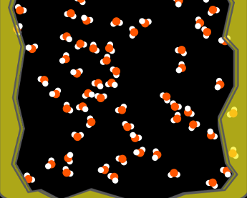

2. Go back to the sim and click on the “Teacher” button on the top left, and make sure your temperature is set on Celsius (ºC).
3. Click on the “Oxygen” button on the top right under “Atoms & Molecules”
4. Click on the “Solid” button on the right under the “Change State,” look at the previous images above in the chart, and record which image is the solid.
5. Repeat step 4 for “Liquid” and “Gas”

Questions
- Describe the small particles moving in the solid state based on the speed rank you observed?

- Describe the small particles moving in the liquid state based on the speed rank you observed?

- Describe the small particles moving in the gas state based on the speed rank you observed?

Explanation Phase

Aim: Define the outside factor that changes solids to liquid then to gas. Describe the outside factor used to change a solid to liquid then to gas.

Here are some concepts:

Atoms and molecules are in a solid-state act differently then when they are in a liquid and gas state.

Click on “Reset All” button and you are still on the oxygen click on the “solid” change state. Use the sim and fill in the blanks of the following table for two different columns of 7 different temperatures and record what you observe. What is the temperature at this state? _________________. Take a snapshot, press “command + Shift + 4” at once to take a screenshot. Place image below:

Move the temperature either up or down underneath the particle.

 | Temperature  (Celsius) | Rank the speed of the particles 1-7. (7 being the slowest, and 1 being the fastest) | Temperature  (Celsius) | Rank the speed of the particles 1-7. (7 being the slowest, and 1 being the fastest)
1 | -260 |  | 20
2 | -206 |  | -50
3 | -186 |  | -80
4 | -166 |  | -110
5 | -146 |  | -140
6 | -126 |  | -170
7 | -106 |  | -200

What variable changes? Come up with a definition of what happens to the atoms and molecules of the oxygen.

At which temperature are the molecules the farthest apart from one another? When are they the closest? Compare the rate of the molecule to the temperature (include vocabulary like increase and decrease).

Click the “reset all” button, and return it to its original state as you had above. Click on the “Liquid” button under change state. What is the temperature at this state? _________________. Take a snapshot, press “command + Shift + 4” at once to take a screenshot. Place image below:

Do the same task as you did above but for the liquid state.

 | Temperature  (Celsius) | Rank the speed of the particles 1-7. (7 being the slowest, and 1 being the fastest) | Temperature  (Celsius) | Rank the speed of the particles 1-7. (7 being the slowest, and 1 being the fastest)
1 | -260 |  | 20
2 | -206 |  | -50
3 | -186 |  | -80
4 | -166 |  | -110
5 | -146 |  | -140
6 | -126 |  | -170
7 | -106 |  | -200

At which temperature are the molecules the farthest apart from one another? When are they the closest? Compare the rate of the molecule to the temperature (use words like increase and decrease).

Compare the solid and liquid states. What did you notice that was similar and what did you notice was the same?

Lastly, click on the “gas” button. What is the temperature at this state? _________________. Take a snapshot, press “command + Shift + 4” at once to take a screenshot. Place image below:

 | Temperature  (Celsius) | Rank the speed of the particles 1-7. (7 being the slowest, and 1 being the fastest) | Temperature  (Celsius) | Rank the speed of the particles 1-7. (7 being the slowest, and 1 being the fastest)
1 | -260 |  | 20
2 | -206 |  | -50
3 | -186 |  | -80
4 | -166 |  | -110
5 | -146 |  | -140
6 | -126 |  | -170
7 | -106 |  | -200

At which temperature are the molecules the farthest apart from one another? When are they the closest? Compare the rate of the molecule to the temperature (use words like increase and decrease).

Compare the liquid and gas states. What did you notice that was similar and what did you notice was the same?

Application Phase

Repeat previous steps, but this time you will investigate the atoms and molecules of “Water.” Click on the “solid” button. What is the temperature at this state? _________________. Take a snapshot, press “command + Shift + 4” at once to take a screenshot. Place image below:

Record your data below.

 | Temperature  (Celsius) | Rank the speed of the particles 1-7. (7 being the slowest, and 1 being the fastest) | Temperature  (Celsius) | Rank the speed of the particles 1-7. (7 being the slowest, and 1 being the fastest)
1 | -260 |  | 20
2 | -206 |  | -50
3 | -186 |  | -80
4 | -166 |  | -110
5 | -146 |  | -140
6 | -126 |  | -170
7 | -106 |  | -200

At which temperature are the molecules the farthest apart from one another? When are they the closest? Compare the rate of the molecule to the temperature (include vocabulary like increase and decrease).

Click on the “liquid” button. What is the temperature at this state? _________________. Take a snapshot, press “command + Shift + 4” at once to take a screenshot. Place image below:

Record your data below.

 | Temperature  (Celsius) | Rank the speed of the particles 1-7. (7 being the slowest, and 1 being the fastest) | Temperature  (Celsius) | Rank the speed of the particles 1-7. (7 being the slowest, and 1 being the fastest)
1 | -260 |  | 20
2 | -206 |  | -50
3 | -186 |  | -80
4 | -166 |  | -110
5 | -146 |  | -140
6 | -126 |  | -170
7 | -106 |  | -200

At which temperature are the molecules the farthest apart from one another? When are they the closest? Compare the rate of the molecule to the temperature (use words like increase and decrease).

Compare the solid and liquid states. What did you notice that was similar and what did you notice was the same?

Click on the “gas” button. What is the temperature at this state? _________________. Take a snapshot, press “command + Shift + 4” at once to take a screenshot. Place image below:

Record your data below.

 | Temperature  (Celsius) | Rank the speed of the particles 1-7. (7 being the slowest, and 1 being the fastest) | Temperature  (Celsius) | Rank the speed of the particles 1-7. (7 being the slowest, and 1 being the fastest)
1 | -260 |  | 20
2 | -206 |  | -50
3 | -186 |  | -80
4 | -166 |  | -110
5 | -146 |  | -140
6 | -126 |  | -170
7 | -106 |  | -200

At which temperature are the molecules the farthest apart from one another? When are they the closest? Compare the rate of the molecule to the temperature (use words like increase and decrease).

Compare the liquid and gas states. What did you notice that was similar and what did you notice was the same?

Conclusion: Compare how the atoms and molecules move in the solid, liquid and gas states. What variable must change in order for this change in matter to occur?

