Circuit Construction Kit (DC Only), Virtual Lab Name:

Goals: Practice drawing circuit diagrams

Reinforcement of Ohm’s Law

Introduction of Series and Parallel circuits

Make sure to explore/click around- if you do it will make your job much easier!

For this assignment- draw bulbs as resistors.

- Create a Circuit using 1 battery, 1 bulb, and 1 switch. Draw a circuit diagram of it below.

- What is the Voltage of the battery above? What is the current running through? What is the resistance of the bulb? (Hint- What tools can you use to find this information)
Students can use the voltmeter and the ammeter to find the voltage and current and then calculate the resistance based off of Ohm’s Law. They may need to be guided to the voltmeter and ohm meter- my class has used them before in the real world first.

- Set up a circuit where there are three bulbs and three switches in use. Create a circuit (and draw the circuit diagram below) where when one switch is open, all the bulbs go out.

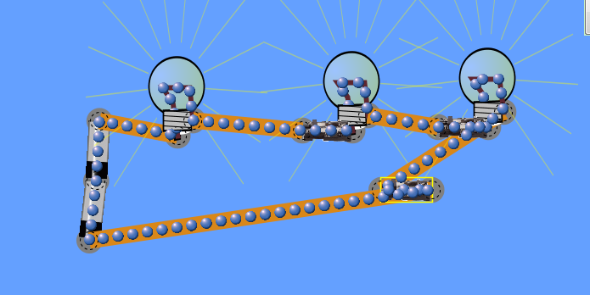

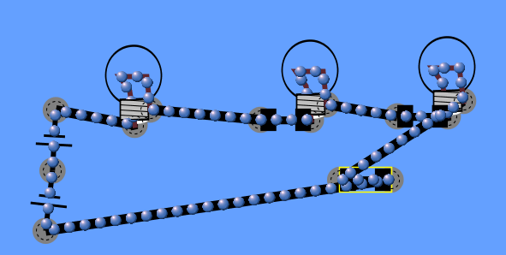

- Set up a circuit where there are three bulbs and three switches in use. Create a circuit (and draw the circuit diagram below) where when one switch is open, only one bulb goes out.

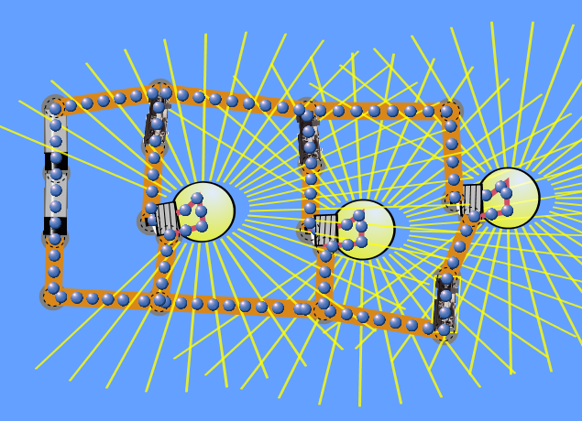
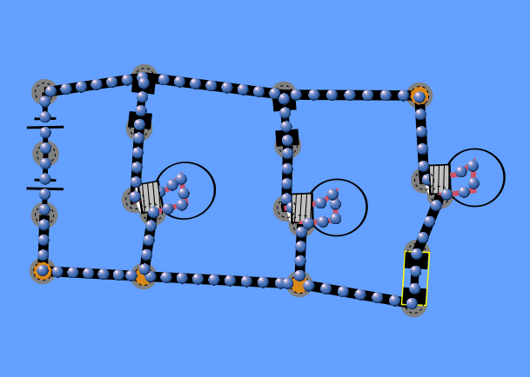

- Create again a circuit where there are 4 bulbs in a “Series”. Draw a circuit diagram below and label the bulbs “brightness”. (Keep Diagram/structure for 5, you will need it for #6)
Brightness should be the same
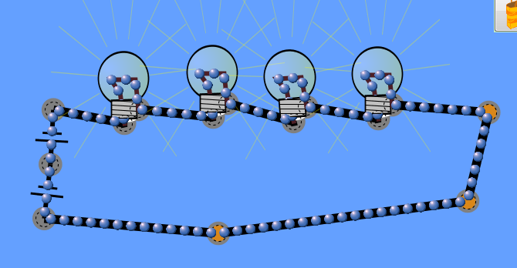
- Now change the diagram do the brightness is different in some blubs.
Batteries could go into some loops and not in others- increasing the electrical potential energy. Current can be split.

- Use the circuit above what can you do (adding/taking away switches, bulbs or wires) to increase the brightness of the bulbs. Draw two circuits that do this, and underneath write and explanation of what you did to increase the brightness.

Tasks that could fit the description- Increase the number of batteries (Electrical Potential Energy/Volts), Decrease the resistance-on the sliding scale, or take away the number of blubs.

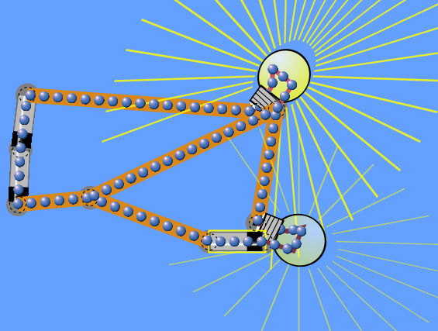

- Create a circuit diagram of a short circuit (we haven’t covered it in class, but what do you think it means based on your background knowledge-or search it online!).
A good sign of this is the wire turning on fire!!
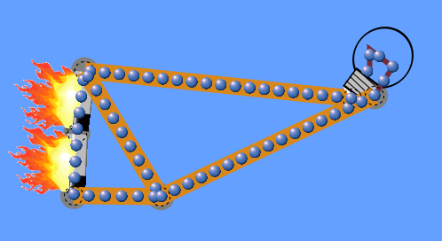

- How many resistors is equivalent to a light bulb? (Make sure to brainstorm different ideas to find that out.)
The neutral settings are 10 ohms to 10 ohms.

