Learning Goals:
- I will be able to measure wavelength on a transverse wave.
- I will be able to explain how amplitude is not related to frequency or wavelength.
- I will be able to explain how frequency and wavelength are inversely related.

Set Up
Click on the Wave On A String Link. (HTML5)
- Set the top controls to Pulse and Fixed End.
- On the bottom menu:
  - Move the Damping slider to None
  - Keep the Tension at High
  - Check mark Rulers, and move the rulers to look like the image below.
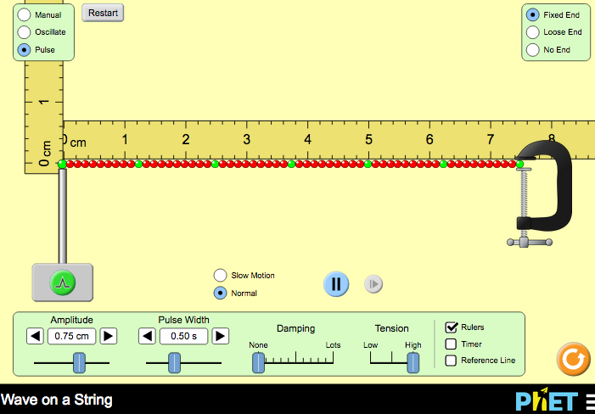
The green button will send a single pulse:
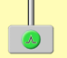
First Activity: Amplitude
- Hit the green button once to generate a pulse. What happens to the pulse when it reaches the fixed end?
- To stop the wave but keep all settings the same, click Restart.
- Which slider will adjust the starting height of the wave?
- What is the maximum height possible?
- Which slider makes the height of the wave decrease as it travels?

Second Activity: Wavelength and Amplitude
  - Set your controls to and .
  - Select Slow Motion
  - Set amplitude at 0.50 cm and frequency at 1.00 Hz.
  - Use the pause button to stop the wave for easier measurement.

- Move the horizontal ruler to measure the wavelength. Remember: Crest to Crest or Trough to Trough. Such as in the image below.
Each tiny mark on the ruler equates to 0.2 cm
Wavelength #1 = _________ cm
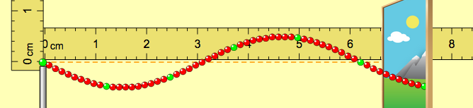
- Double the amplitude so it is now at 1.00 cm, but keep the frequency at 1.00 Hz.
- Restart the wave. Play the oscillation, then pause it.
- Move the horizontal ruler to measure the wavelength. Wavelength #2 = _____cm
- How does the wavelength #1 compare to wavelength #2?

- Did changing the amplitude affect the wavelength?
Third Activity: Wavelength and Frequency
  - Set your controls to and and
  - Keep amplitude at 1.00 cm and change the frequency to 1.50 Hz.
  - Use the pause button to stop the wave for easier measurement.

- Move the horizontal ruler to measure the wavelength. Wavelength #3 = _____cm
- Set the frequency so it is now at 2.00 Hz, but keep the amplitude at 1.00 cm.
- Restart the wave. Play the oscillation, then pause it.
- Move the horizontal ruler to measure the wavelength. Wavelength #4 = _____cm
- Set the frequency so it is now at 3.00 Hz. Keep the amplitude at 1.00 cm.
- Restart the wave. Play the oscillation, then pause it.
- Move the horizontal ruler to measure the wavelength. Wavelength #5 = _____cm
- Summarize your data in the chart below.
Data # | FREQUENCY (Hz) | WAVELENGTH (cm)
#1 | 1.00 Hz
#2 | 1.00 Hz
#3 | 1.50 Hz
#4 | 2.00 Hz
#5 | 3.00 Hz

- Why did the summary chart not include any information about the amplitude?

- Did changing the frequency affect the wavelength?
- As the frequency increased, what happened to the wavelength?

- What happens to the wavelength of a wave if the frequency is doubled?

- What happens to the wavelength of a wave if the frequency is tripled?

