Table of Contents
Introduction:
Part A: Gather and Filter information from NGSS and PhET Interactive Simulations
Step 1: Select PEs and PhET Simulation(s) that work together
1a. Select PEs & Identify associated Clarification Statements & Assessment Boundaries.
1b. Evaluate PhET sims for alignment with PEs, Clarifications, Boundaries
Step 2: Collect and Filter NGSS specifics for lesson
2a. Identify the three dimensions that are coded to the PEs.
2b. Use DCI grade band progressions and/or Appendix E for previous and future grades.
2c. Select additional Science and Engineering Practices that support your chosen DCIs and CCs.
2d. Select related Common Core Mathematics Standards (CCSS-M) and Common Core Literacy Standards (CCSS-L) related to the PEs selected.
Part B: Plan your lesson using steps in Part A and PhET’s teacher tools
Step 3: Refine lesson focus
3a. Break the DCI into lesson segments
3b. Blend the Practices, DCI Target Segments, and CCs into lesson-specific PEs and sequence the lesson progression.
Step 4: Determine evidence for formative and summative assessment
Step 5: Develop a Big Idea and Lesson Plans
Step 6: Re-examine lesson

Introduction:

This template defines a process for designing lessons based on the Next Generation Science Standards (NGSS) and PhET research-based guidelines for activities. The template was developed by middle school and high school teachers in a PhET/NGSS workgroup that met during the summer of 2014. The teachers in the workgroup had a diverse background in these areas: previous use of PhET for inquiry activities, grade level focus, science content focus, experience with NGSS aligned activities, and years of teaching experience.
The template consists of several steps that are listed in an order that we found useful. The design process is a cycle, however, and we found that we revisited steps; adding ideas, using strikethrough to remove items, and using highlight to focus on items. The process is somewhat iterative - back and forth between the standards, the sims, and the steps. Some teachers liked to organize their information in tables, others preferred lists. Example tables are provided, and can be adapted according to personal preference. The use of lists is shown in some parts of the HS Energy Skate Park Lesson Design.

Part A of the template demonstrates ways to gather and organize information from NGSS and PhET. This information will form the basis of your lesson. Part B outlines ways to help you design your lesson in alignment with part A. The HS Energy Skate Park Lesson Design demonstrates how a teacher might use the template when creating an Energy Lesson.

The process is an adaptation of the 10 steps from “Planning Instruction to Meet the Intent of the Next Generation Science Standards” by Joseph Krajcik et al, the standards listed on the all integrated with the NGSS Framework and PhET Teaching Resources. All of the resources are open-source.

Part A: Gather and Filter information from NGSS and PhET Interactive Simulations

Step 1: Select PEs and PhET Simulation(s) that work together

1a. Select PEs & Identify associated Clarification Statements & Assessment Boundaries.
The four Science Disciplines are Science, Earth and Space Science, Physical science, and Engineering Design. When you open the NSTA hub - NGSS standards, it will look like Figure 1. Notice that the first three science disciplines each have a column, but the Engineering Design is at the bottom of each grade band. Select your grade band and click on your topic of interest, such as MS energy. The Standards by Topic page will open (Figure 2); it lists the PEs for that topic. The PE numbers are at the end of each statement.
Figure 1 NGSS Standards Figure 2 Standards by Topic
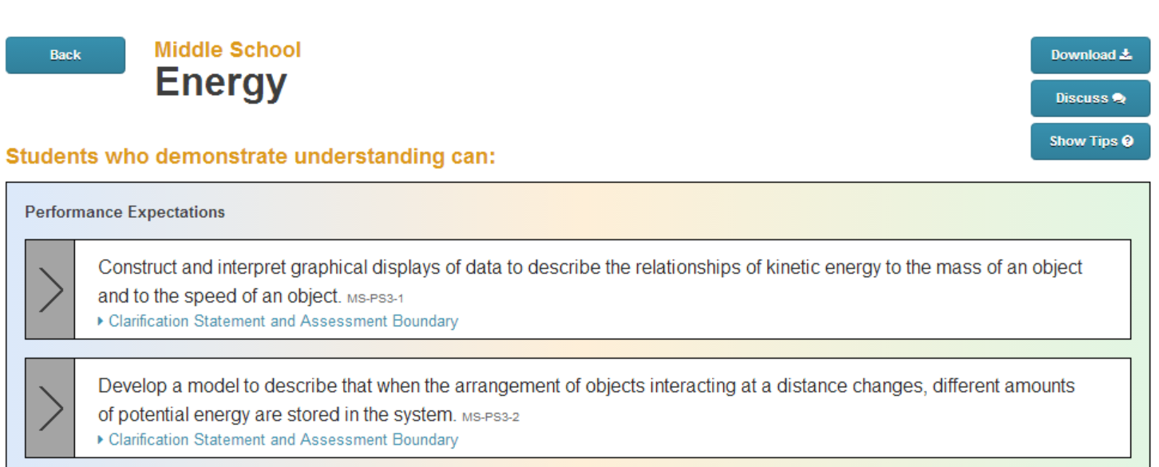
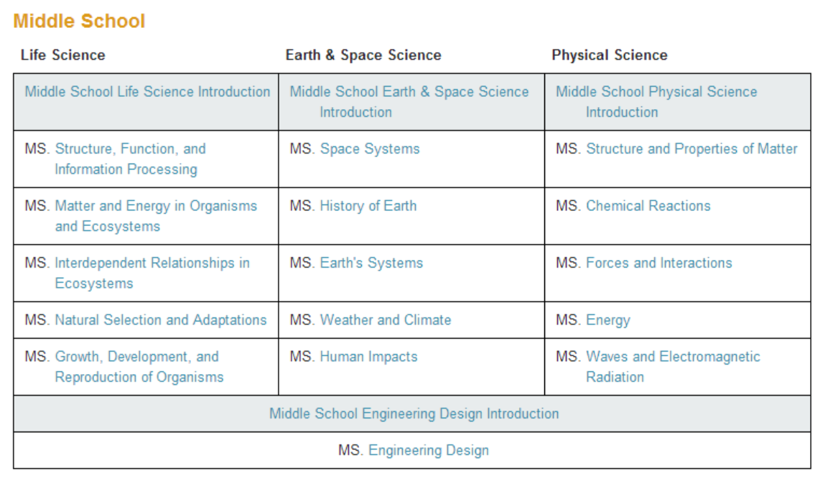

Click on the link under the Performance Expectation (PE) to see the Clarification and Assessment Boundaries (Figure 3). Copy the PE and add the Clarification Statements and Boundaries.
Figure 3 Standards by Topic with one expanded PE shown
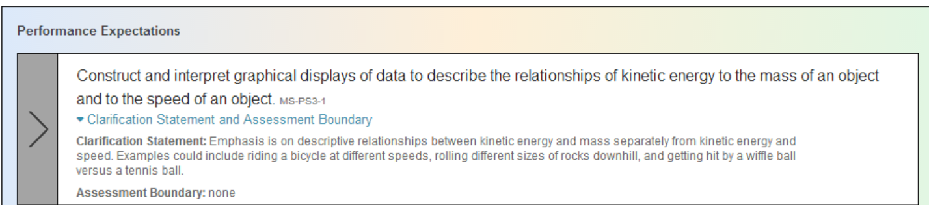

1b. Evaluate PhET sims for alignment with PEs, Clarifications, Boundaries
Use PhET website keywords or topic list (FIgure 4). Check Main topics and/or Learning Goals by scrolling on sim page (Figure 5) to see if the sim matches the PEs, clarification statements and assessment boundaries. Use Table 1b (below) to help organize why you chose the sim and the parts of the sim that you think you will use to meet NGSS information in 1a. This table is meant to help you brainstorm. Later in the design process, you may choose to highlight parts you want to use and strikethrough parts that will not be part of this lesson.

Table 1b: PhET Sim Selection
Sim Name | Main Topics | PhET Sample Learning Goals | Reflection and Reasoning

Figure 4 - Key Word Search and Topic List Figure 5 - Energy Skate Park sim page
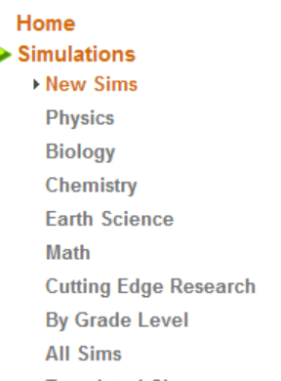
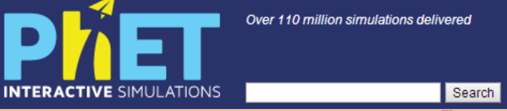
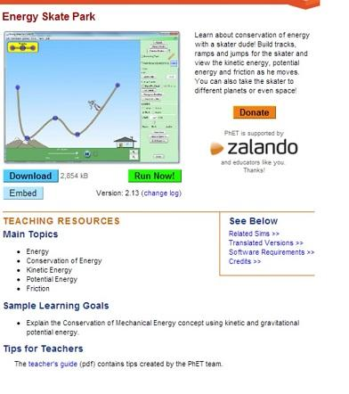
on PhET “Play with Sims” page

Step 2: Collect and Filter NGSS specifics for lesson

2a. Identify the three dimensions that are coded to the PEs.
Use Table 2a to organize the DCI, Practice, and CC coded to the PEs you chose.
Table 2a: PE Dimensions
Science and Engineering Practices | DCI | Crosscutting Concept( CC)

The DCIs, CCs, and Practices are found using the instructions below . These correlations are suggestions from NSTA, more can be added (Step 2c, below, has ideas for finding more). Copy the highlighted parts of each DCI. Any coding with an ending letter (example: DCI - PS3.A) refers to the specific DCI, whereas any coding that ends with a number such as MS-PS3-1 refers to the selected Performance Expectation. Then read each item and highlight the parts you want to address in this lesson and strikethrough the parts not addressed. The purpose is to identify what you are addressing in this lesson and making it easy to see what you need to address in another lesson.
Instructions for finding Dimensions recommended by NGSS
2a1. From Standard by Topic screen, click on the black arrow on the left (Figure 6) to select one PE.
2a2. Scroll down the page to the colored columns (Figure 7). For the specific PE selected, Science and Engineering practices, DCIs, and CCs have been recommended by highlighting.
2a3. Click on any highlighted element to pull up grade band endpoints. (FIgure 8 - shows only an example of clicking on a highlighted Practice)

Figure 6 One PE selected on Standards by Topic page
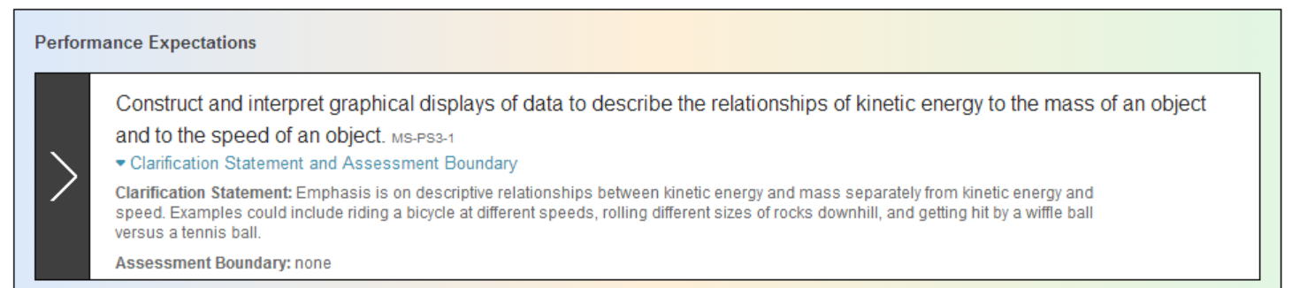

Figure 7 Correlated Practices, DCsI, and CCs found by scrolling
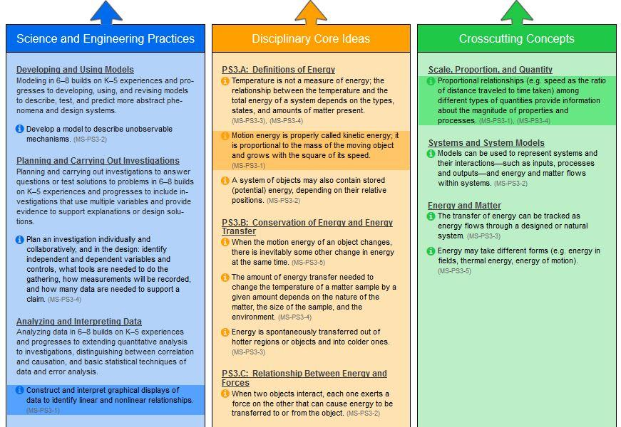

Figure 8 - shows only the Science & Engineering Practicesgrade band endpoints
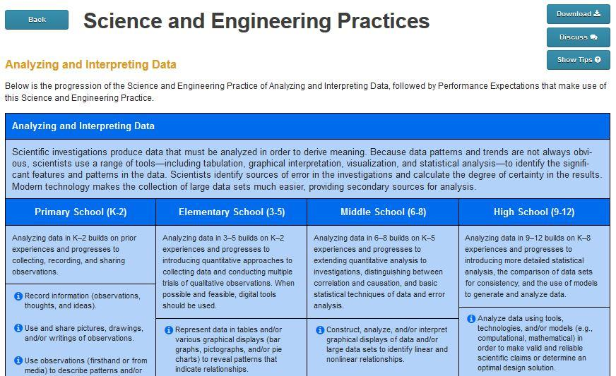

2b. Use DCI grade band progressions and/or Appendix E for previous and future grades.
This step focuses on DCIs only and helps identify what students should know from previous grades, the grade band you are targeting, and future grades. Use the same instructions as 2a (grade bands are shown in Figure 8) or see NGSS Appendix E (FIgure 9) where the grade band DCIs are summarized. High School teachers may want to use College readiness standards for Future column or not use the column. Some teachers like to think of enrichment ideas during this step, so the column is included in table 2b..

Table 2b: Grade Level Bands DCIs
Previous Grade DCIs | Target DCI | Future Grade DCI (not for HS) | Enrichment

Figure 9 Appendix E example
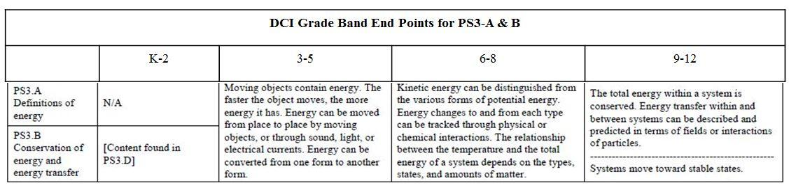

2c. Select additional Science and Engineering Practices that support your chosen DCIs and CCs.
In Step 1, you found items that have been recommended. In this step, you will look for other Practices. The highlighted materials on the Hub are designed to show good examples for integration of the three dimensions. However, more options are possible and identifying them can help your course development especially since PhET sim design principles enable leveraging many Practices. You may want to add these ideas to your Table 2a.There are 2 ways to get more information from NSTA/NGSS hub:
1) To find ideas quickly, start at NSTA/NGSS hub, select your topic, then look at all the Practices listed in the blue column on the Standards by Topic page. Not all Practices will be listed, but some are recommended.
OR 2). For a more broad exploration of Practices, use Appendix F. From the NSTA/NGSS hub starting page, use the right hand navigation menu to select Appendices - Science and Engineering Practices (Appendix F), then select each Practice to see grade band detail. . Figure 10 shows a grade band progression table of condensed Practices from page 17 of Appendix F.
Figure 10 Example of Practices Progression (condensed version)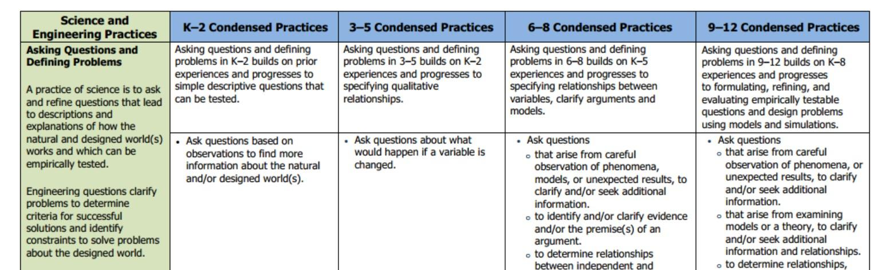

2d. Select related Common Core Mathematics Standards (CCSS-M) and Common Core Literacy Standards (CCSS-L) related to the PEs selected.
Scroll down on Standards by Topic page (Figure 6) to find the Common Core Mathematics and Literacy Standards that have been identified by NSTA. You may find it useful to copy and paste these into your design while you are on the Hub and filter later. If it is difficult to identify the ones you want to use, come back to this step after considering the lesson level expectations.

Part B: Plan your lesson using steps in Part A and PhET’s teacher tools

Step 3: Refine lesson focus

3a. Break the DCI into lesson segments
The purpose of this section is to sort the parts of the current standard (the DCI, practices, and CCs) into parts that will be targeted by this lesson, the parts that have been covered in previous lessons (generally in this grade-band), and what must be covered in future lessons (in the grade-band). Depending on the complexity of the standard, the current lesson may address all parts of the standard and this step can be skipped.
Make a table of grade band DCIs and put a copy of the target DCI(s) in every column. Add separate rows to the table for each targeted DCI. Then, read each item. In the “targeted lesson” column, highlight the parts you want to address in this lesson and strikethrough the parts that will be done before or after this lesson. Repeat this editing in the other columns, for previously covered items and those that must be addressed in future lessons. You may also include DCIs not identified in Part A, as needed. Remember that the NGSS is meant to be used as an integration of components. Since NGSS is new and students may have just begun to learn this way, it might help your course sequence to identify DCI segments from previous grade bands or topics that must precede or follow this lesson. For example, you might be addressing Energy, but a knowledge of Forces may be needed, so you could add a DCI not identified in Part A.

Table 3a: DCI Analysis for grade level

DCI Identification Code | DCI Segments Previously Covered in this Course | DCI Segments Targeted in this Lesson | DCI Segments Still to be Addressed in Course
(For example, PS3-A) | Paste all DCI’s from Table 2a here. Filter by highlights and strikethroughs. | Paste all DCI’s from Table 2a here. Filter by highlights and strikethroughs. | Paste all DCI’s from Table 2a here. Filter by highlights and strikethroughs.

3b. Blend the Practices, DCI Target Segments, and CCs into lesson-specific PEs and sequence the lesson progression.
Use Table 3b as a tool to organize and blend the dimensions pieces identified for your lesson. Copy and paste the targeted DCI segments (from column 3 of table 3a), sorting them into a logical lesson-level progression. Reflect on the sim design to help you put segments in order. The sims are designed and tested to provide a logical progression by the use of scenes and tool location. Using the sim in the order for which it was designed will enable a more student-centered approach to your activity. Put each DCI Segment in a separate row, and then label the rows for easy reference (e.g. Part A, Part B, etc.). [See HS Energy Skate Park lesson for example.]

Next, organize the other dimension pieces to make sense for your lesson. From the identified Practices (Table 2a and Step 2c), select one or two practices that blend well for each DCI segment you have placed in column 2 of Table 3b. Also, select one or two CCs (from step 2a) that blend with each DCI Component in Table 3b. Continue to reflect on the sim to make sure the chosen practices are a good match. Blend key words from each of the first 3 columns in the table to develop lesson-specific expectations for each DCI Segment. We found that during the process of making this table, ideas for learning came to mind and we wanted to make notes, so we added the Learning Ideas column. Some may find this useful and others may not want to use it.

Table 3b: Develop Lesson Level PEs
Practices | DCI Target Segment(s) | CCs | Lesson-specific PEs | Learning Ideas
Do after sequencing the Target DCI Segments. Add specific Practices that align with DCI segment in each row. | Do this column first. Copy Target Segments (column 3 of Table 3a). Sort into a logical sequence, and put each individual segment (topic) into its own row. It is helpful at this point to label each row (Part A, Part B, etc.) | Do after sequencing the Target DCI Segments.  Add specific CCs that align with DCI segment in each row. | Do after the first 3 columns are done. Using words from each column, blend the 3 columns to write a performance expectation for this specific DCI segment. | Optional.  Record specific lesson ideas.

Step 4: Determine evidence for formative and summative assessment

Table 4 is designed to identify very specific products that students can use to demonstrate they have met the performance expectation using the lesson-specific PEs written in Table 3b. Also, this is a good place to think about prompts and formative assessments you will use to help students during the activity.
4a. In the first column, just write the segment names in separate rows (Part A, Part B, etc.)
4b. For column two, copy Lesson-specific PEs from the fourth column table 3b into the appropriate rows of Table 4. These are general learning objectives for the lesson.
4c. Write one or more PhET learning goals in each row. These provide both specific tasks for students to aim for and are in student-friendly language that can be used on the actual assignment . These should align with PhET activity design and facilitation research base. See PhET’s Goals for Teachers and Students, Approach for Guided Inquiry, Activity Design for MS and Elementary, and Facilitation Strategies. More information to help teachers will soon be available on the PhET website.
4d. Write specific performance evidence in column four. Use the Lesson-specific PEs and PhET Learning Objectives to develop acceptable evidence of student learning, including formative and summative. Also, consider the Math and Literacy standards from 2b when defining evidence. We found that we often wrote extra notes below the table to help us with the Teacher Directions and Student Directions.
4e. The last column is optional. We found it useful like the "Learning Ideas" column in Table 3b. This column is for brainstorming specific prompts, cues, and assessment question ideas that will help elicit evidence of student progress toward meeting the PEs.

Table 4: Assessment Evidence

Lesson Segment | Lesson  Specific PEs | PhET Learning Objectives (Student-Friendly Language) | Specific Performance Evidence | Cues, Prompts & Assessment Ideas (to Elicit Evidence)
Add row labels from here (Part A, Part B, etc.) | Do first. Copy from column 4 of table 3b, but sort in the order you plan to use. | Rephrase Lesson Level PE into student-friendly language with specific tasks. | What specific evidence will I look for to know that students have met the PE? | What questions can we ask to elicit evidence of student proficiency? What cues will get students to extend and share their thinking? What specific questions could we ask on formative or summative assessments?

Step 5: Develop a Big Idea and Lesson Plans
5a. Decide on one or more Big Idea - the connection with the real world that will motivate student investigations.

Students learn more when they can see that science is relevant to their everyday life. The sims often use images from everyday life, but where possible the activity should explicitly help them relate science to their personal experience and answer fundamental questions about nature. As you write questions, consider their interests, age, gender, and ethnicity and use friendly language. For example, when studying balancing chemical equations the “big idea” might incorporated in the question “When you mix baking soda and vinegar, why does it stop bubbling after a while?” A prompt to start the lesson might use a sandwich metaphor and you might ask, “If you were talking to your friend, Rose, about making sandwiches, what would you tell her to do to figure out how many sandwiches she can make from 10 pieces of bread?” A big idea question can be used to start a lesson and elicit student interest, but it can also be used to assess understanding after the lesson is finished. A prompt can be used to elicit prior understanding at the start of a lesson.
Big Idea examples:
- Using Energy Skate Park: “How do designers know how high to make the hills on a roller coaster?” or “How does a perpetual motion machine work? Why hasn’t someone developed a system like this for cars so we don’t need as much gas?”
- Using Energy Forms and Changes: “How can you explain what happens when you put something cold like ice into something warm like hot tea?”
- Using Eating and Exercise: “How does what you eat and what you do during the day affect your health?
- For Reactants, Products, and Leftovers When you mix chemicals to make a reaction, does everything get used up to make products? What do you need to know to answer this?
- For Electric Field Hockey: “How can objects apply forces to one another, even when they are not touching?” or “Do fields affect people?

b. Make a lesson plan, that includes teacher and student directions, by bundling elements from the previous steps.
We did not make templates for these since circumstances vary widely and many teacher are require to use a specific format. Step 4, which incorporates both NGSS and PhET ideas, should enable you to build quality lessons.

Step 6: Re-examine lesson
Curriculum examination can occur at many levels and there are many resources you could use. Here we present a few ideas. Review your lesson design and teacher and student directions. As you reflect, considering things like:
- Do the student directions match the PhET sim and encourage student-centered engagement?
- Is the lesson relevant to students?
- Will the sequence help students recognize what they already know and help them expand their knowledge while tying new to old?
- Are the learning goals (content, practices, and crosscutting concepts) clearly stated and do they match the NGSS?
- Does the lesson provide an appropriate path to meet the Dimensions identified in Part A?
- Are the Lesson Design, Teacher Directions, and Student Directions written so another teacher could understand how they work together?
After using the lesson with students, make notes about things to revise for next time. Consider sequencing, prompts, assessments, etc. Although self-reflection is useful, consider asking for a peer review.

