TITLE
Intermolecular forces and molecules

AUTHORS
Ted Clark (The Ohio State University)
Julia Chamberlain (University of Colorado Boulder)

COURSE
General Chemistry

TYPE
Interactive Lecture Demonstration Guide

TEACHING MODE
Lecture Demonstration

LEARNING GOALS
Students will be able to:
- Use VSEPR theory to construct common molecules.
- Sketch electron density and identify partial charges based on molecule geometry and electronegativity.
- Distinguish between bond and molecule dipoles.
- Classify molecules as polar or non-polar.
- Compare and contrast permanent and induced dipoles.
- Identify hydrogen-bonding, and discuss its origin in terms of molecule geometry and electronegativity.
- Explain properties, such as boiling or melting point, by considering different intermolecular forces.
- Relate the relative strength of intermolecular forces with melting point or boiling point data, and with particle-level representations of substances at different temperatures.
- Describe the dynamic particle motion in a liquid, including the arrangement and motion of molecules accompanying hydrogen-bonding and ion-dipole interactions.
- Explain ion-pairing at the particle-level, and describe how this affects colligative properties.

COPYRIGHT
This work is licensed under a Creative Commons Attribution 4.0 International License.
This license allows users to share and adapt the materials, as long as appropriate attribution is given (with a link to the original), an indication if changes have been made, and an indication of the original licensing.
Intermolecular Forces and Molecules

Different intermolecular forces and their role in phase changes are introduced and investigated by examining molecule geometry, polarity, and charge distribution in molecules.

Placement in course:
- This activity follows the PhET activity “Intermolecular Forces and States of Matter”.
- End of 1st semester or start of 2nd semester of General Chemistry.

Prior knowledge:
- States of Matter, Physical and Chemical Changes
- Lewis Structures, VSEPR-predicted Geometry
- Electronegativity, Bond and Molecular Dipoles, Partial Charges
- Polar and Non-polar Molecules
- Electrostatic forces have been introduced, e.g. to introduce ionic compounds, but may not have been explicitly identified in molecules.

Learning objectives
Simulations | Format | Objectives, concepts
Molecule Shapes | Instructor-led | - Use VSEPR theory to construct common molecules.
Molecule Polarity | Instructor-led | - Sketch the electron density and identify partial charges for different molecules based on molecule geometry and electronegativity.  - Distinguish between bond and molecule dipoles.  - Classify molecules as polar or non-polar.  - Compare and contrast permanent and induced dipoles.  - Identify hydrogen-bonding, and discuss its origin in terms of molecule geometry and electronegativity.  - Explain properties, such as boiling point and melting point, by considering different intermolecular forces.
States of Matter | Instructor-led | - Relate the relative strength of intermolecular forces with melting point or boiling point data, and with particle-level representations of substances at different temperatures.
Sugar and Salt Solutions | Instructor-led | - Describe the dynamic particle motion in a liquid, including the arrangement and motion of molecules accompanying hydrogen-bonding and ion-dipole interactions.  - Explain ion-pairing at the particle-level, and describe how this affects colligative properties.
Resources:
Molecule Polarity: http://phet.colorado.edu/en/simulation/molecule-polarity
Molecule Shapes: http://phet.colorado.edu/en/simulation/molecule-shapes
States of Matter: http://phet.colorado.edu/en/simulation/states-of-matter-basics
Sugar and Salt Solutions: http://phet.colorado.edu/en/simulation/sugar-and-salt-solutions

Keywords:
Electrostatic potential, molecule geometry, VSEPR, dipoles, partial charges, electronegativity, polar and non-polar molecules, intermolecular forces, ion-pairing, phase changes.

Teacher Warm-Up:
Use the sim for 10 minutes before you teach with it to achieve the following goals:

- Find and understand all the controls and what they do. Which will be most useful for illustrating your learning objectives? Make sure you can use the sim to answer student questions and illustrate additional points that come up.
- Practice the actions and pacing for your demonstration using the sim. Make sure you are comfortable explaining what you’re doing while controlling the sim.
- Think about how you will use the sim to engage students in making predictions, observing and experiencing the demonstration, and reflecting on those predictions and observations.

Teacher-Led Activity Description

Benchtop Demonstration – Discussion of Liquid Nitrogen

Consider a container of liquid nitrogen. This liquid is used in industry, in laboratories, and in television and movies.
- Would you describe liquid nitrogen as “hot” or “cold”?
- What happens when the liquid is heated up? Do the molecules move apart, do bonds break within the N₂ molecules, or both?
- Would you say the attractions between N₂ molecules are strong or weak? This room contains a lot of nitrogen gas. Is it easy to vaporize N₂(l)?

Molecule Shapes:

The sim Molecule Shapes allows investigation of VSEPR-predicted geometries for model and real molecules.

- Using the sim, investigate and review common molecule geometries.
- Prompt students to draw the Lewis structures and apply VSEPR theory for molecules like H₂O, CO₂, and SO₂. To check answers, students report the number of bonds and/or lone pairs. Molecules are constructed within the sim to illustrate VSPER theory. These molecular shapes are then summarized on a slide (Slide 1).
- Emphasize that identifying the proper molecule geometry is necessary for determining a molecule’s polarity.
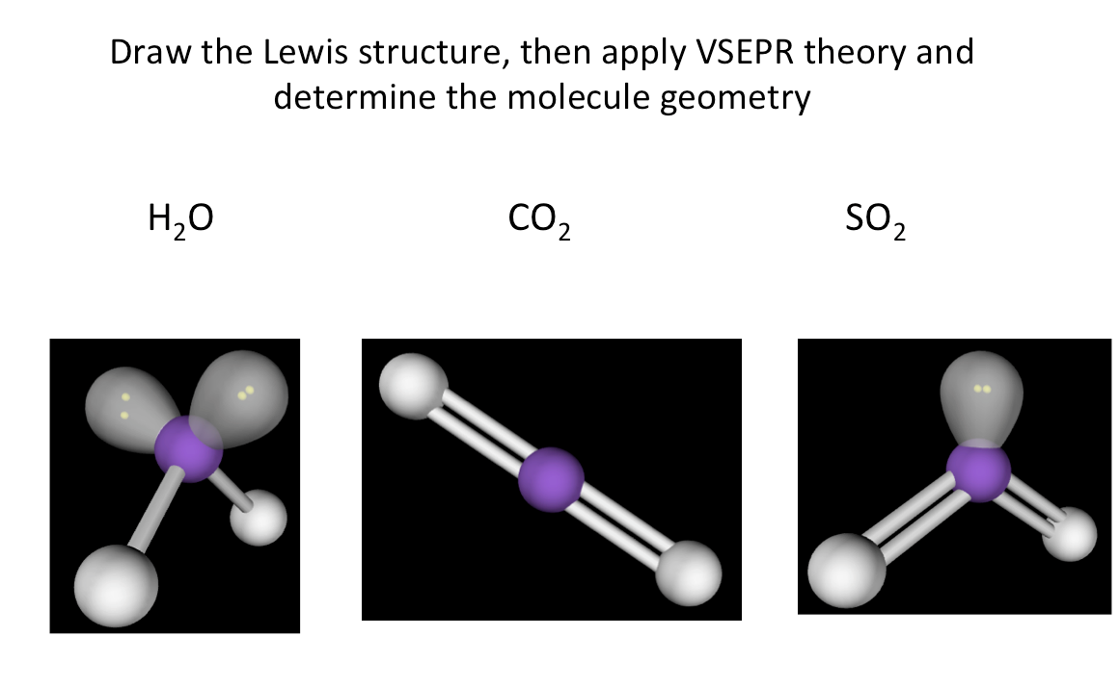
Slide 1: Practice with VSEPR and Determining Molecule Geometry

Molecule Polarity – Three Atoms Screen Part I:

Use the Three Atoms screen of the Molecule Polarity sim to manipulate the electronegativity of, and angle between, the three atoms.

- Keep in mind; you are likely much more familiar with these different representations than your students. As you do this demonstration, explicitly note what various representations communicate, including partial charges, bond and molecular dipoles, and electrostatic potential.

- Use the sim to illustrate how differences in electronegativity lead to bond dipoles as follows:
- Make a change in the sim, e.g. increase electronegativity, and see the response in the sim. This may lead to predictions, such as “given the electronegativity difference, which region is partially negative?” that may be checked within the sim.

- Turn on the electric field, causing a polar molecule to align with the field. Use this to show how the negative region of the molecule becomes aligned toward the positive. Introduce the term dipole moment.

- After using the sim, summarize the information on a slide (Slide 2). Prompt students to discuss how this analysis applies for H₂O, CO₂, and SO₂. Which molecules will rotate and align when placed in an electric field? Return to the sim and check predictions.

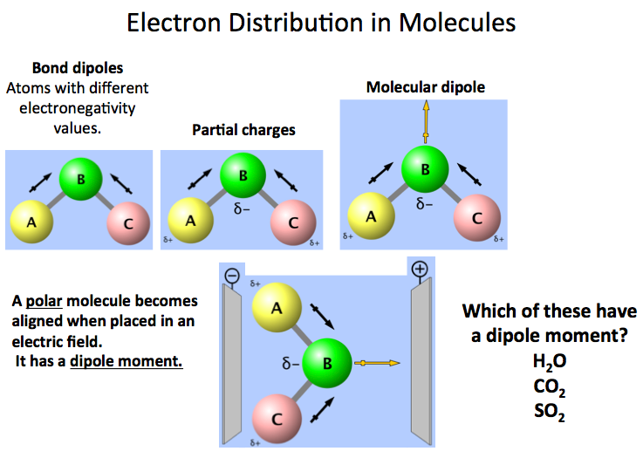
Slide 2: Summarizing Molecule Polarity and Determining Dipole Moments

Molecule Polarity – Three Atoms Screen Part II:

- Students may not understand how a molecule can have bond dipoles but not a molecular dipole. As needed, investigate a molecule (like CO₂) that has bond dipoles but not a molecular dipole.

- Walk students through exploration of the non-polar three-atom model example in the sim:
- Adjust the electronegativity, predict then show the bond dipoles and partial charges.
- Change the bond angle, predict then show the molecular dipole.
- Predict then show the response in an electric field.
- Identify as non-polar
- Summarize findings on a slide (Slide 3)

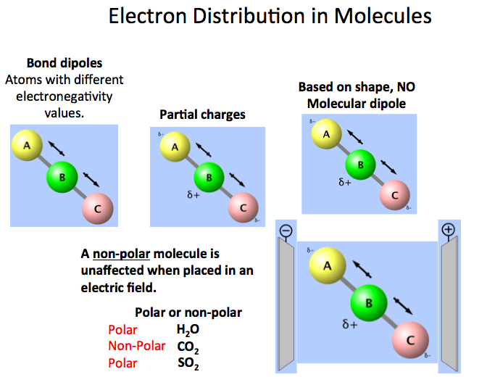
Slide 3: Summarizing Polar and Non-Polar Findings

Molecule Polarity – Real Molecules Screen:

The Real Molecules screen of Molecule Polarity allows the user to investigate various molecules and examine various representations.

- Identify the molecules H₂O, CO₂, and H₂, as polar or non-polar. Prompt students to predict/sketch what the electrostatic potential looks like. Which regions are positive? Which regions are negative?
- Since H₂O has clear positive and negative regions, it is possible to envision how polar molecules are attracted to each other (and “fit” together). This orientation is observed in the States of Matter sim for H₂O(s). It is less clear how/why non-polar molecules are attracted to each other, and even less obvious how a covalently bonded molecule (like H₂) has intermolecular attractions (see Slide 4).
- The sim images show that a molecule like H₂, even though it does not have a permanent dipole, still has a surrounding electron density. This point can lead to a discussion of van der Waal forces and spontaneous and induced dipoles.

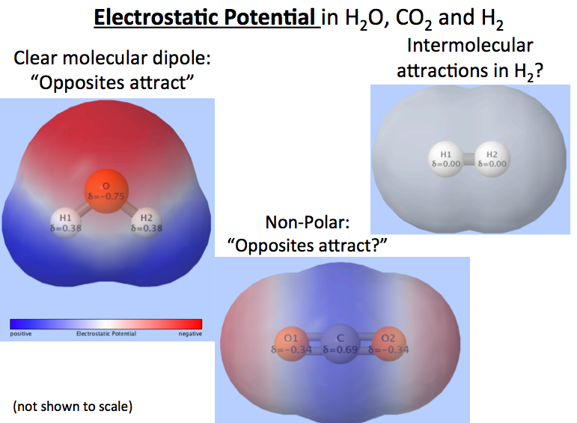
Slide 4: Comparison of Electrostatic Potential in Polar and Non-Polar Molecules.

States of Matter – States of Matter Screen

The sim States of Matter shows particle-level representations of different substances in different phases. The relative strength of intermolecular forces can be compared for different substances by examining which phase exists at a particular temperature.

- Begin with Ne(s) and add heat. Prompt students to identify when the phase change occurs; this requires an understanding of how the solid and liquid differ at the particle-level. Estimate the temperature for this phase change. Continue and identify the approximate boiling point Ne(l). Record the data.
- Discussion: “Would the melting point and boiling point be different for a substance with stronger intermolecular forces? One with weaker intermolecular forces?”
- Move on to an image (like Slide 5) that shows the particle-level representations for different substances at the same temperature. Analyze and discuss the relative strength of intermolecular forces. The manner in which molar mass (and polarizability) affects van der Waals forces may be introduced to explain the differences between neon and argon.
- Given their experiences, ask students to identify the relative strength of H₂O’s intermolecular forces when compared to argon and oxygen.

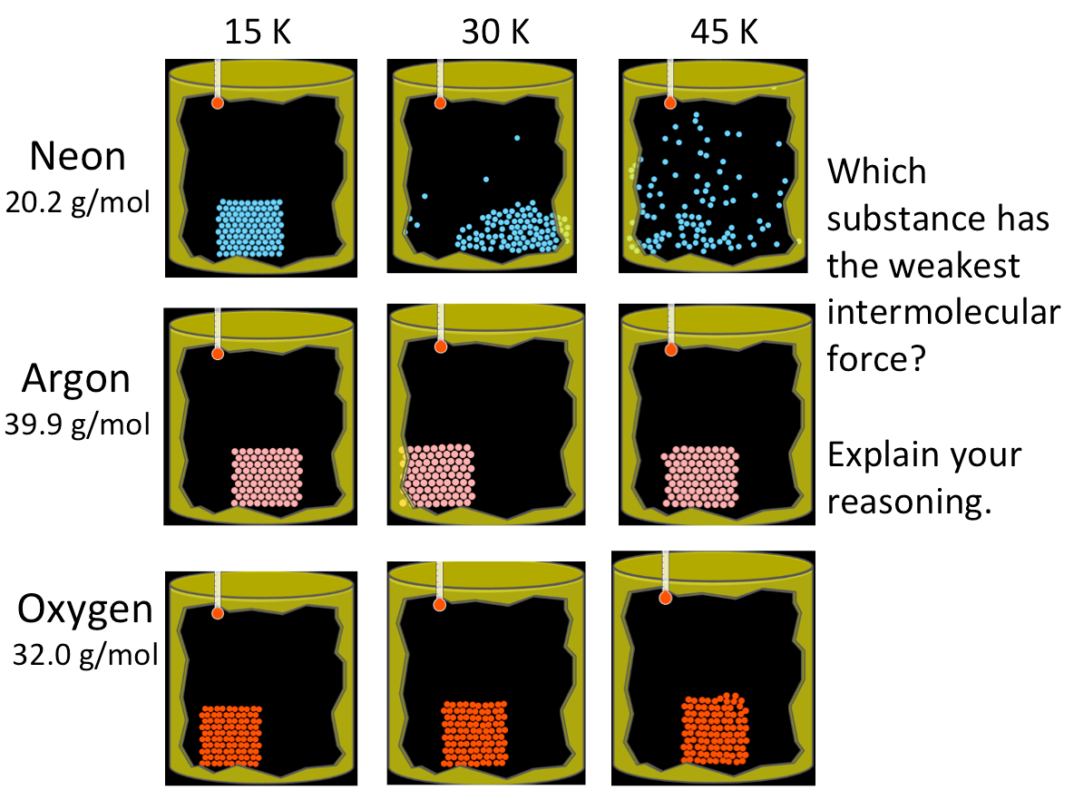
Slide 5: Intermolecular Forces Question

Molecule Polarity – Real Molecules Screen:

To investigate dipole-dipole interactions and hydrogen-bonds, it is important to first examine molecular geometry. Use the Molecule Polarity sim to illustrate the geometry of various molecules.

- Begin by having students determine the molecular geometry (based on Lewis structures and VSPER theory) and sketch each one. Within the sim confirm their structures and then share the information on a slide (Slide 6). Rotating a molecule is a good way to show its geometry.
- Having determined the geometry of different molecules, ask students to predict partial charges and molecule dipoles for each one. The electrostatic potential and partial charge representations are then added in the sim and summarized on a slide (Slide 7).
- Compare and contrast the negative and positive regions in molecules with hydrogen-bonding (H₂O, HF, NH₃) versus those without (BF₃, CH₃F, H₂).
- When identifying hydrogen bonding, a common misconception is labeling hydrogen bonds within a molecule as “hydrogen bonding”. Utilize this in-class assignment to address this point: “Sketch a mixture of H₂O and H₂. Use about 5 molecules of each, and include the correct molecular geometry. Then, within the sketch, show the hydrogen bonding with dashed lines.”

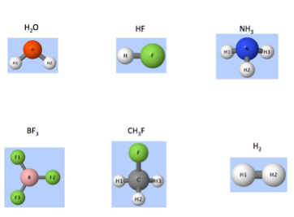 | 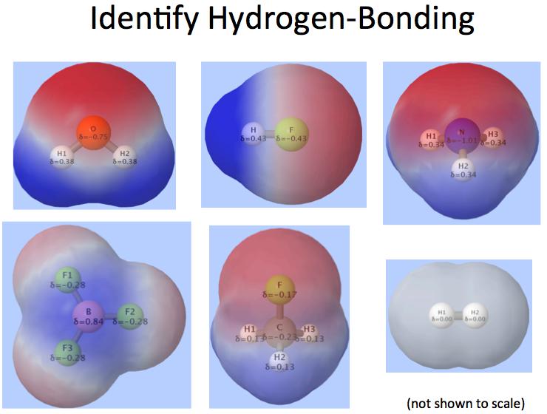
Slide 6: Molecular Shapes for Real Molecules | Slide 7: Showing the Electrostatic Potential for Molecules with and without Hydrogen-bonding.

Molecule Polarity – Real Molecules Screen:
Intermolecular forces and electrostatic interactions at the particle-level may be used to explain variations in a physical property.

- Different molecules are shown, along with their electrostatic potentials and electronegativity values (Slide 8).
- Both CH₄ and CF₄ are non-polar, but CF₄ has stronger intermolecular forces leading to a higher boiling point. Do electronegativity differences account for this difference? Due to the molecule geometry, the bond dipoles in each cancel. In this case, differences in molar mass (polarizability) account for the variation in boiling point.
- Having noted that molar mass affects van der Waals forces, a comparison is then made between CF₄ and CH₃F. Which has stronger intermolecular forces? The CH₃F. How can CH₃F have the stronger intermolecular forces than CF₄ since it has a smaller molar mass? As shown in Slide 7, CH₃F is a polar molecule with dipole-dipole intermolecular forces.

- There are many topics included in this discussion and subtleties to the reasoning:
  - All of the molecules have van der Waal interactions, but it was only used to explain differences between the non-polar molecules.
  - The electronegativity for fluorine is much greater than hydrogen, but both CH₄ and CF₄ are non-polar and neither has a dipole moment.
  - Even though these molecules include H and F, there are not hydrogen-bonds.
- Many times intermolecular forces are used to explain variation in a property once the “answer is already known”. In other words, given the boiling point data, differences in molar mass cannot be the determining factor when comparing CF₄ and CH₃F. Note that multiple intermolecular forces are required to explain the boiling point differences between CH₄, CF₄, and CH₃F. Questions like the one on Slide 8 help students to think broadly about the possible intermolecular forces for each case, rather than choosing one intermolecular force as a category for “ranking”, without considering other factors.

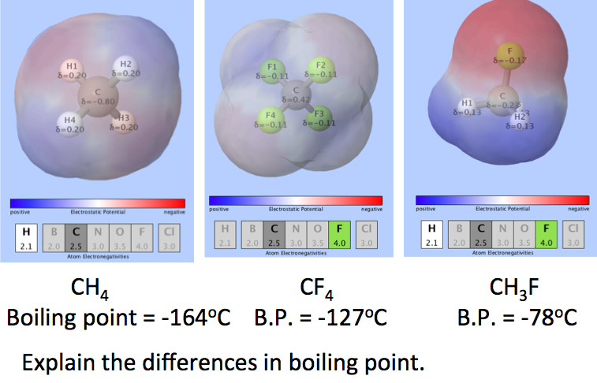
Slide 8: Showing the electrostatic potential for molecules along with electronegativity values.
Sugar and Salt Solutions – Water screen:

Another type of intermolecular forces is ion-dipole interactions. Ion-dipole interactions are present in a NaCl(aq) solution.
- Use the sim to show H₂O(l). Partial charges may be included and the alignment of the molecules noted. This helps reinforce the idea that intermolecular forces are acting between molecules.
- Due to particle motion, the + and – charges are not always aligned. The sim is well-suited to illustrate the dynamic motion in the liquid and the balance of intermolecular forces and kinetic energy.
- NaCl(s) is then added to the water in the sim. It may be helpful to pause and reset the sim since the Na⁺ and Cl⁻ ions move quickly on the screen. You can also grab an ion and move it. Identify the ion-dipole attractions acting between the cation or anion and the water.
- In the sim, solvation is shown to be a dynamic process with H₂O molecules moving about an ion. This is an improvement over static images showing the water always aligned in an optimal arrangement around an ion when describing ion-dipole interactions.

- Ion-pairing refers to the clustering of ions in the solution, which affects colligative properties like boiling point elevation by reducing the number of independent solute particles in solution.
- A common misconception is that electric charge “is used up”, e.g. when explaining ionization energy. Ion-dipole interactions do not “use up” the electrostatic potential and interactions between Na⁺ and Cl⁻ still occur. This point is considered in Slide 8.
- Summarize the intermolecular forces uses the examples and information in Slide 9.

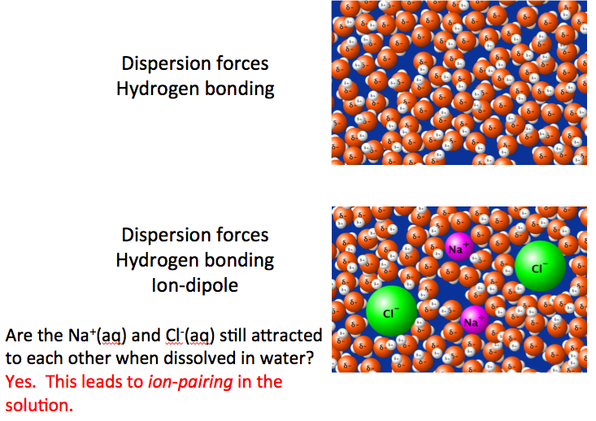
Slide 9: Identifying the Intermolecular Forces in Water and Salt Water

