PhET Mass Spring Activity

Name____________________________________ Period______

Setup: Search “PhET Spring Mass”, click on the first hit and then “Run Now”. Click on the dashed line and move it below the green menu. Set friction to “lots”. Hang the 50 g, 250 g, and the medium size unknown on each spring, as shown below.
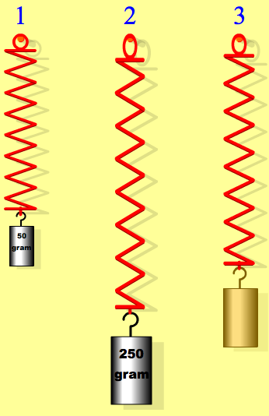
1. The 3 different masses are hung from 3 identical springs. Use the ruler and the first 2 masses to determine the spring constant of the spring, Record all of your measurements and calculations below. (Hint: the spring constant is the SLOPE of a force Vs distance graph)

2. Use the spring constant from step 1 to find the length of the un-stretched spring. To check your result, remove either the 50 g or 250 g mass and use the ruler to measure the length of the spring. Record all of your measurements and calculations below. (Hint: find the distance either known mass actually stretches the spring)

3. Use your spring constant from step 1 and the length of the spring from step 2 to determine the unknown mass. Record all of your measurements and calculations below. (Hint: make sure you measure x as the distance the spring is stretched from its unstretched length)

4. Select Planet X in the menu on the left. Use the 250 g mass and your results from steps 1 and 2 to determine g on Planet X. Record all of your measurements and calculations below. What planet in our solar system has the same gravitational field strength (g) as Planet X?

