Lauren Dykstra Prof. Robbins
Physical Science 3/3/2014

Title: Digital Curriculum Lesson: Static Electricity, A Force to be Reckoned With

Lesson Duration: 45 mins

Grade Level: 4th grade

Vocabulary: insulator, conductor, repel, attract, static electricity

Aim: Static electricity is a force that transfers electrons from one surface to another. Some materials are better conductors of static electricity than others. Establish a method for determining which materials are conductors and which are insulators.

Materials: Computers/laptops, balloons, cotton cloth, polyester cloth, saran wrap (enough for 1piece per pair of students in the class), rulers, notebooks, pencils

Introduction: In this activity you will investigate the force of static electricity. First, explore the Phet simulation found at the link below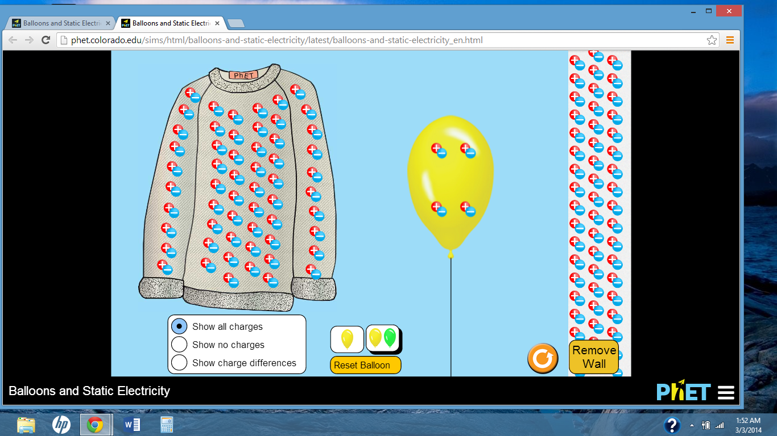

https://phet.colorado.edu/sims/html/balloons-and-static-electricity/latest/balloons-and-static-electricity_en.html

Explore: Begin with the settings as they are. One balloon, a wall to the right, a sweater to the left and the box below set to “Show all charges.” Move the mouse over the balloon and click the left button. Hold down the left mouse button and move the balloon toward the sweater and the wall.

As the students explore, the teacher(s) will observe each screen and ask the students: “ Is the balloon attracted to the sweater? Is the balloon attracted to the wall? Does the wall repel the balloon when it has more electrons?”

After 5 minutes of free investigation, begin to answer the questions below. Tell whether the balloon “attracts to,” or “repels from,” each surface.

1 What happens when you rub the balloon on the wall? What happens when you let go of the balloon (take your finger off the left mouse button)?

2. What happens when you rub the balloon on the sweater? What happens when you let go of the balloon on the sweater?

3. After rubbing the balloon on the sweater, what happens when you bring the balloon directly in between the sweater and the wall? What do you think is going on?

Count the number of positive charges on the sweater and record the number in the table below. Continue filling in the table below. Discuss the data with your partners/table groups.

 | Starting # of + charges | Starting # of - charges | After rubbing the balloon on the wall: # of + charges | After rubbing the balloon on the sweater: # of + charges | After rubbing the balloon on the sweater: # of - charges
Balloon | 4 | 4 | 4 | 4 | 60
Sweater | 56 | 56 | 56 | 56 | 0
Wall | 48 | 48 | 48 | 48 | 48
Answer the questions below based on your data and observations:

- The negative charges on the sweater are now on the _______________.
- The negative charges on the wall escape and attach to the balloon.( T / F )
- The negative charges on the sweater escape and attach to the balloon (T / F)
- All positive charges remain in the starting position. ( T / F )

Explain:An insulator is a material in which, when exposed to an electric field, the electric charges do not flow freely. During the Phet simulation you should notice that the positive and negative charges do not escape the wall. The wall is working as an insulator.

A conductor is a material that when exposed to an electric field, the electric charges flow freely. Negative charges (electrons) escape from one material and attach to another.

Based on your observations during the Phet simulation, Which material(s) allow charges to move freely (conductors)?

Which material(s) keep an equal amount of positive and negative charges (insulators)?

Apply: After working with the simulation students will work in pairs. Students will read and follow the instructions at their own pace (put on handout).

- Rub the balloon on the cotton cloth quickly for 10 seconds. Describe what happens when you try to stick the balloon to the cloth?

- Will the balloon stick to the wall after rubbing it on the cloth?

- Rub the balloon on the polyester cloth quickly for 10 seconds.
- Place the cotton cloth and the polyester cloth 5 inches from the balloon on opposite ends.
- Each partner should hold one piece of cloth.
- Move the pieces simultaneously closer to the balloon. Describe what happens?

You will rub the balloon on each material quickly for 10 seconds

Predict which material will allow the balloon to remain stuck to the wall the longest:

Is there a material that will not allow the balloon to stick to the wall after rubbing?

- Rub the balloon in your hair and stick it to the wall.
Record how many seconds the balloon remains stuck to the wall:

2. Rub balloon on polyester quickly for 10 seconds and stick it to the wall.
Record how many seconds the balloon remains stuck to the wall:

3. Rub the balloon on the cotton quickly for 10 seconds and stick it to the wall
Record how many seconds it remains stuck to the wall:

4. Rub the balloon on the saran wrap quickly for 10 seconds and stick it to the
wall.
Record how many seconds it remain stuck to the wall:

Place a check in the appropriate box for each material.
Material | Repels Electrons | Attracts Electrons
Wall
Balloon
Polyester
cotton
saran wrap

