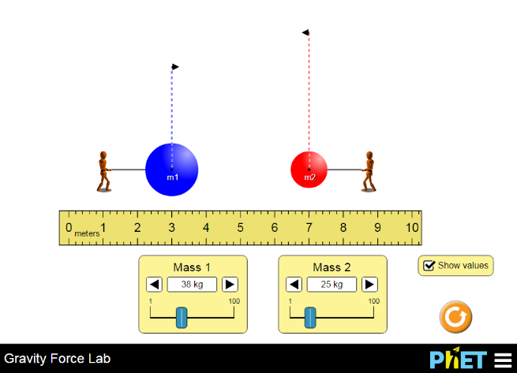
Determination of the Force of Gravity
Go to http://tinyurl.com/ma8rw9x

Qualitative Observations
- How does the changing the separation of the objects affect the force between them? (increases, decreases, not affected)

- What happens to the force between the objects when mass 1 increases? (increases, decreases, not affected)

- What happens to the force between the objects if Mass 2 decreases? (increases, decreases, not affected)

- What is the ratio of the force on the blue object to the force on the red object? What if the mass of the blue one is twice as big as the red object? Explain.

- What direction are the gravitational forces acting on the objects?

Quantitative

It is now time to build a model.

- What THREE things can we change/vary?

- Select an independent and dependent variable and constant

  - DV ___________________________

  - IV ___________________________

  - C ___________________________

- Collect 10 data points and graph

- Select a new independent and dependent variable and constant

  - DV ___________________________

  - IV ___________________________

  - C ___________________________

- Collect 10 data points and graph

- Repeat the varying mass vs. force experiment, changing the second mass.
Questions
- Explain why varying the second mass had the same effect on the force as varying the first mass.

- What is the relationship (proportionality) between Mass and force? What happens to the force if you double the mass of the blue object? What happens to the force if you then triple the red object’s masses?

- What is the relationship between distance and the force of gravity? What happens if you triple the distance between the objects? Half the distance between them?

- Combine your proportions between Mass 1 (m₁), Mass 2 (m₂) distance (r) into a single proportion to the Force of gravity (F_{g}).

Show your instructor your proportionality before you continue.
- Does your lab data for m₁, m₂, and r does equal F_{g}? Also work out your units, do they equal a unit of force?

- Make a graph of Force vs. your proportionality

- Determine the gravitational constant (G) that will satisfy your units

G=_________________________

- Write your full formula and check with your instructor.

