PhET Energy Simulations
Name _______________________________________

per ____________

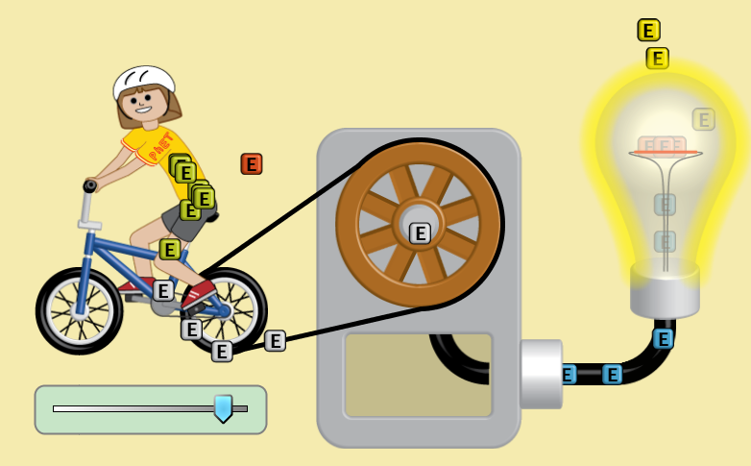

(energy form) |  |  | transformed into/ transferred to | (what work or change it does)
chemical | from the | girl’s digestion | transformed into mechanical | moves her legs
mechanical | from the | legs | transferred to wheels | moves the wheels
mechanical | from the | wheels | transformed to electrical | heats the wire inside the bulb
thermal | from the | wire | transformed to light | radiates out into the room.

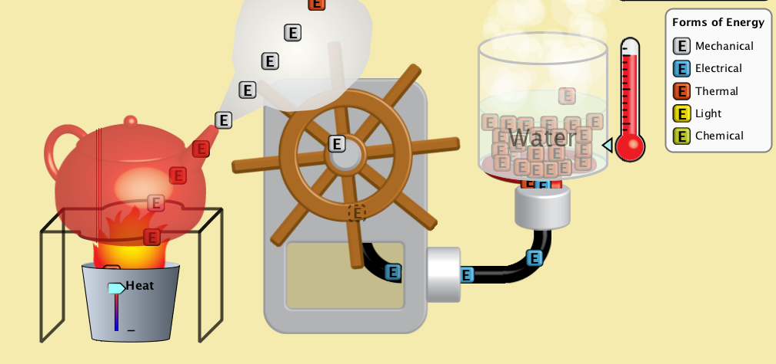

(energy form) | from the |  | transformed into/ transferred to | (what work or change it does)
thermal | from the | burner | transferred to the  1.___________________ in the kettle | heats the water to steam
2.___________________ | from the | steam | transformed to mechanical | moves the wheel
mechanical | from the | wheel | transformed to  3. _____________________ | heats the burner
thermal | from the | burner | transferred to the water | 4. ____________________________________

(energy form) | from the |  | transformed into/ transferred to | (what work or change it does)
5. | from the | water | transferred to wheel | turns the wheel
mechanical | from the | wheel | transformed to  6. | heats the wire in the bulb
thermal | from the | wire | transformed to  7. | xxxxx
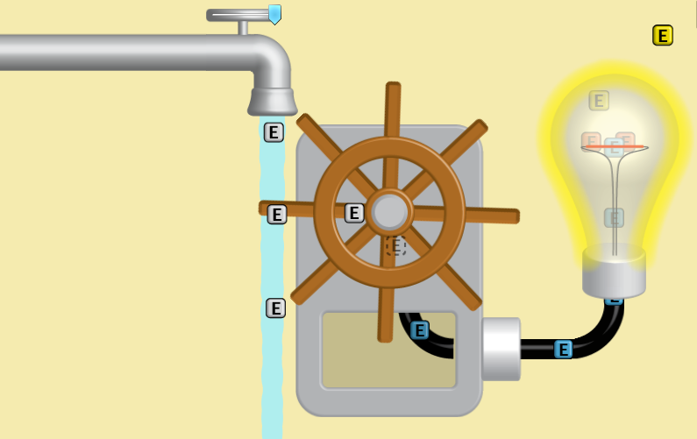
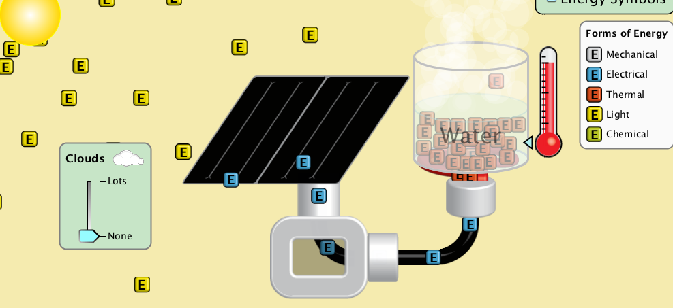
(energy form) |  |  | transformed into/ transferred to | (what work or change it does)
8. | from the | sun | transformed to  9. ____________________________ by solar panel | heats burner
thermal | from the | burner | transferred to  10. ______________________________ | heats the water
(energy form) | from the |  | transformed into/ transferred to | (what work or change it does)
 | from the
 | from the
 | from the
