Gas Properties

Introduction: In this activity you will investigate the relationship between volume, temperature, and gravity in relation to light gasses.

Go to http://phet.colorado.edu/en/simulation/gas-properties

Click “Run Now”

This picture should appear on your screen:

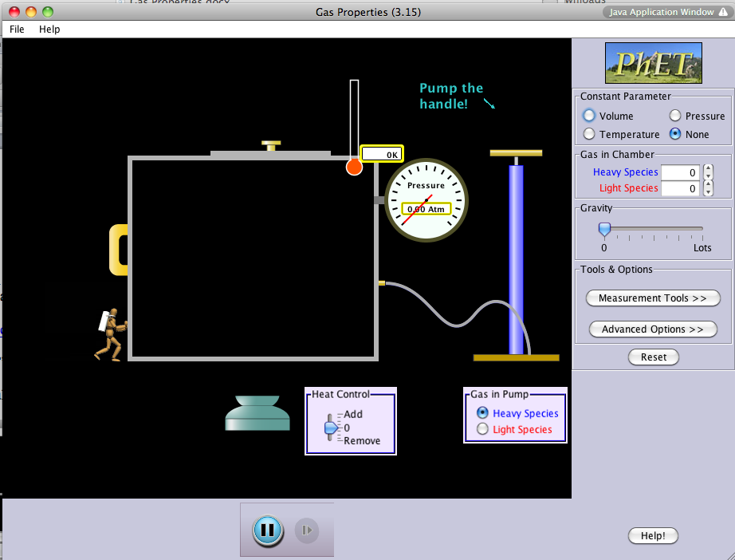

Explore:

For the next 5 minutes become familiar with the sim. Change various features, sliders, buttons, click-and-drag items, etc.

While you are exploring, notice how the heat control affects the gas particles.

Next: Click “Reset All” and conduct the following investigation.

Explain:

Aim: To understand the relationship between temperature, volume, and pressure in regards to light gasses.

Make sure the constant parameter is clicked on volume.

Click the Light Species on the gas pump.

Make sure gravity is set on 0.

Your screen should look like this:

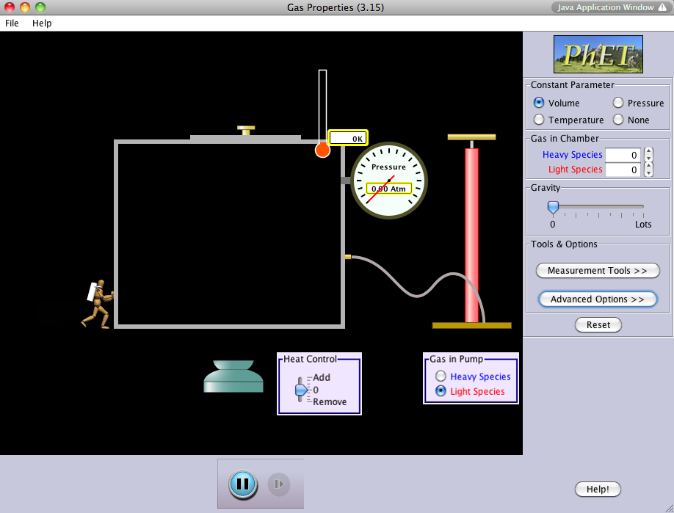

In the area under “Gas in Chamber” (top right) add 160 “Light Species” in the gas chamber.
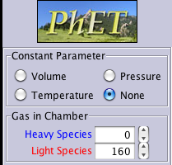
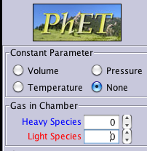

Next, under “Tools & Options” click on “Measurement Tools” and check “Stop Watch”
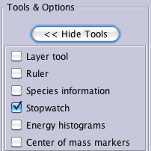
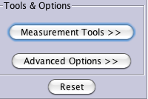

Press “Start” on the timer. Let it run for 10 seconds and then press the Pause button on the simulation.

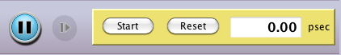

Record the temperature and range of pressure that is on the screen in the chart below.

Temperature  (K) | Range of Pressure  (Atm)

Describe what is happening in the container: (think about the speed and location of the gas)

Reset the timer and then press “Start.”

Now move the arrow in the “Heat Control” box up until it is even with add. Hold the arrow in place for 10 seconds and then press the Pause Button on the Simulation.

Notice what happens to the Temperature and Range of Pressure. Record the numbers in the chart below.

Continue doing this for 50 seconds, stopping every 10 seconds. Be sure to press the Play Button each time and then the “Start” button on the timer.

Time  (Seconds) | Temperature  (K) | Range of Pressure  (Atm)
10
20
30
40
50

What did you notice happened to the Light Gas Species when you increased the temperature (make sure to include words such as increase, decrease, or stay the same)?

Reset the timer and then press “Start.”

Now move the arrow in the “Heat Control” box down until it is even with remove. Hold the arrow in place for 10 seconds and then press the Pause Button on the Simulation.

Notice what happens to the Temperature and Range of Pressure. Record the numbers in the chart below.

Continue doing this for 50 seconds, stopping every 10 seconds. Be sure to press the Play Button each time and then the “Start” button on the timer.

Time  (Seconds) | Temperature  (K) | Range of Pressure  (Atm)
10
20
30
40
50

What did you notice happened to the Light Gas Species when you decreased the temperature (make sure to include words such as increase, decrease, and stay the same)?

Write a general rule of how increasing and decreasing the temperature in a closed system affects the speed and pressure of the system.

Apply

Make a prediction: Think about two ways you would make the lid of the container pop off while keeping the volume constant, but being able to manipulate other factors.

1. If _____________________________, then ____________________________________ .

2. If _____________________________, then ____________________________________ .

Now click the “Reset” Button.
Make sure Volume is checked on the constant parameter.
Set the gas pump to “Light Species”

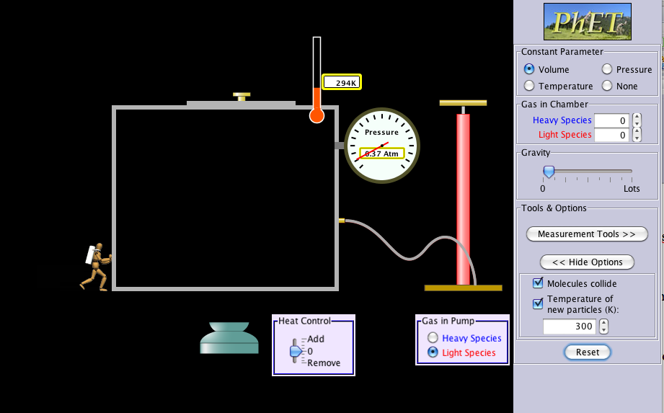
Top

Try out your first prediction.

Predication #1 (From Above): If ___________________, then _______________________ .

Were you successful?

If no, why were your predictions unsuccessful? What did you need to do to modify them?

Try out your second prediction.

Predication #2 (From Above): If ___________________, then _______________________ .

Were you successful?

If no, why were your predictions unsuccessful? What did you need to do to modify them?

Based on your experience with your predictions, explain the relationship between temperature, volume, and pressure:

