**Title: Measuring Current in a Series Circuit**

**Introduction:**

In this activity you will investigate the physical science of electrical circuits. By the end of this activity, you will be able to create a simple series circuit. You will also be able to identify the purpose of a resistor and how to read and use a voltmeter.

1. Click this link: <http://phet.colorado.edu/en/simulation/circuit-construction-kit-dc>

This is a screen shot of the website:

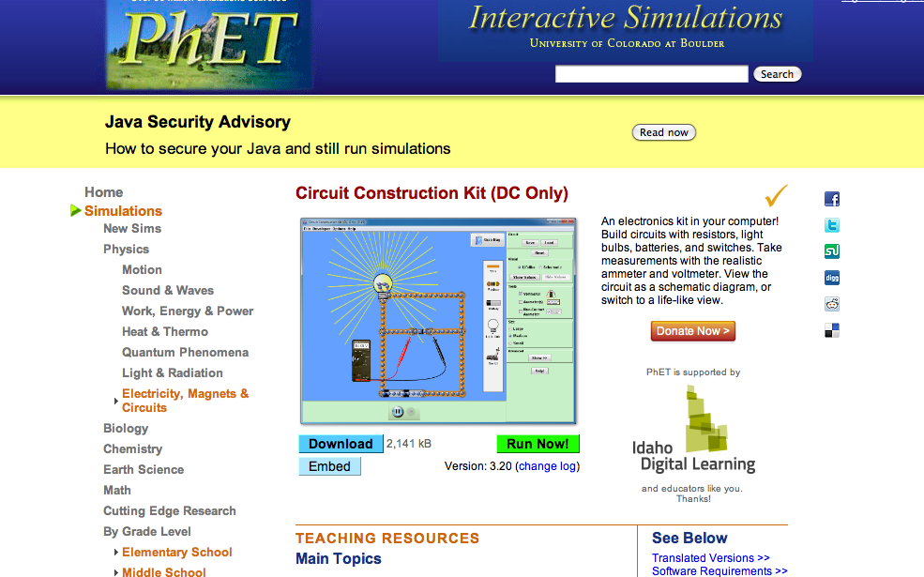

2. Click “Run Now!” It will take some time for the sim to load.

3. Switch between this document and the sim, “Circuit Construction Kit (DC Only)” to complete this activity.

**Exploration Phase #1:**

Part I: Building a simple series circuit (6 minutes)

1. On the right-hand side, under **visual** click on ‘schematic’. This is to help us stay consistent with our drawings in class.
2. Freely explore the simulation for 3 minutes.
3. After exploration, click the **reset all** button.
4. Create a circuit using the following materials: wires, a cell (battery), a light bulb, a switch and an ammeter (under **Tools**).
   1. Make sure the ammeter is connected on both sides by wires, within the circuit. See image below.
   2. 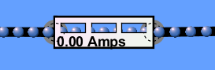
5. Once the light comes on, capture a screen shot of your circuit (Windows: ALT+PrtScn -> open Paint-> Paste // Mac: Command+Shift+4 ->drag your cursor to select the portion of the screen you wish to capture).
6. Congratulations, you have built a simple series circuit!

Explain: (5 minutes)

1. What happens when the switch is opened/ closed? Be sure to use the words *electrons* and *current* in your response.
2. What is the purpose of the ammeter?
3. What is the reading of the ammeter?
4. Does the reading of the ammeter change at any time?
   1. If so, why does it change?

Notes:

Notice that when you close the switch to complete the electrical circuit, the electrons start moving and the ammeter indicates that there is current flowing in this circuit. Also notice that the light bulb begins to glow. This happens because the electrons moving through the tiny wires in the bulb (or filament) make them become so hot that they glow.

* Ammeter: is a measuring instrument used to measure the electric current in a circuit.
* Amps: amperes; the unit of measure for electric currents

Part II: Building a series circuit with resistors (8 minutes)

1. Hit the **reset all** button to clear the screen.
2. Create a series circuit again (repeating steps 1-4 from Part I). This time add a voltmeter (under **Tools**), and more wires. Do not be afraid to use more than 4 wires, this will make it clearer to see.
   1. 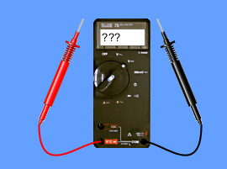 This is a voltmeter.
3. Click on the ‘Show Values’ under **Visual**.
4. Turn the switch ‘on’ (close the switch).
5. What is the voltage of the battery? _____________
   1. Place the black wire of the voltmeter on the side of the cell where the electrons are moving out from and the red wire of the voltmeter on the side of the cell where the electrons are moving into.
6. What is the Amps of the ammeter?_____________
7. Right-click on one of the junctions of two wires. Click on ‘split junction’.

Prediction: (5 minutes)

What do you think will happen if we add a resistor to our circuit?

[In your answer, be sure to include how the ammeter will change or if it will stay the same and if the brightness of the light bulb will change or stay the same.]

1. Add a resistor between those two split wires. Notice what happens to the value of the ammeter (amperage). Write it here ________amps.
2. Add a second resistor into the circuit. You may need to add another wire. Notice what happens to the value of the ammeter. Write it here ____amps.

Explain: (8 minutes)

1. What was the difference in the value of the ammeter? (Use words like current, constant, increases, decreases).
2. Did the light bulb become brighter, stayed the same, or became dimmer?
3. Was there a difference in Ohms in the light bulb? (Did it change or stay the same?)
4. What do you think the purpose of a resistor is in a circuit?
5. Write a definition for *resistor.*
6. If more and more resistors were added to a series circuit while the voltage remained constant, the total electric current for the circuit would ___________________ (increase, decrease, remain constant, differ with each resistor).

Notes:

“*Resistors are components that are used to control that amount of current flowing in a circuit. The light bulb in the first circuit was actually acting like a resistor because it only allowed a certain amount of current to flow through it. If there are no resistors or components that act like resistors to slow the flow of electrical current, too much current may flow through the circuit and damage its components or wires. Too much current flowing through a component results in the generation of heat that can melt the conductive path through which the electrons are flowing. This is known as a short circuit and is the reason fuses or circuit breakers are often included in a circuit*,” (ndt-ed.org).

**Exploration Phase 2: Using a Voltmeter (**

The purpose of a voltmeter is to measure the potential difference between two points. Or more simply put it measures the voltage between two points.

1. Set up your circuit to resemble the circuit from part II of phase 1—without any resistors.

It should look similar to this:

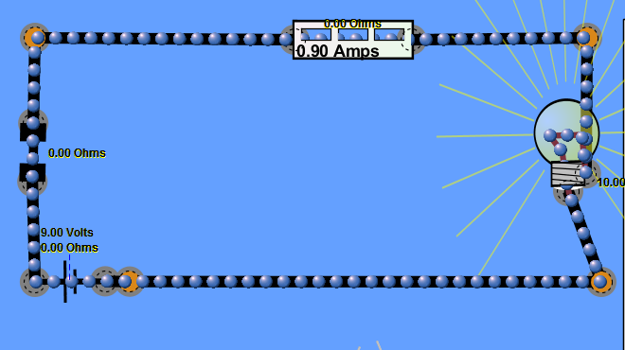

1. Add a voltmeter to your circuit.

Fill in the missing columns. [LBu=Light Bulb]

|  |  |  |  |  |
| --- | --- | --- | --- | --- |
| Battery (v) | Ammeter (amps) | Amount of resistors | Resistance of light bulb (ohms) | Reading of Voltmeter (v) |
| 9v |  | 1 LBu | 10 ohms |  |

Predict: (5 minutes)

What will happen if we add another light bulb (which will act like a resistor) into the circuit? Form a hypothesis. (Include the voltage that each light bulb will use).

If we add another resistor to the circuit, then the voltage that each light bulb will use will _____________ (increase, decrease, or remain constant).

1. Add another light bulb into the circuit. Measure the voltage of each light bulb. (Remember: black is for electrons moving into a resistor and red is for electrons moving out of the resistor)Write what happened in the chart below.

Fill in the chart. [LBu=Light Bulb]

|  |  |  |  |  |
| --- | --- | --- | --- | --- |
| Battery (v) | Ammeter (amps) | Amount of resistors | Resistance of light bulb (ohms) | Voltage (v) |
| 9v |  | 2 LBu | Both LBu:  10 ohms | LBu 1:__________  LBu 2:__________ |
| 9v |  | 2 LBu | LBu1: 15 ohms  LBu2: 10 ohms | LBu 1:__________  LBu 2:__________ |

Explain: (5 minutes)

1. Was your prediction correct? Why or why not?
2. What happened to the value of our ammeter?
   1. Why?
3. What occurred to the reading of the voltmeter when we changed the resistance of the light bulbs?
   1. Why did this occur? (Include the flow of energy in your response)

Part II: Where does all of the voltage go? (5 minutes)

1. Measure the voltage of the second light bulb; the side where the electrons are coming into the resistor and where the electrons are coming out of it.

*Remember: black is for the electrons moving out of a resistor and red is for electrons moving into the resistor.

* 1. Voltage of Light Bulb 2: ______V

1. Measure the voltage of the second light bulb (the side where the electrons are coming out from) and the ammeter (where the electrons are moving into).
   1. Voltage of Light Bulb 2 and the ammeter: ______ V

Explain: (3 minutes)

1. Why is the voltmeter reading a voltage of 0.00V between the second light bulb and the ammeter? (Hint: Think back to the voltage of the cell, how much voltage was used up in the first light bulb).

C:\Users\Darya\AppData\Local\Microsoft\Windows\Temporary Internet Files\Content.IE5\SM9J2DK5\MC900383582[1].wmf

Congratulations! You’ve lit up with information on series circuits, resistors and voltmeters!