Title: States of Matter

Introductions:
In this activity you will investigate the physical science of the different states of matter. You are going to see how different atoms and molecules change state (solid, liquid, and gas) when they are heated or cooled.
- Click on the link: http://phet.colorado.edu/
This is a screen shot of the website:
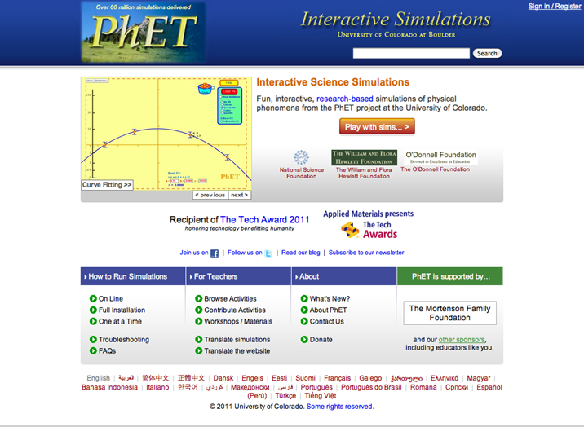
- Click the “Play with sims” button.
- Click “By Grade Level” > Click “Elementary School”>Click “States of Matter: Basics”
This is a screen shot of the simulation:
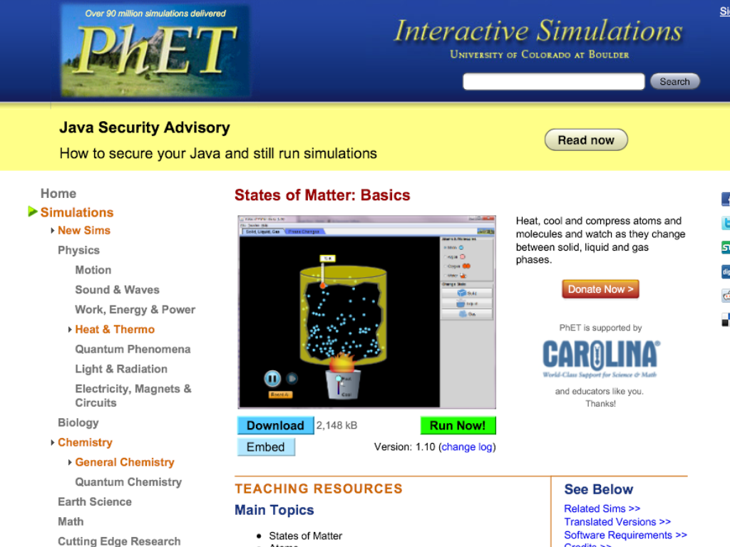

- When you see this screen you will then click on “Run Now!”
- Switch between this document and the simulation “States of Matter: Basics” to complete this activity.

Exploration Phase #1:
- When you open the sim, make sure it is on the tab Solid, Liquid, Gas.
- On the side it has a list of atoms and molecules. Click on the neon atom first. (the neon atom is blue)
- Increase the heat and observe what happens. Then decrease the heat and observe what happens.
- When you are finished observing what happens, repeat steps 2 and 3 but now for the argon atom, oxygen molecule, and water molecule.

Questions:
- What happened to the neon atoms when you heated the container?

- What happened to the neon atoms when you cooled the container?

- Did you get the same results when you did this with the argon atoms, oxygen molecules, and water molecules in the container?

Predict:
Do you think that neon atom, argon atom, oxygen molecule, and water molecule all change states of matter at the same temperature?

Exploration Phase #2:
- When you have finished answering the questions above go back to the sim and click “Reset All”.
- Explore freely what happens to the different atoms and molecules when you heat up the container. This time pay attention to the thermometer.

Explanation Phase:
Aim: What happens to atoms and molecules when you heat up the container? What happens to atoms and molecules when you cool the container? Do all atoms and molecules change states of matter at the same temperature?
- When the container is heated:

- When the container is cooled:

- Do all atoms and molecules change states of matter at the same temperature?

Concepts:

- When you heat up the container whatever is in the container will turn from a solid, to a liquid, and then if you continue heating it up it will turn into a gas.
- When you cool the container whatever is in the container will change from a gas, to a liquid, and then if you continue cooling it back into a solid.
- In the sim the thermometer has a K next to it, K stands for Kelvin.
273Kelvin = 0° C.
- Each atom and molecule changes its state of matter at different temperatures.
- When the atoms and molecules are closer together they are in the solid phase, when they start getting further apart they are in the liquid phase, and when they are the furthest apart they are in the gas phase.

- Go back to the sim click “Reset All” and complete the graph below:

At what temperature did each substance change state?

Temperature: 273K=0°C | Neon: | Argon: | Oxygen: | Water:
Solid:
Liquid:
Gas:

- Was your prediction correct? Do all the four atoms and molecules change states at the same temperature?

Application Phase:

- Now go back to the sim and click “Reset All”.
- On the right side it says “Change State” and underneath it says Solid, Liquid, and Gas. Click on neon first then click on solid, look at what the thermometer reads, record it on the table below.
- Then click on liquid, look at what the thermometer reads and record it on the table below.
- Click on gas, look at what the thermometer reads and record it on the table below.
- Do this for all four atoms and molecules.

At what temperature did each substance change state?

Temperature: 273K=0°C | Neon: | Argon: | Oxygen: | Water:
Solid:
Liquid:
Gas:

Conclusion: Compare the data in both tables.

