What is a quadratic?
This is y = 2x²
^{So is this} y = x² + 3
And these y = 5x² – 4x + 7
y = x² – 7x – 12
y = – 1.5x² + 3.2 x
In general, a quadratic is an equation with a squared term (but no higher power)
In algebraic language, that is y = ax² + bx + c (a, b and c are numbers)
What happens when we change a, b and c?
In this worksheet, you will investigate these questions.
To do this, open the simulation found at:
http://phet.colorado.edu/sims/equation-grapher/equation-grapher_en.html

Part A: Changing a (the coefficient of the x² term)
- Draw the graph y = x² by setting the value for a to 1. 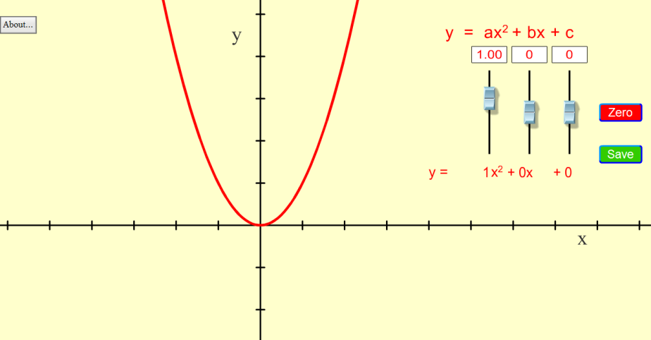
HINT
You can change the value using the slider but to get a particular value, you may find it easier to type it into the box.
- Draw a set of axes and sketch the graph of y = x² on them.
- Click on the save button and then change the value of a to 2.
Sketch the new graph on the same set of axes in a different colour.
- Change the value of a to 0.5. Use a third colour to record this graph on the same axes.
Label the graphs y = x², y = 2x² and y = ½x² respectively.
- Write a sentence or two about how changing the value of a affects the graph.
But what about negative numbers?
- Use the simulation to draw a graph of y = -2x² and record it on the same axes as before.
Write an explanation of how negative values of a affect the graph.

Part B: Changing a (the coefficient of the x term)
- Draw a new set of axes and change a to 1.
- Leave a = 1 and try several different values of b. Sketch the graphs on the axes in different colours, as before. Label the graphs (y = x² + x, y = x² + 2x, y = x² - 2x etc.)
Include some negative values for b.
- Write a sentence or two about how changing the value of a affects the graph.

Part C: Changing c (the constant)
- Draw a new set of axes and change a and bto 1.
- Repeat the same process used in parts a and b to find out what happens when you change b.

Part C: Challenge
- Work in pairs. One student sets the other a particular description of a parabola. The other student has to use the simulation to draw a parabola which meets the set criteria, sketch the graph and write the equation for the graph.
- Reverse the roles and the second student sets a challenge for the first.
Examples of challenges:
- A parabola with the turning point at (1,2)
- A parabola with x=-1 as the axis if symmetry.
- A parabola with the y intercept at (0,4) and only one y intercept.
- A parabola with the turning point at (1,0)and two x intercepts, 4 units apart.
… or any other combination of turning point, axis if symmetry, x or y interceptsor anything else you can think of.

