Circuit Lab
Parallel and Series Circuits

http://phet.colorado.edu/en/simulation/circuit-construction-kit-dc

Download the applet. You must have Java 6 on your computer (Mac’s won’t do this, because they won’t run Java). If you do not have the correct version of Java on your computer, you can download it for free from http://www.java.com/en/download/index.jsp

Wires – you can change the length and orientation of the wires by clicking and dragging on the yellow circles on the ends of them. The little circles that are in the wire are the electrons. They will not move until you have a complete loop from one side of the battery to the other. Notice the speed that the electrons move, faster = higher current.

Resistors – you can change the resistance of the resistors by right clicking on them and opening the dialogue box. Notice that when you change the resistance, the color bands on the resistor change colors to correspond to the resistance shown. You can show the value on the picture by right clicking and selecting “show value.” The default is 10 ohms, so you’ll have to change it to the correct value.

Battery – You can change the voltage of the battery by right clicking on it and selecting “Change Voltage”. You can also show the voltage the by selecting, “show value”. Don’t worry about changing the internal resistance of the battery. Leave it at zero ohms. The default voltage is 9 V

Voltmeter – To use the voltmeter to find the voltage drop, you need to click on the “voltmeter” box on the right. It will place a voltmeter on the board. You then need to drag the voltmeter to the position that you want to use it. You can drag the red and black leads so that they touch either side of the part of the resistor you want to measure. Make sure that the voltage reading is positive. If it is negative, you hooked them up backwards and need to switch them.

Ammeter – To use the ammeter, again, check the box next to “Ammeter”. This time, the ammeter was added to the list of devices that you can place into your circuit. Ammeters measure current and have to become PART of the circuit, so you need to disconnect the circuit in order to place the ammeter in it. To disconnect, you need to right click on the yellow circle on the end of the wire and select “split junction”. That will separate the wires. Drag the ammeter from the box to place it IN the circuit and connect it with wires to the rest of the circuit. The current will show up in the display.
You are going to build 2 series circuits, 2 parallel circuits and one combination circuit and measure the current through and voltage across each resistor.

Series Circuit:
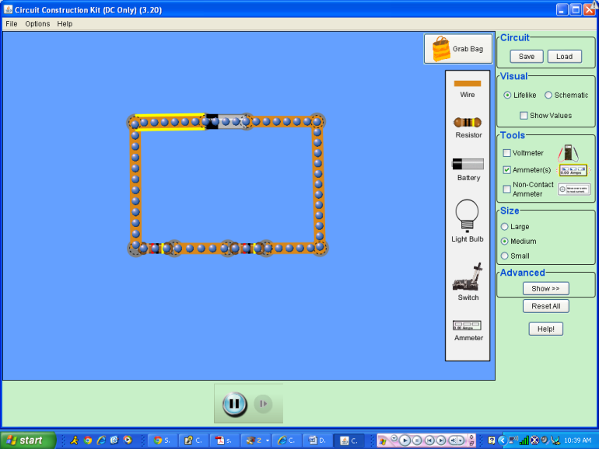
You will construct the following series circuit:
On the board, it should look like this:
R = 12Ω
V = __
I = __
R = 12Ω
V =__
I = __
V = 9V
I = __
What color are the color bands on the resistor?

Use the voltmeter to measure the voltage across the battery and each resistor. Record in diagram above. It will look like this to measure the voltage across the battery:
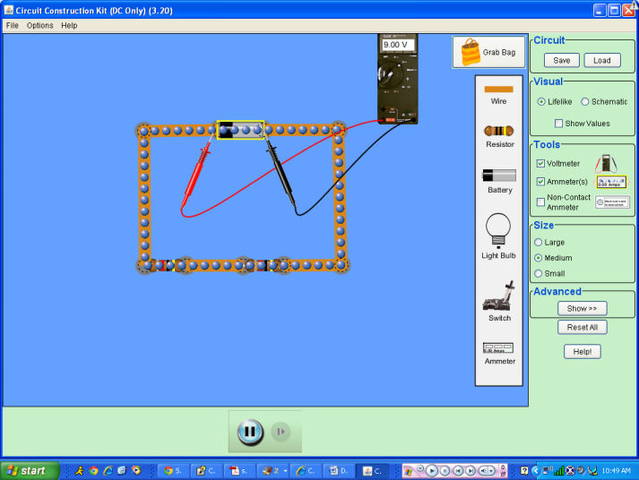
When you measure the current from the battery, it will look like this:
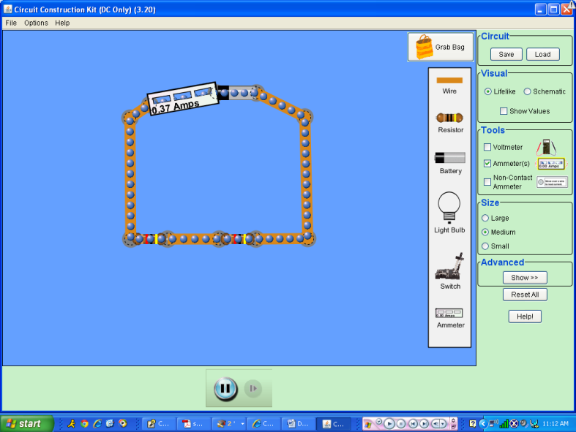

The second series circuit will have a 12 Ω and a 24 Ω resistor in it.
R = 12Ω
V = __
I = __
R = 24Ω
V =__
I = __
V = 9V
I = __
What do the color bands for the 24 Ω resistor look like?

How does the flow of electrons through the wires in this one compare to the last one?

Record the voltage and current in the diagram to the left.

How does the voltage across the 12 Ω resistor compare to that from the battery and the 24 Ω resistor?

How does the current through the 12 Ω resistor compare to that from the battery and the 24 Ω resistor?

Now you will construct a parallel circuit with two 12 Ω resistors according the diagram below:

It will look like this on the board:
R = 12Ω
V = __
I = __
V = 9V
I = __
R = 12Ω
V =__
I = __
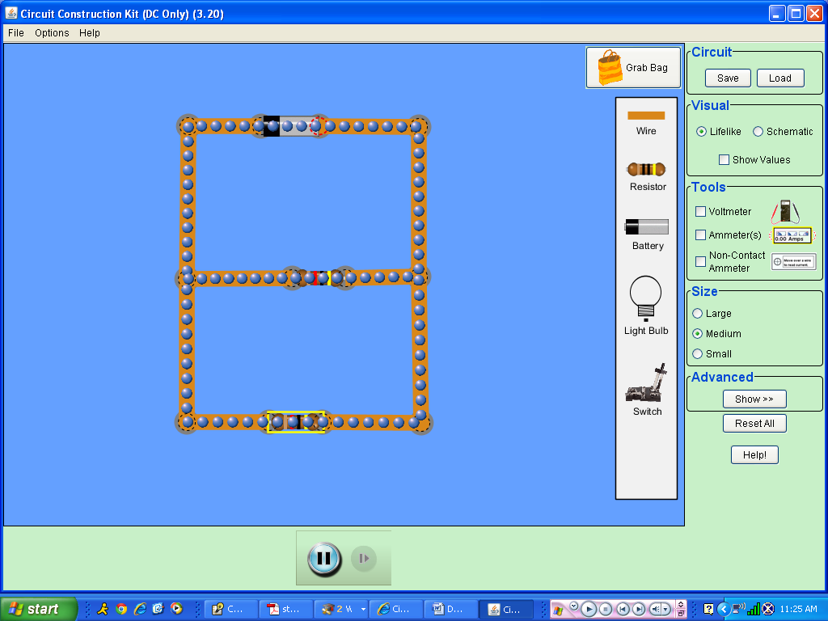

How does the motion of the electrons in the wires from the battery compare to the first series circuit?

How does the motion of the electrons through the resistors compare to those from the battery?

Measure the voltage and resistance at each indicated spot and record in the chart above.
R = 24Ω
V = __
I = __
V = 9V
I = __
R = 12Ω
V =__
I = __
Make a second parallel circuit with a 12 Ω and a 24Ω resistor.
Record the voltages and currents through each part.

How does the voltage across the 12 Ω resistor compare to that from the battery and the 24 Ω resistor?

How does the current through the 12 Ω resistor compare to that from the battery and the 24 Ω resistor?
Turn in this page ONLY
Now you are going to create a combination circuit. You will have two 12 Ω resistors in parallel with each other and in series with a 24Ω resistor.
Record the voltages and the currents in the table below.
***Draw what the setup looks like***
R = 6Ω
V =__
I = __
R = 18Ω
V =__
I = __
R = 12Ω
V =__
I = __

How are the currents/voltages similar/different through each resistor? Explain your answers. This answer is what will be graded, so be as complete as possible, using information from the previous circuits to support your answer.

