Things you can show with ‘My Solar System’
My Solar System is a simulative method that can visualize a part of astronomy. Where words are not effective enough, simulations will visualize and it will let the children understand the contents better. We store about 40% of what we see, and we only store about 10% of what we read.
Table of Contents:
I – Introduction to the simulator
II – Basic introductory lesson
III – Expanding basic introduction.

I – Introduction to the simulator
When you open the simulator you will see this:
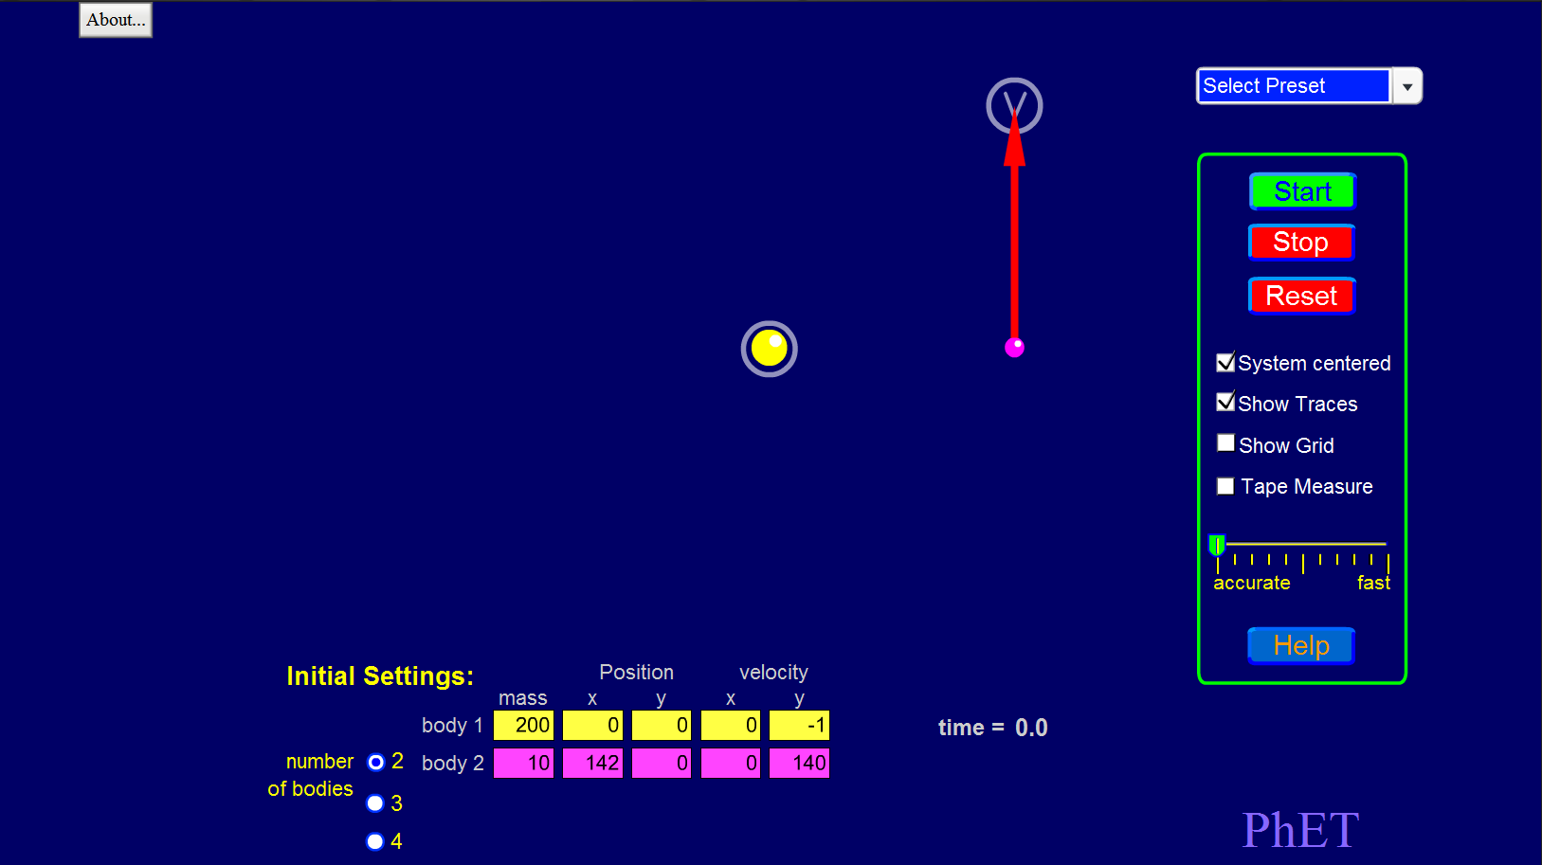
This is the initial screen we start off with.
We see a sun and a single orbiting planet.

When you press that start button, you will see the planet in orbit with the sun. This is not accurate yet. To make this accurate: We press the Select Preset button, and we select Sun and planet.
You screen should now look like this:
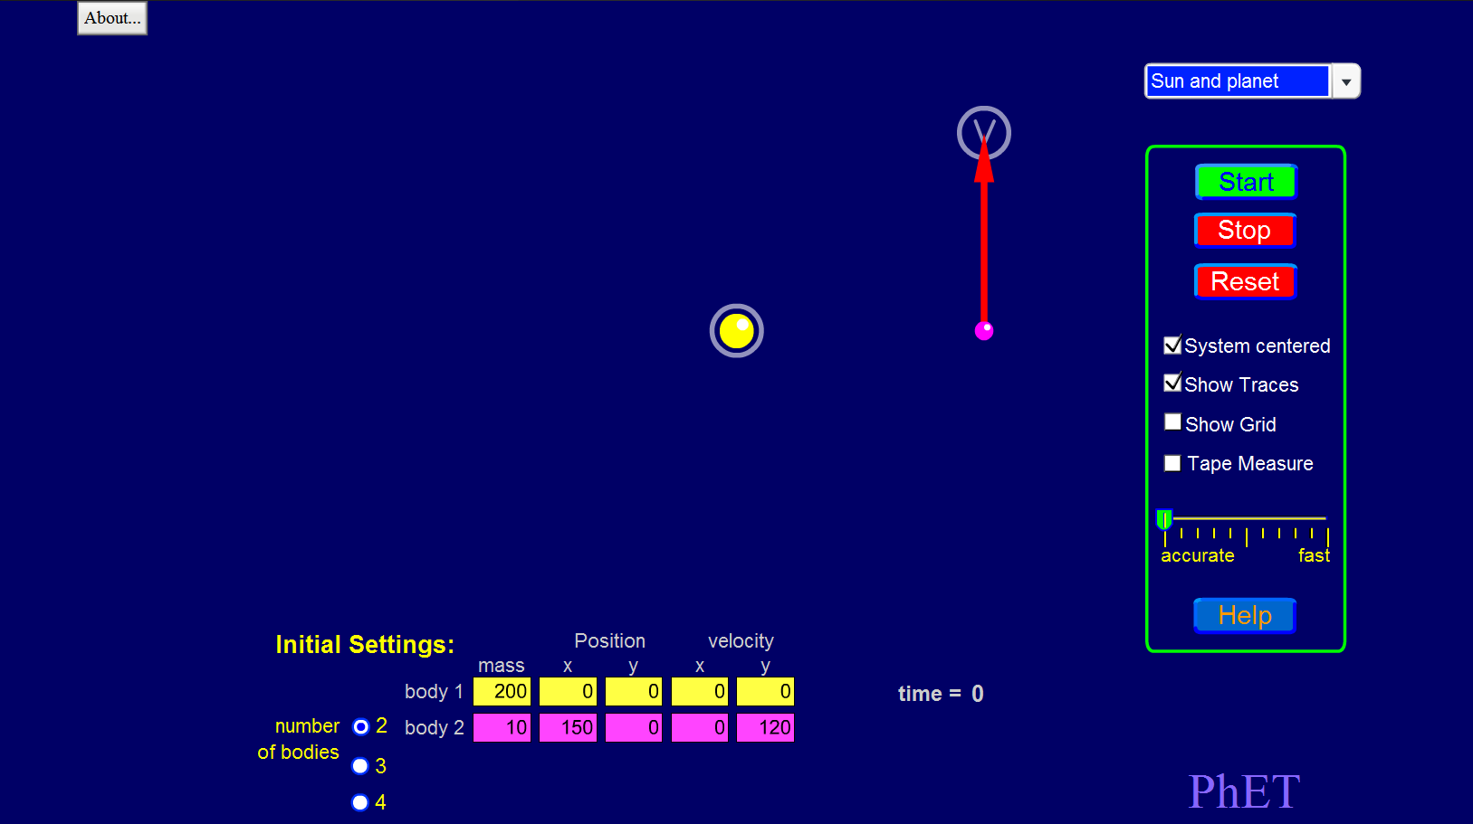
It shows ‘Sun and planet’, so you know which preset is currently running.
You can also notice the pattern inside the sandbox has changed a little bit.
When we now press on the start button, we can see the planet in a smooth orbit with the sun.
We can select more presets for this simulation.
Let’s take the ‘Sun, planet, moon’ preset. If you have done this correctly you will see this screen:
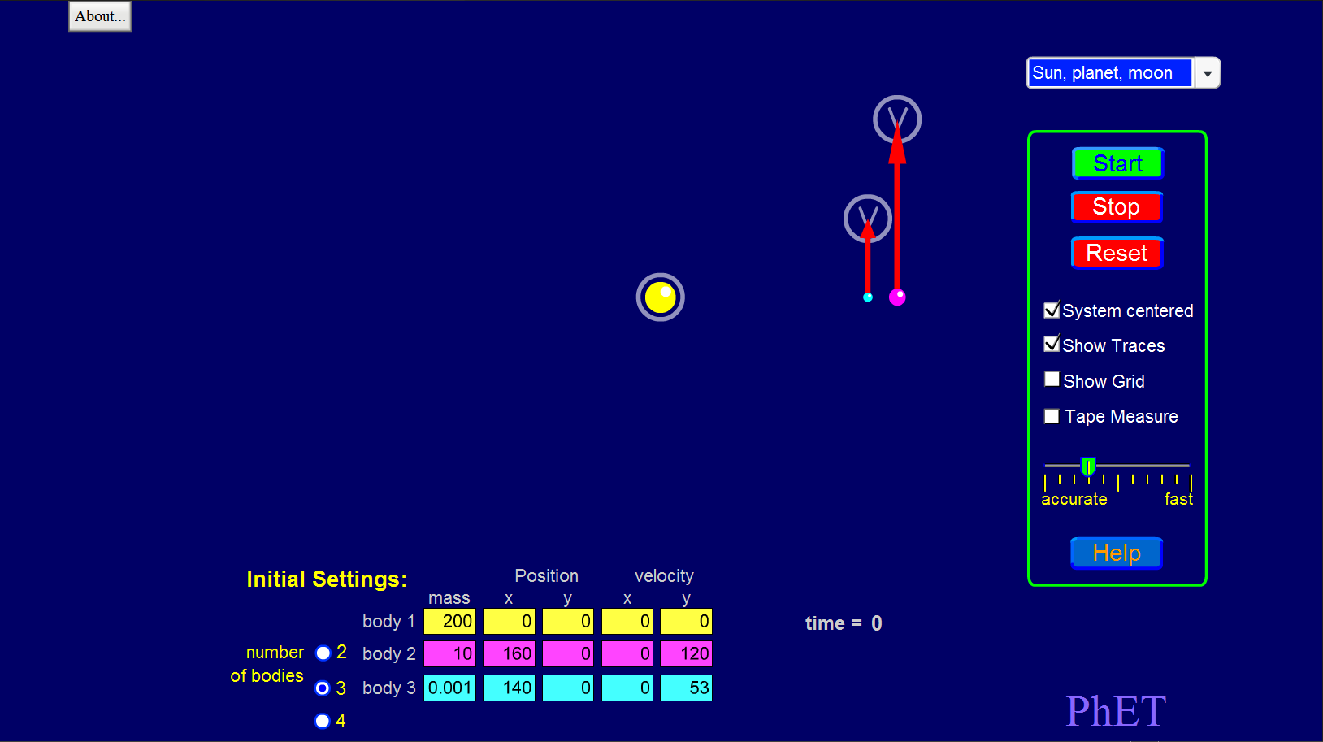
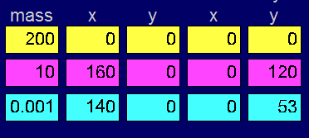
When you take a look at the bottom left screen. You can notice the number of bodies has changed to 3. This (ofcourse) due to having 3 objects in our sandbox. We have a sun, a planet, and a moon now. When we press the start button now, we will see our planet orbiting the sun, and the moon orbiting the planet. You can also see our mass, position, and velocity settings. Before the simulation starts, we can adjust these settings.

Adjusting these settings has effect on the sandbox.
You can toggle a grid by clicking ‘Show Grid’ on the middle right menu.
You can also toggle a Tape Measure by clicking that option in the middle right menu.
II – Basic introductory lesson
You can show the following things:
Orbits between planets and moons
Orbits between planets and a sun
That velocity and position affects a planet or a moon
Comets getting inside a sun’s or a planet’s atmosphere (with the correct preset)
That an orbit do not always have to be the same
Comparison between mass, and velocity
You can also adjust the velocity of a moon/planet by dragging the V in a circle, by doing this, the velocity of the body changes.

III – Expanding basic introduction
If the children understand the basic introductory lesson, and you have further explained it, you can expand the basics, like further explaining about orbits (from your own knowledge).
You can also use other simulators from PhET that support with this simulator.

Thank you for reading this guide and good luck educating,
Carlo Smits

