Circuit Construction Kit
Open "Circuit Construction Kit (DC Only)" Simulation at http://phet.colorado.edu/en/simulation/circuit-construction-kit-dc. (The link opens a new window; click on "Run Now" to run the simulation.)

Answer the questions and record your meter readings on your own paper.

Part 1. Simple Circuit
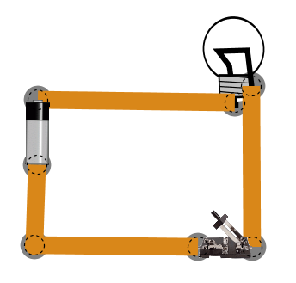
1. Set up a simple circuit with one battery, one bulb, and one switch, as shown. (You can hide the “electrons” by clicking “Advanced Show>>” in the right-hand side control panel.) Turn the light bulb on and off by closing and opening the switch.

2. Add a voltmeter by checking the “Voltmeter” box in the right-hand side control panel. Drag the black voltmeter wire so that the metal “point” is touching the negative (silver) end of the battery. Drag the red voltmeter wire so that the metal “point” is touching the positive (black) end of the battery. If the voltmeter reads “9.00 V”, you’ve done it right.

3. With the circuit switch open (so the light bulb is off), drag the red voltmeter wire to the locations listed in the table and, in the first column, record the reading on the voltmeter.

 | with the switch open | with the switch closed
left side of the bulb
right side of the bulb
right side of the switch
left side of the switch

(a) Which component has a voltage difference across it? In other words, which item has a different voltage on one side than on the other?
(b) The bulb is at 9 V. Why isn’t it on?

4. Now close the switch so that the light bulb is on. Repeat the same four voltage readings that you did in question 3. Record your answers in the second column in the table. Which component has a voltage difference across it? Does this help you answer question 3b, above?

Part 2. Series Circuit
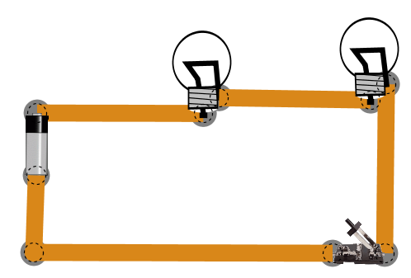
1. Set up a series circuit with one battery, two bulbs, and one switch, as shown. (You can either add a bulb to your previous circuit or click “Reset” and start over, whichever is easier for you.)

2. Add a voltmeter by checking the “Voltmeter” box in the right-hand side control panel. Drag the black voltmeter wire so that the metal “point” is touching the negative (silver) end of the battery. Drag the red voltmeter wire so that the metal “point” is touching the positive (black) end of the battery. If the voltmeter reads “9.00 V”, you’ve done it right.

3. Close the switch so that the bulbs light up. (What do you notice about the brightness of the bulbs compared to the previous circuit?) Use the red voltmeter wire to measure the voltage on both sides of both bulbs. Calculate the voltage difference across each bulb and record it in the table.

 | left bulb | right bulb
left side of bulb
right side of bulb
voltage difference for this bulb (left minus right)

4. Right-click on the bulb on the right and select “Change Resistance” from the menu that pops up. Enter “20” for the new resistance. Repeat your measurements and calculations from step 3. Which bulb (the high resistance or the low resistance) requires more voltage (energy) for the charges to get through it?

 | left bulb | right bulb
left side of bulb
right side of bulb
voltage difference for this bulb (left minus right)

5. Add a non-contact ammeter by checking the “Non-Contact Ammeter” box in the right-hand side control panel. Move the “cross-hairs” of the ammeter over each wire in your circuit. What do you notice about the current in a series circuit?

Part 3. Parallel Circuit
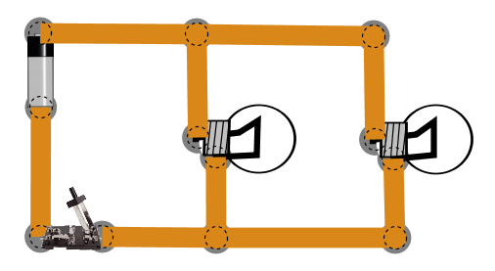
1. Set up a parallel circuit with one battery, two bulbs, and one switch, as shown. (Again, you can either rearrange your previous circuit or start over. I find it easier to start over with this one. If you rearrange, make sure you reset the resistance of each bulb to 10.)

2. Add a voltmeter by checking the “Voltmeter” box in the right-hand side control panel. Drag the black voltmeter wire so that the metal “point” is touching the negative (silver) end of the battery. Drag the red voltmeter wire so that the metal “point” is touching the positive (black) end of the battery. If the voltmeter reads “9.00 V”, you’ve done it right.

3. Close the switch so that the bulbs light up. (What do you notice about the brightness of the bulbs compared to the previous circuit?) Use the red voltmeter wire to measure the voltage on both sides of both bulbs. Calculate the voltage difference across each bulb and record it.

 | left bulb | right bulb
top side of bulb
bottom side of bulb
voltage difference for this bulb (top minus bottom)

4. Right-click on the bulb on the right and select “Change Resistance” from the menu that pops up. Enter “20” for the new resistance. Repeat your measurements and calculations from step 3. Does the resistance of the bulb affect the voltage difference across it when they are wired in parallel? Which bulb is brighter? What does that mean about how much current is going through each bulb?

 | left bulb | right bulb
top side of bulb
bottom side of bulb
voltage difference for this bulb (top minus bottom)

5. Add a non-contact ammeter by checking the “Non-Contact Ammeter” box in the right-hand side control panel. Move the “cross-hairs” of the ammeter over each wire in your circuit. What do you notice about the current in a parallel circuit?

