Understanding the Properties of Energy
Energy Skate Park

Instructions: Get your laptop out and go onto the internet. Go to this web page: http://phet.colorado.edu/simulations/sims.php?sim=Energy_Skate_Park or, go to Google and search for: phet skate park. Click on the Run Now! Button.
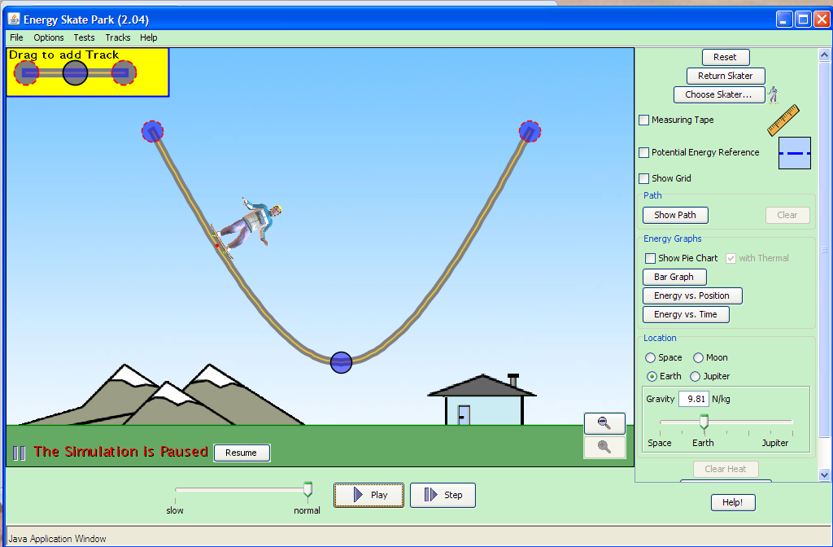
1. Click on Show Pie Chart and with Thermal
2. Click on Potential Energy Reference
3. Find the box that says Location. Click on Earth.
4. The program should be running. You can click on Pause or simply drag the skater and put him anywhere on the ramp at any time.

- What do the pie charts tell you?

- Click on Bar Graph on the tool panel. What does the bar graph show? What rules does it follow?

- What determines the Thermal energy pie section? What rules does it seem to follow? Draw two pie charts to explain.

- What determines the Gravitational Potential energy pie section? What rule(s) does it seem to follow? Draw two pie charts to explain.

- What determines the Kinetic energy pie section? What rules does it seem to follow? Draw two pie charts to explain.

- What does the size of the pie represent? How many ways can you find to make the pie bigger or smaller? What rules does it seem to follow?

- Can you determine what the system is in this simulation? What things do you think store the energy? How can you tell?

- How does going into outer space affect the energy pie charts? Specifically, what happens to the gravitational energy?

- What objects must be in your system in order to have Gravitational energy?

Click on Reset in the upper right corner and Pause the Skater. Click on the three blue dots in the upper left hand corner that says, “Drag to add Track”. Add some sections onto your track and arrange your track as you see fit. Keep friction turned off, and leave the gravity on Earth.

Sketch your track below:

J. What general rule about the hills do you have to follow to get the skater to go all the way from one side of your track to the other? What can affect whether it works or not?

